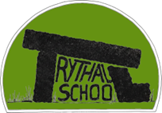
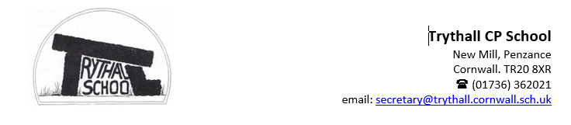
Dydd Da (hello) parents and carers,


Meur ras (thank you) for your continued support throughout this academic year. It’s hard to believe that it has already been a full year since I joined the Trythall community. This time last year, I had sold my house in Herefordshire and was preparing to leave a school that had been such an important part of my life for five years. I was nervcited — a perfect childhood word Rhys coined to describe that mix of nerves and excitement about what was to come.
This Photo by Unknown Author is licensed under CC BY-NC

I knew Trythall would become an equally important part of my life, but I had no idea what it would truly be like. The school’s ethos captured my heart and imagination in just three short visits: meeting Mat Strevens and Andrew Stott on a wet and windy February day, my interview on a much brighter March morning, and two transition days during a June heatwave. I also knew how important it would be to spend this year getting to know the children, their families, and the staff. There have been moments of pure joy — and a few bumps along the way — but every step has deepened my appreciation for this remarkable community.

Trythall is definitely bryntin (brilliant). Choosing highlights has been almost impossible, but here are just a few of the moments that have made this year so special:
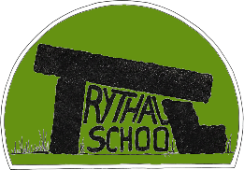
- Forest School at Higher Keigwen Farm
- Sports Day camaraderie with Sennen Surf
- Sporting achievements in hockey, football and swimming
- Pulling together after Storm Gorreti
- Performing — Christmas Play, Music Recitals, Minack Theatre
- John Dwyer’s visit (and of course, his wife’s)
- The Trythall Mystery Trail being shared far and wide, receiving so many positive comments
- French Pen-Pals — thank you, Julia
- Residentials for Classes 1 and 2
- Trips — too many to list
- Learning Cornish

Personal Development is one of Trythall’s greatest strengths. When I talk to friends and family about the brilliant things our children experience, many are genuinely awestruck that this is our normal. We are very lucky indeed.

Opportunities like these — alongside a robust curriculum and an environment where every child can thrive — happen because of our dedicated staff, who give so much to the school and to your children. We achieve wonderful things together, and you are an essential part of Trythall’s network of support for our inspirational learners. Ubuntu is at the heart of what draws us all to Trythall, whatever our role.


As we head into what will hopefully be a sunny summer, filled with the people and activities we love, I want to express my gratitude to everyone in our community for all they bring to the children — and to thank the children themselves for their responsibility, resilience, teamwork, independence, curiosity, creativity, determination, gratitude, courage, kindness, and respect. They show these virtues in abundance every single day.

Have a safe and happy summer — see you in September.

Nicky and the Trythall Team

Go Cornish!

You might have notice Cornish phrases being used around school since we enrolled with Go Cornish. Emma Cape and her Kryw Kernewek (Team Cornish) are leading this initiative with such enthusiasm that we are confident of achieving our bronze award in the Autumn Term.

Go Cornish gives young people across Cornwall the opportunity to embrace their own sense of Cornishness, learn about the place in which they live and to contribute to the future of our unique language. Take a look at the school website to find out more. Trythall Community Primary School - Cornish / Kernewek


Cleaner air for our children:
Trythall is an environmentally concious community and we teach our children to care for everyone and everything. Our science, PSED and RE curriculums alongside important enrichment activities promote responsibility for looking after our environment from pre-school through to year 6 and beyond. Many of you will have chosen Trythall for that reason.

Over recent weeks, concerns have been raised around the increase in cars idling during pick-up. We completely understand that that in the recent heatwave an air conditioned car was an effective way of keep young children cool, but leaving engines running — even for a short time — has a real impact on air quality around the school gates. Exhaust fumes linger at child height, and our pupils, are more vulnerable to the effects of pollution.
Turning off your engine while waiting:
- Reduces pollution around the school
- Protects children with asthma or breathing sensitivities
- Keeps our community environment cleaner
- Supports our commitment to sustainability

We know that everyone wants the best for our children, and this small action makes a big difference. Meur ras for helping us keep the air around Trythall as clean and safe as possible. We are happy to endorse this message but we also ask the school to respect that some cars may be idling due to babies or children with medical conditions that are impacted by the current temperature travelling in the car.

New Kit:
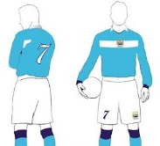
Following on from our success on the football and hockey fields this year we have applied for a sports kit through Octopus Energy, who share our commitment to renewable energy. The school council will be making final decisions this week about colour and elements of the design we can influence. We hope to have the kit in time for the new season.


The School Grounds
The children and staff would like to extend to Julia (Olive and Alba’s) mum and Virg for giving their time each Tuesday morning to help us keep on top of the management of our beautiful environment. We are hoping to organise a day in the holidays to complete some of the jobs that we haven’t been able to to complete so far. If you would like to be involved please see Virg, Julia or Nicky so we can make sure you have the dates when confirmed.
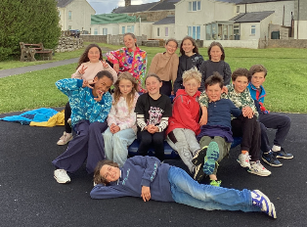
A fond Farewell:
It is time to say goodbye to our year 6’s who have played such an important role in the Trythall Community since they joined the school. They are such a fabulous bunch of humans who understand the importance of Ubuntu. We are all going to miss you so much and hope you will stay in touch.

September and beyond

With Trythall School celebrating its 150th anniversary in 2027, we are beginning the academic year with an exciting whole-school project focused on our school, its unique location and the community it serves. This will provide the perfect opportunity to begin planning for the anniversary celebrations that will take place throughout the year.

Children and staff will work together to explore what makes Trythall such a special place in 2026–2027, while also discovering more about the generations of families and communities the school has served over the past 150 years. It is a wonderful opportunity to celebrate everything that is inspiring, unique and magical about Trythall.


As part of this journey, children, staff and parents will all play an active role in helping to shape the school's vision for the future as we move into the next chapter of its story. Please be assured that this is not about changing the values and traditions that have always been at the heart of Trythall. Rather, it is about building on these strengths and making the most of our exceptional location by embracing nature and engaging with the rich cultural opportunities that this special part of Cornwall has to offer.

Some of the developments planned for September and beyond include:
- An engaging and ambitious curriculum that continues to challenge children's thinking, inspire creativity and nurture curiosity. The Early Years and National Curriculums will be delivered by skilled teachers and teaching partners through purposeful learning experiences both indoors and outdoors. As part of this, we are excited to be reintroducing planned outdoor and Forest School learning opportunities for all classes.
- Specialist teaching opportunities, with Scott, John Brolly and Christine continuing to share their expertise in PE, drama and music with children in Year 1 and above.
- Greater opportunities for children of all ages to work together, with medium- and long-term planning designed to encourage interaction, collaboration and shared learning experiences across year groups.
- Enhanced play opportunities, making use of a range of spaces to support safe, happy and purposeful playtimes, with designated areas catering for different interests and types of play.
- Strengthened outreach and inclusion support, ensuring that children who require additional help to access the curriculum receive the support they deserve. This will inturn promote safe, happy leaning environments across all year groups, where all children achieve their full potential.
- Personal Development fostered through Ubuntu and our school virtues will continue to be the golden thread that runs through our school promoting fairness, tolerence, respect and kindness.

This is an exciting time for Trythall School, and we are delighted to be working in partnership with our families as we look ahead to this significant milestone. Early next term, we will be inviting parents and carers to a vision-building meeting, where we will share our plans, gather your ideas and answer any questions you may have. Together, we can celebrate our rich history while shaping an ambitious and inspiring future for Trythall School.

