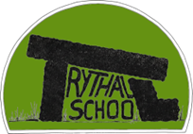


Dear parents and carers,


Welcome back to another busy term. We are delighted to finally have some sunshine and hope it continues into the summer term. The children have settled back in quickly and are already embracing our new learning, “Cornwall – My Home.” This is a wonderful opportunity to find out about local geography, history and heritage. We will be sharing the myths, the legends and the magic of Cornwall and taking every opportunity to connect with the environment. We are also hoping to introduce the Cornish language into school, and this may lead to working towards a whole school “Go Cornwall” award.

Thank you to everyone who supported our walk into school week at the end of last term. It was lovely to see so many of you taking part. Thank you to the staff who facilitated this, we enjoyed having the opportunity to walk before school and chat with the children in the process. We certainly experienced a range of weather over the week, but this didn’t stop us! If you are hoping to continue walking the last leg of the journey into school, please note that there won’t be any staff available and you should walk with the children. Parking in the layby at the top of Bone Valley and in New Mill should respect other road users and please keep to the footpaths when crossing the fields.

We are entering a busy period for our farming neighbours which increases the frequency of agricultural vehicles using the roads around school. Please remember this when dropping off and collecting at the front of school, by leaving enough room for a tractor to pass your vehicles. Our neighbours are mindful of how busy and difficult it is to facilitate the drop off and collection of our children without adequate carparking so try to avoid this time of day but of course this isn’t always possible when working to deadlines or in weather windows!

Nicky and the Trythall Team

Decider Skills
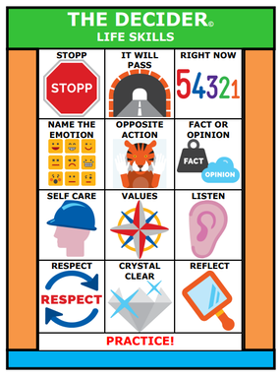
As part of the work the children have been doing with Maeve around recognising and responding to different emotions we are beginning to embed a consistent response to supporting children at school who are showing signs of dysregulation. Emma led a staff training on this as part of our inset on Monday. You may also see some new posters around school that reflect this proactive approach designed to help us all to be more resilient, resourceful, responsible and respectful. It aligns perfectly with our Golden Virtues used for all children while offering additional support for children as and when they need to draw on it. If you want to find out more this has been added to our website, where you will find a number of resources designed for parents. Trythall Community Primary School - Decider Skills

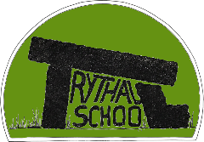
The School Website:
The development of the school website is ongoing and we received some lovely feedback following it’s launch last term. Georgia is currently working with eschools to sync the school calendar as a useful tool for checking diary dates. We also hope to add recent news, celebrating everything that is going on at Trythall. Our aim is to add all the curriculum information over the course of this term, so you have information about how we cover the EYFS and National Curriculum

Football league:

Congratulations to the girls team who played in the play offs on Tuesday. They showed teamwork and sportsmanship. They came 2nd in the league! We celebrated them in assembly and the whole school are so proud of them.

This term our 3 and 4 are playing in the league and we wish them every success in their future matches but the key message is enjoy it!


Calling all Parents/Grandparents:
Julia (Olive and Alba’s mum) is keen to support school by offering time to maintain the spaces the children use for gardening. She has met with Virg and they have a list of things that need to happen as we move into spring and beyond. Julia is in school from drop off until 11am every Tuesday and she would love some more volunteers to join her. Many hands make light work! If you need any more information please speak to Julia or keep an eye out on the Friends of Trythall WhatsApp where Julia posts what jobs are being focussed on in each session.
Friends of Trythall:
Everyone is a member of Friends of Trythall. We welcome new ideas so if you would like to be involved or have any suggestions please talk to Kylie (Jagger and Harley’s mum) who is the chair of FOTS.

FOTS are looking for your support with:
- Planning and running fundraising events such as the gala
- Baking cakes and savory treats for events…
- Collecting raffle prices
- Supporting gardening days – keeping the grounds in check!
- Finance skills – auditing accounts
- Sources grants for schools and completeing the application

Thank you to Julia for all her work in finding different revenue streams. We are now signed up for easy fundraising. Please follow the link if you shop online as this will mean we get cashback.

Diary Dates: Here is a list of events and activities happening next week from Monday 23rd March

OTHER IMPORTANT UPCOMING EVENTS INCLUDE

- Friday 24th April - Class 3 - Smarter smiles - fluoride application
- Tuesday 28th April - First Year's 3/4 Football Fixture
- Friday 1st May – First swim for Class 2 / Year 1

