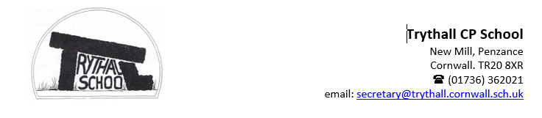
Dear Parents and Carers,

We have all settled back into school and have had an action packed first for weeks. There is always so much going on at Trythall, there is never a typical day! The children are so engaged in everything that is presented to them and their love of learning is embedded through the strong early years and national curriculum that is taught by our skilled teaching team. Where Trythall differs from other schools is how we enhance those core curriculum expectations placed on schools through using our unique environment and seeking out further opportunities such as our clubs offer, surfing and trips that bring the subjects we teach to life.

We also provide a purpose for learning through planning towards an outcome for our learning that is celebrated outside the school. This term we started the term by learning about Anna Atkins, an English Botonist and photographer. The children have used the images from what is believed to be the first book illustrated with photographic images to inspire their art. We hope to display invite you to their art gallery after half term.

This week the children in class 2 took their science learning to Virg’s and enjoyed an afternoon of apple picking and pressing. There was some delicious apple juice to sample as a result. Thank you to Virg for giving us the opportunity to visit. Last week, class 1 took the glut of apples from our school grounds and the eggs from our chickens to produce some apple pies which they shared with the school. It was delicious and I think Summer was so right when she declared, “This is the best pie ever because class 1 put their love in it.”
On Thursday morning, Class 1 experience what it was like to go to School during the Victorian Era – their verdict was very strict!

We hope that you all have a lovely weekend.

From Nicky and the Trythall Team

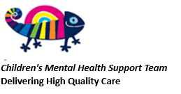Parent Workshop - Resilience: Meave hosted the first workshop for parents on Wednesday. Thank you to everyone who was able to attend. We have received some lovely feedback about how relaxed it was and there was an opportunity to chat which promotes our Ubuntu philosophy – community is key!

The next workshop for parents will be on Wednesday 19th November at 2.15pm – all welcome. The focus will be Understanding Behaviour as Communication (another key part of our philosophy on supporting children whose behaviour sometimes challenges.)

We will be purchasing some of the books that Maeve has recommended. These will be on display outside the school office for staff to use with children and you are of course welcome to borrow them. We can make photocopies of any activities you are interested in trying at home.

Maeve has also sent across some resources which are attached to the email with this letter. You might also find tge link to the video Maeve shared useful too. https://www.youtube.com/watch?v=JfdoJxPjp1k

Toys in school:

We have seen an increase in the number of toys and cuddliys coming into school. This is causing a distraction during lesson time and an increase in the number of arguments at playtimes. Please can we ask that toys stay at home. We have sensory boxes which are used if a child has a sensory need to fiddle while concentrating. Thank you for your support.

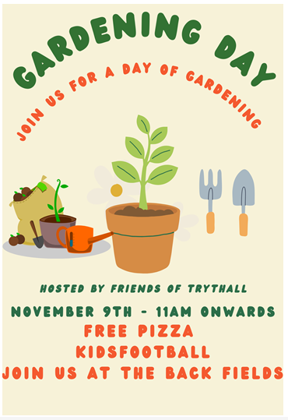
News from Friends of Trythall:

Diary Dates:

