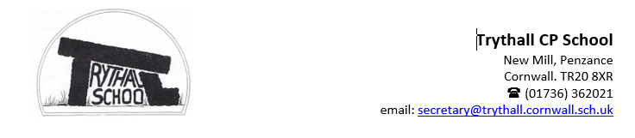
Dear parents and carers,

As we approach the end of term, the school is full of festive spirit. Our Christmas Making Day was a great success—children and staff created beautiful decorations now brightening our entrance. Thank you to Mole Valley for donating the school and pre-school trees, and to Rueben’s Grandad, Nigel, for nominating us again this year. The children have also made paper angels for the Zennor tree, which you can enjoy next week.

Our Christmas performance, prepared by the children with Christine and John Brolly, will be a highlight at Zennor Church on Monday afternoon. For pupils learning instruments, there will be a separate recital during Tuesday’s assembly; invitations have been emailed to the families of this performing. The change ensures our growing group of musicians have time to shine.

Thank you for your flexibility during recent winter illnesses which have affected so many of our families. We hope everyone is feeling better and ready for a joyful Christmas.

Next week, is going to be full of more festive fun:
The children will be performing in Zennor on Monday afternoon. We will spend the much of the day there rehearsing and enjoying a whole school picnic lunch in the village hall. Children will travel to Zennor on the minibus or in staff cars. Please ensure that your child has a packed lunch as there will be no hot dinners on Monday. FOTS will be serving hot drinks and cakes following the performance and Nicky will draw the raffle.

On Tuesday, we are expecting a visit from Father Christmas at our Christmas Party. The children can wear festive party clothes to school if they wish.

On Thursday, years 1 to 6 will be at Rogue Theatre. Please note that they will need to dress warmly and bring along a packed lunch. Our reception and pre-school children will remain at school and enjoy John Brolly’s performance of “A Cinderella Story.” Hot lunches are available for Reception and Pre-School.

End of Term: School finishes Friday at 1:30 pm. Please note there is no wraparound care that day. We return on Tuesday, 6 January 2025.

Wishing you all a Merry Christmas and a Happy New Year!
Nicky and the Trythall Team


Toys in school:
Thank you for supporting our request to keep toys at home. We’ve noticed a real difference—children are more focused, and playtimes have been calmer with fewer disagreements. To keep this positive momentum going, we kindly ask that toys remain at home again next term. For children who need something to help them concentrate, we have sensory boxes available in all classes. Your continued support makes a big impact, and we truly appreciate it!


Dogs on the school site: We have really enjoyed meeting so many new puppies that have joined your homes over the last term. However, we need to remind everyone that dogs cannot come onto the school site as they present a risk for those children who have allergies or are frightened of dogs. We also want to make sure that your dogs are not overwhelmed by those children who want to come over and make a fuss of your lovely new pets.


Football league:
We are delighted that we can be part of the football league again next term. Letters have been sent out to children in years 4 to 6 with more information. Thank you to everyone who has been working behind the scenes to ensure that our children continue to have this opportunity. We are sure that our teams will continue to show their Trythall spirit on the pitch this year. Unfortunately, our kit is beginning to look a bit tired and we are hoping that we will be able to purchase a new kit soon. If you have any suggestions of companies that might like to sponsor our new kit please speak to Georgia or Jeanette.

