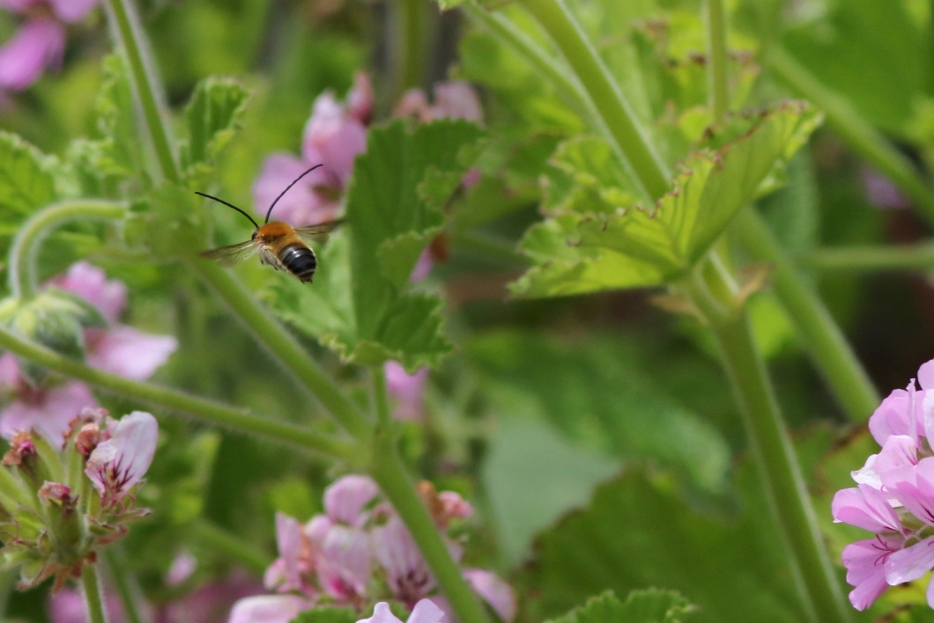

Long horned bees have been photographed in Mousehole
near where we provided them with boxes of ‘food flowers’ last year.

Dear Parents/Carers 21.06.2019

Garden Volunteer Day
First of all can I say a huge ‘Thank you’ to all the parents that came to the garden volunteer day in the Spring. The number of people that came out to help was amazing and we got far more work done than we anticipated and had a great time too. This work is really appreciated and makes a great difference to the children.

Climate Emergency
Both British Parliament and Cornwall Council have declared a ‘climate emergency’. The advice of the United Nation’s IPCC (Intergovernmental Panel on Climate Change) has warned that ‘urgent and unprecedented changes’ will be needed by 2030 to keep global warming to a maximum of 1.5 degrees Celcius and avoid climate breakdown including the risks of runaway climate change, crop failures, flooding etc.

Obviously, as parents, we are concerned about the type of world that our children will grow up in, while children all over the world are protesting, inspired by the 16 year old Greta Thunberg.

While it might seem hard to address such a massive worldwide problem we should not underestimate what the children can achieve:
- Children from Trythall gained national recognition for saving the long- horned bees by raising awareness, persuasion and practical conservation work.
- Children from Trythall invited Derek Thomas to their own climate demonstration several years ago. He has now made some significant moves to persuade his own party members to take measures to protect the environment.

Children and young people say they are worried because they know about the problems of global heating but adults do not seem to be taking appropriate action. If they see action, they might start to worry less. There are undoubtedly things we can improve about what we do at Trythall to reduce our Carbon Footprint and the children are keen to see this done.

We generally follow the policy of promoting the 3 Rs (in order of importance):

1. Reduce/Refuse.
2. Re-use
3.Recycle

What we are already doing:
- Reducing heating and (particularly outside) lighting when we don’t need it
- Looking into more efficient heating eg Air source heat pump
- More efficient minibus
- Improved recycling and composting to reduce waste
- Making sure the children are well informed
- Being careful about what we buy – is it really necessary?

What we would like to do:
- Investigate the possibility of becoming an eco-school
- Investigate improving transport to and from school (see also parking) eg car sharing, cheaper buses
- Continue to provide environmental learning opportunities for children and school community
- Send school newsletters by email – no paper copies

There is lots of information available on the internet, but we would like to invite you to consider the following:
- Make the First News ‘Wonderful World’ pledge at https://live.firstnews.co.uk/first-news-wonderful-world-pledge/
- Investigate your carbon footprint, perhaps using: http://www.footprintcalculator.org
- Giving us your ideas or help on how we can become a greener school/area/country/world
- NASA for Kids

Car Parking
It is obviously important to keep the roads clear to make travel around the school more efficient but it is also important for safety reasons eg road crossing and access for emergency vehicles.

What we have done:
- Improved the car park and access to it
- Extended school club timetable to stagger the pick up
- Requested that local road users, particularly those with larger vehicles, avoid busy times if possible
- Advised parents on efficient use of the car park

What you can do:
- Avoid parking - Could you make a drop off at either gate, so that your child/children can safely walk in independently? Walk? Cycle? Or take the bus.
- Only stop in front of the school for brief drops.
- Park with consideration for other road/car park users.
- Use the school car park
- Generally it’s ok to park in front of the staff cars and the minibus but please don’t block in the minibus on a Friday around 3pm.

What we plan to do:
- Continue to encourage efficient parking and transport
- Bring in electronic payments so that there is less need to visit the office
- Look at the possibility of building a bike shelter

Would you like to convert your bike to an electric bike. We can provide advice and help with conversions. The cost of a kit is less than £500.

Mazey Day
Tony Crosby is working hard with the children to produce another amazing image to take through the streets. If you have any time to help it would be much appreciated. Please come and tell Lucy when you might be available.

Transition Days (see dates below)
The children will all take part in ‘Transition Days’ where they get a chance to be in their new classrooms with their new teachers. This helps the children settle in well in September and might prevent children from worrying about anything over the Summer Break.

Class 2 Teacher
We look forward to welcoming Emma back on 1st July after her maternity leave with Milly-May. We will be sad to see Paul finish his maternity cover period but hope we can find a way to keep him involved at the school. He has done a fantastic job with the class and will be greatly missed by the children, teaching team and school community.

Peas 4 Bees
Flower meadows are established at Mousehole and St Loy. The children have grown thousands of plants and we have been promised new growing areas near Sennen, St Just and possibly Perranuthanoe.
Channel 4 may want to include the school in a programme about children’s environmental work.

Swimming
Reminder: Please can the boys wear swimming trunks rather than swimming shorts for our weekly swimming lessons.

Playing in the School Grounds before or After School
It’s lovely to see the children playing in the school grounds at the end of the day there are a couple of problems associated with this. Most of the problems are associated with supervision:

- chickens/chicks being chased with sticks;
- chicken doors being closed/opened when inappropriate
- items being left out damaged
- children being left unsupervised
- children playing in a way that might endanger themselves or others

The children at Trythall are very well behaved and independent. Children on the school grounds before and after school must be closely supervised by parents. The school cannot take responsibility for the safety of children on the school site before the beginning or after the end of the school day.

Madron Parish Neighbourhood Development Plan Start Up Meeting: Thursday 11th July, Landithy Hall. Details on poster in the Hallway.

Yours sincerely,

M.Strevens

Headteacher

Diary Dates:
Saturday – 29th June Mazey Day 1 p.m. parade
Thursday - 4th July Transition Day
Tuesday – 9th July Transition Day
Friday – 19th July Performance/BBQ
Tuesday 23rd July Last day of the Summer Term
Wed 4th Sept Staff Training Day
Thurs 5th Sept Children return for the start of the Autumn Term

