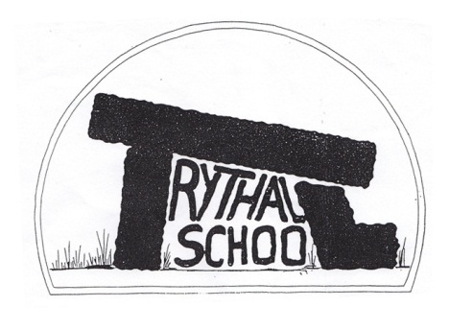
Trythall CP School
New Mill, Penzance
Cornwall. TR20 8XR
 (01736) 362021
email: secretary@trythall.cornwall.sch.uk

25.09.2015

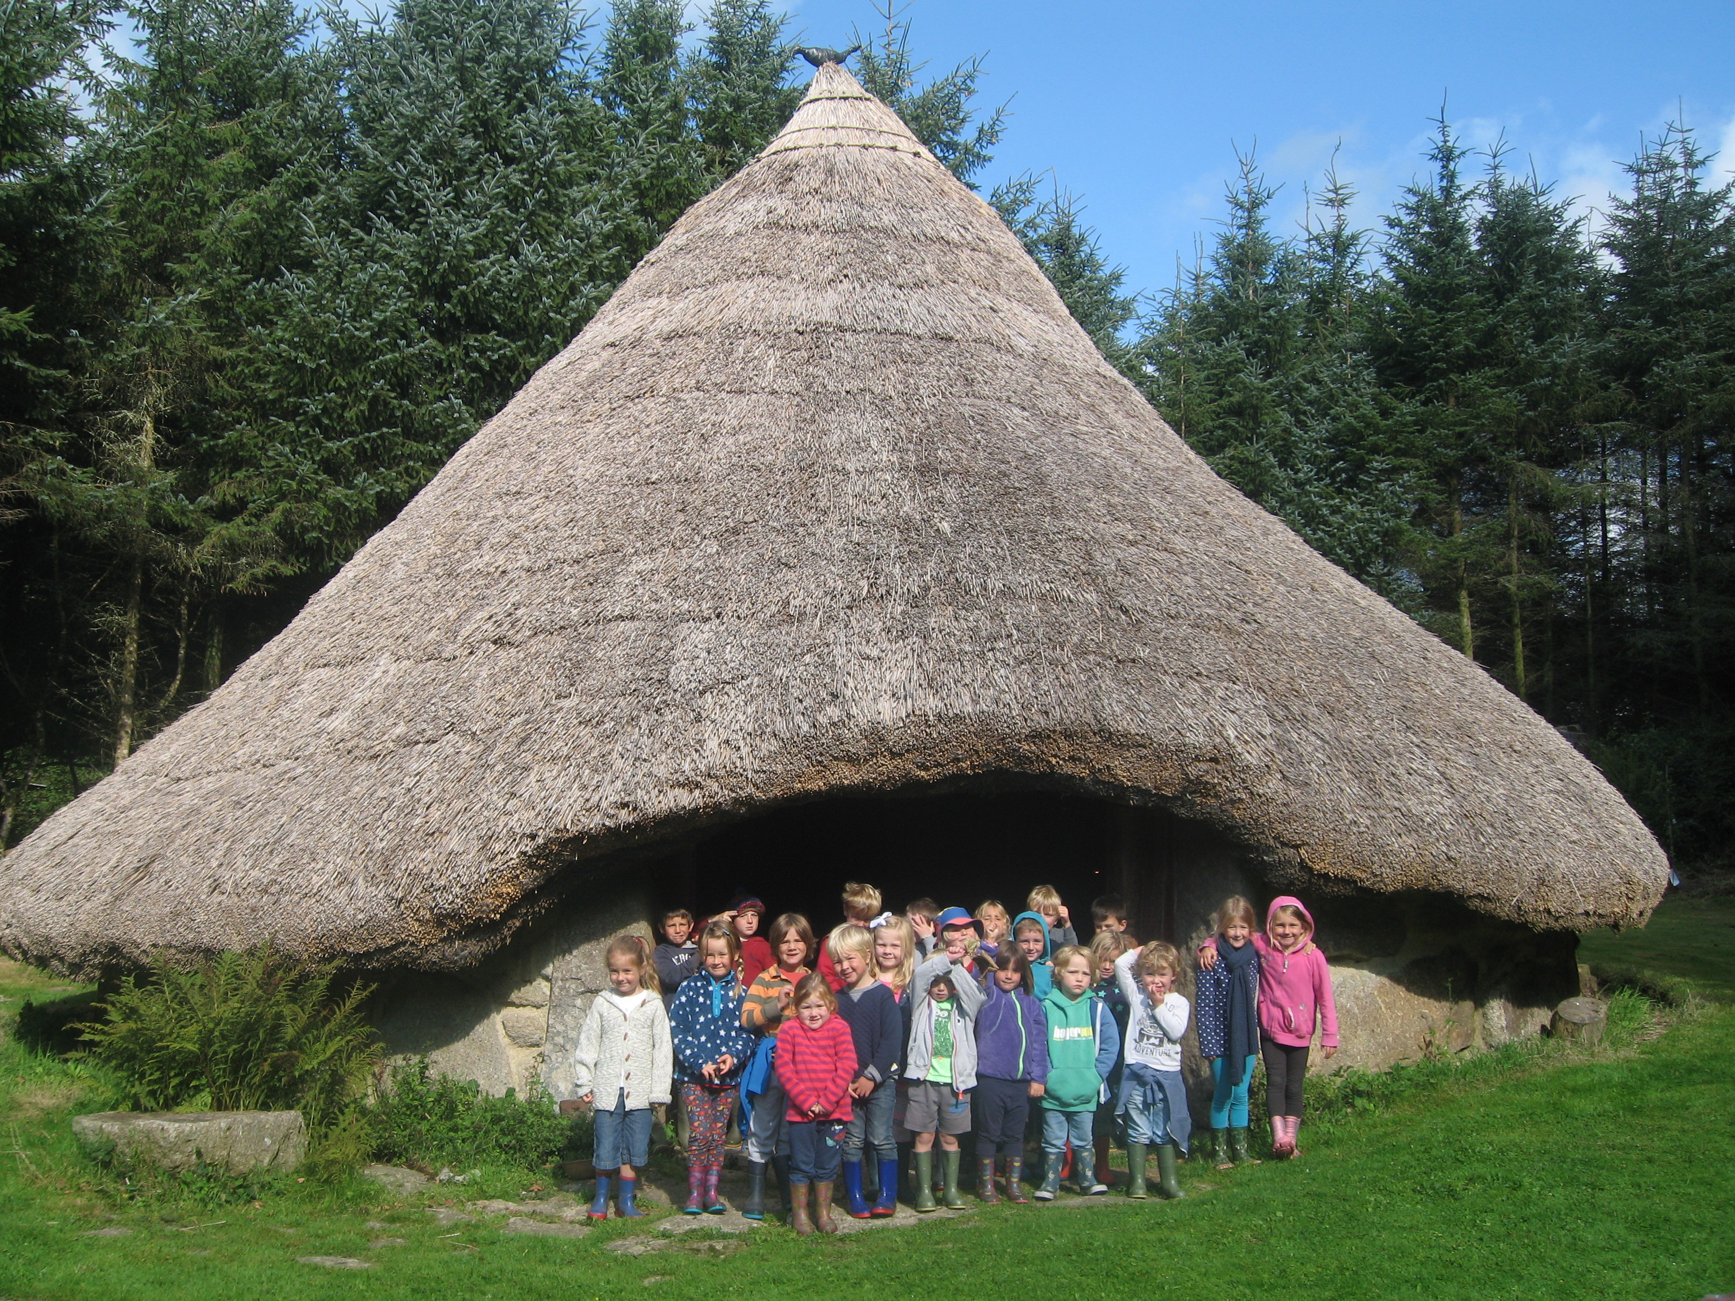
Children at Bodrify learn about what life was like before anyone invaded.

Dear Parents,
It’s been great to catch up with everyone again after the Summer. The children loved coming back and meeting all their friends. I hope that everyone had a great time, despite the weather.

Project Work
We plan to continue to deliver our curriculum through topic work. It is reassuring to see that the approach that we use is what many schools are working to emulate. Project Based Learning (PBL) and immersive learning (as it is now called) is also increasingly endorsed by educational experts. The national report on assessment has also reinforced the importance of the depth of learning: ensuring children fully understand what they are learning and can apply their knowledge. To deliver this, our outdoor areas and approach to learning means that, we are well ‘ahead of the game’. Nevertheless, we will continue to develop our methods and to support other schools.

Our approach involves making sure there is a real purpose for their learning. Often we do this by getting the children to work towards some sort of event or product which the children have to plan and deliver themselves. By linking all areas of the curriculum to the final product, the children become more engaged in their learning because they have a genuine need to know.

This terms whole school topic is about invaders and settlers: Romans, Anglo Saxons and Vikings. Our central question is: Would you rather be a Roman or a Viking? The ‘product’ is a special event (held on the afternoon of 12th November) to which you are invited, so that you can decide for yourselves. The children will present the information they have gathered through performances, talks, drama and some special food and refreshments. We hope you will be able to come along.

French
As part of the changes to our curriculum, language teaching is now compulsory at Key Stage 2 (Juniors). In addition, we have made the decision to teach some French right through the school, starting at preschool.
French is best taught by introducing it at every opportunity rather than just discrete French lessons.
The children have responded well to this approach and invariably surprise the French teachers when they go to lessons in secondary schools. Learning a language at young age will greatly increase their ability to learn other languages that they learn after primary school.
By producing bilingual children, they may also have the chance to emigrate to France if the weather here remains the same!

We pay a subscription for an online French teaching resource for children which you may wish to try at home. The key info is:
Website:http://smart.cyber-coach.co.uk/?N=LaunchFrench&EMailAddress=head@trythall.cornwall.sch.uk

Username:head@trythall.cornwall.sch.uk
Password:tr208xr
Parent Governor Needed
There is a vacancy for a parent governor and the election process will start next week.

Club Attendance
We would be grateful if you could let us know when your child will be absent from a school club; when we have to track children down, it can cause concern and waste time for the club leaders.

Data Checking
To ensure our data is as up-to-date as possible, data checking sheets will be coming home with your child(ren) next week. Please check, amend if necessary and return them to the office as soon as possible.

Nit Checking
We have had reports that one or two children have headlice. Please can you be vigilant in checking your child(ren’s) hair and treat as necessary.

Asthma/Medicine
All medicines should be brought to the school office and a form completed before school staff can administer any medication to children.

Asthma Pumps
Due to a change in the law, the school can now keep emergency pumps to administer to children if we have written consent from a parents/carer. We do not have the emergency pumps yet but will receive them in the near future. These are intended for emergency use only, so the children will still have to look after their own personal pumps. We will keep you informed about when these become available and let you know what paperwork you will need to complete before we can use them with your child.

In the meantime, if your child does need an inhaler, please could you make sure that: they have an inhaler available in school; it is not out of date; you have completed the necessary paperwork.

If you have any questions about this, please do not hesitate to contact Lucy or myself in the office.

Parents in the School
We are very proud of our open door policy at the school and hope that parents would feel comfortable to come in to the school building. In order to safeguard the children, parents cannot be granted completely free movement around the school without staff supervision. While parents are always free to be in the main foyer, they should only be in other areas of the school building when a member of staff is present. We are grateful for your continued co-operation in keeping the children safe.

Vacancy for a Servery Assistant
Mel has been promoted to another position. Please contact the school office or contact Chartwells.

School Dinners
Census day is Thursday 1st October. A range of data is collected. The number of school dinners ordered on this day will influence the funding that the school gets. The more free school dinners ordered, the more money we get. There will be a special ‘America’ menu, details to be sent out soon.

Sex Education
The school has responsibility to deliver sex and relationships education. It is very important that the children get the right messages at the appropriate age. The programme that we will follow, throughout the school, is based on a well-recommended scheme called the Timothy Winters Project. This programme covers lessons from Reception to year 6.
If you would like look at the resources that will be used or would like to discuss this area please do not hesitate to contact me.

Diary Dates
26-30th Oct Half-term
4th Nov Parent Meetings in the afternoon
12th Nov Invaders and Settlers Production . Parents are invited to join us from 12 noon
8th Dec Christmas Performance, Zennor Church 2 p.m.
17th Dec Children’s Christmas Party and Disco (disco 4 – 6 pm)
18th Dec Break up for Christmas Holidays
5th Jan 2016 Start of Spring Term

Kind regards

M.Strevens

Mat Strevens
Headteacher

School Feedback Form Parent/Carers name: __________________
Your thoughts or ideas

l

