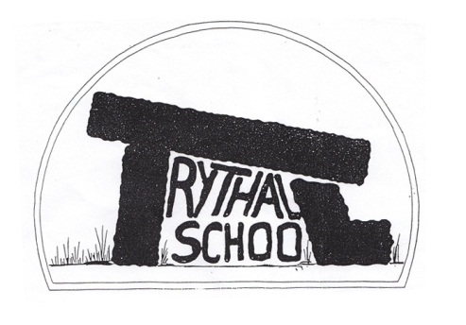
Trythall CP School
New Mill, Penzance
Cornwall. TR20 8XR
(01736) 362021
email: secretary@trythall.cornwall.sch.uk

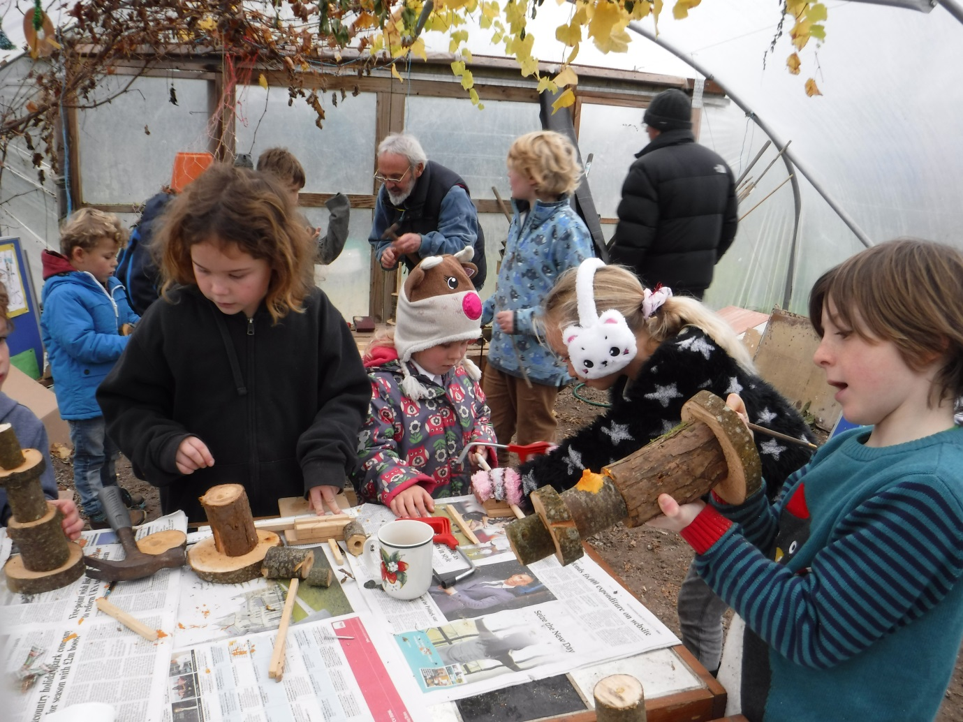
Working together on Christmas Craft Day.
29.11.16

Dear Parents
I thought it was worth putting out a quick newsletter, mainly to give the dates of the important events in the run-up to the end of term. Also, on behalf of all the staff, we would like wish you all a very happy Christmas and New Year.

This Term’s Project: Inventors
The go-carts have gone very well and are nearly finished. We hope that we have a chance to show them before the end of term. In any case you are welcome to come and have a look-just ask your child to show you which one they have worked on.

Would you like to be a Parent Governor?
A vacancy now exists for a parent governor. Nomination forms have gone out and (if more than one person is nominated) a ballot is held. Further forms can be requested from the office. Closing date for applications is 7th December.

Pre-School Promotion
Please don’t forget to promote our pre-school if you get the chance. Word of mouth is the best (and cheapest!) advert we can have.

Perfect Christmas Present- A Child’s Portrait of West Penwith
So many people have been thrilled to receive this book written and illustrated by our children. If we can sell enough copies to break even we can justify similar projects in future. The book costs just £7 if you buy it from the school office.

Have Fun on Sunday and Support Wildlife
If you have an hour or so on Sunday morning (4th Dec) you may want to come and help run a water-station to support the Race for Wildlife. We need to have some children to hand out cups of water between 10 am and 11 am. The children always enjoy this task.

Christmas Craft day
This was great fun again- the children were brilliant and made a good variety of lovely things. We are very grateful for the significant amount of help given by parents to support this event.

Diary Dates
Saturday 3rd Dec- all day County Chess tournament in Truro for our chess team
Tuesday 6th Dec- am Practice for Christmas production
Tuesday 6th Dec- pm Carol singing at Trevaylor Nursing Home
Wed 7th Dec – Christmas Production – Zennor Church 2 p.m.
Friday 9th Dec pm Class 1 Carol singing at Ponsandane Care Home
Friday 9th December Last swim Fun Session for Year 2 to Year 6

Mon 12th Dec – Children’s Christmas Party and Disco – 6pm finish
Tues 13th Dec – Years 3,4,5, and 6 Skating at The Eden Project
Wed 14th Dec – Reception, Year 1 and 2 Play on Ice at The Eden Project
Thurs 15th Dec – Christmassy Christmas Show at The Acorn Theatre, Reception to Year 6
Friday 16th Dec- Last day of term ending at 3:15pm as usual (children can bring in their own games- not electronic please)

Jan 4th First day of Spring Term

More details will be given for some of these events on separate letters.

Yours sincerely

M. R. Strevens
Headteacher

