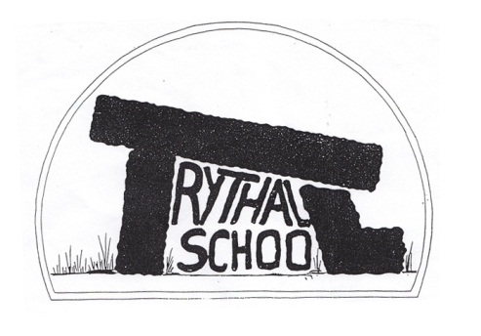
Trythall CP School
New Mill, Penzance
Cornwall. TR20 8XR
(01736) 362021
email: secretary@trythall.cornwall.sch.uk

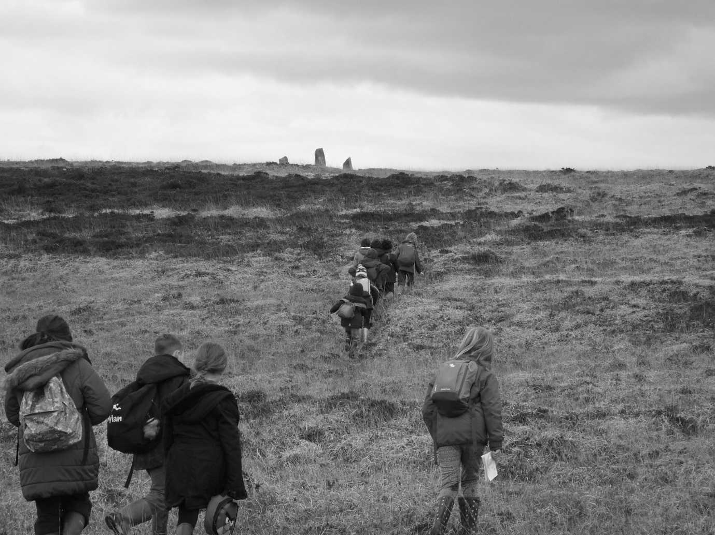
2.3.16
Dear Parents
I hope that everyone has enjoyed the breaks in the rain and that we are beginning to recover from the range of viruses that have descended on the area recently.
I know that everyone will be pleased to hear that Otto, who was hospitalised, has started to recover. I know that we have all been shocked by what happened and will be thrilled hear that he was well enough to return home yesterday. Well done Otto!
Asthma – Important Changes
Reminder: All parents of children who need inhalers should collect the appropriate paperwork from the office and complete it as soon as possible.

A Child’s Portrait of West Penwith
The project is going very well with lots of exceptional work being produced by the children. We were delighted to receive a beautiful card, painted by Sue Lewington, after she visited Chun castle with Class 2. We were also pleased to receive the news that we have received grant funding from FEAST for our project which will help us further. Thank you to all the parents who have volunteered to help on our trips - they have talked enthusiastically about their experiences and some were even painted by Sue L.

Gardening
It’s time to start to plant some early crops in the polytunnel so we will be gardening again on Wednesday afternoons. Please let us know if you have time to join us as we can achieve a lot more with some extra adult support.

New Faces at the School
Jenny Defriez is now gaining teaching experience at Trythall on Mondays before applying her SCITT course. Kay Nicholls, who is waiting to start her SCIIT course, will start work at the school on Monday, providing cover for Anna Pilbeam, who, as you probably know, is on Maternity leave.

Bad Weather procedures: a reminder
Just a note to remind you of our procedures should we have severe weather. In the event of the school having to close, the information will be broadcast on Radio Cornwall and Pirate FM. Lucy will telephone you on the first day of closure and will send a text and email message on any subsequent days.
The latest guide for Parents and Guardians on School Emergency Closures (distributed before Christmas) is displayed in the foyer (further copies available from the office on request).

Arriving Late for School
While it is impossible to avoid certain circumstances, late school arrivals appear to have several negative effects. School begins at 8:45am with a relaxed start before lessons at 8:55am. It is important that any children, who are not in class by 9:05, go to the school office to register so that we know who is in the building.

Class 1 (Juniors) Trip to Marine Aquarium
The juniors loved this trip and learned a great deal from the experience. Hopefully we can consider arranging this one again in the future.

E-Safety Tips
Both Windows and Mac OS X have built-in parental controls so that you can do things like restrict your child’s Web access, set time limits and block specific programs.

Diary Dates
Mon 21st March Easter Disco for Children 4pm-6pm
Wed 23rd March Easter Hats
Thurs 24th Break up for Easter Holiday
Mon 11th April Commencement of the Summer Term
Mon 2ns May School closed – May Day Bank Holiday
Thurs 5th May School closed as it is being used for Police and Crime Commissioner Elections
Week Beg 9th May SATs Week for Year 6
Mon 30th May – Fri 3rd June Half-term
Thurs 23rd June School closed for voting
Sat 25th June Mazey Day
Sun 3rd July Newmill Gardens Open Day
Fri 8th July School closed for staff training
Fri 15th July Barbecue and Performance Evening
Thurs 21st July Last day of Summer Term

Yours sincerely
M. R. Strevens
Headteacher

