
Trythall CP School
New Mill, Penzance
Cornwall. TR20 8XR
 (01736) 362021
email: secretary@trythall.cornwall.sch.uk

1.04.2015
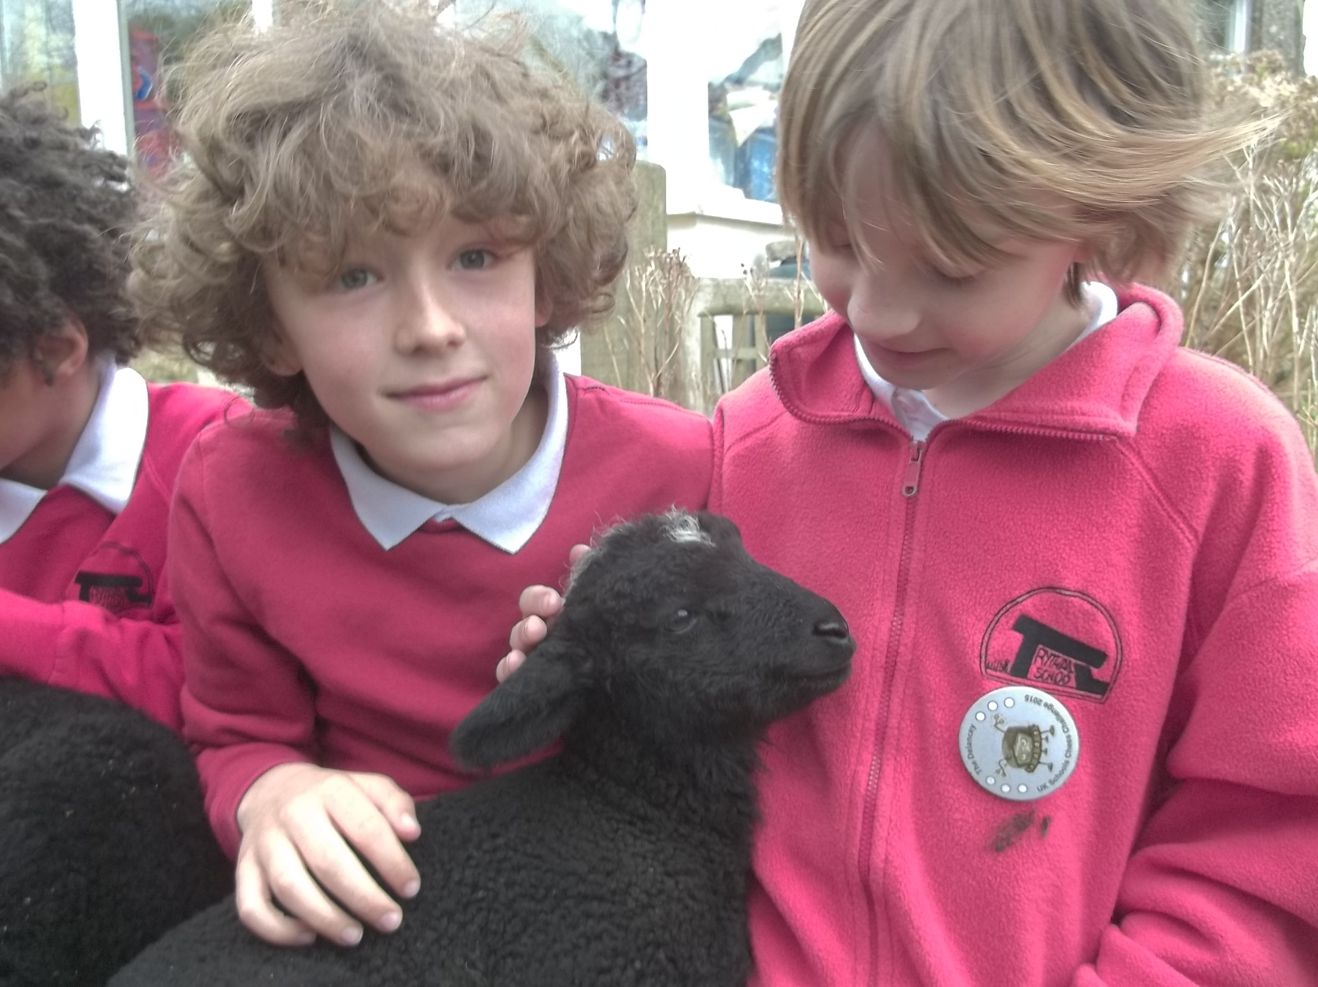
Uther and Joseph welcome one of our new pupils!

Dear Parents,
We’ve had a great time at Trythall this term. The children have enjoyed their whole school project work and, while developing new knowledge, skills and understanding, they have achieved a lot and developed a real sense of purpose. The whole school project for next term will be ‘How can we save the world?’ looking in more depth at looking after the environment.

Growing Links
Many parents have been in to help with the work in the poly tunnel but Lynne (Tuula’s mum) and Dax Ansell have given up lots of time to get things going and it’s starting to look very special up there. I would like to thank them both for their hard work.

We can look forward to an even better crop of fruit and veg this year with a greater variety of plants being grown. There is a possibility of artichokes, kiwi, pineapple guava and grapes. Who knows, the pasta tree, which so far has only yielded spaghetti, may start to produce some pasta twists or ravioli!

Plans for Sport After Half Term
Surfing with Sennen surfing Centre will recommence, on Thursdays, from 23rd April. Dave will be running the ‘I am’ bands system of assessment which is a little bit like the belt system for some martial arts. More information, including what they need to do for each band, is available through a link on the Trythall website homepage.
The Cornwall Sports Partnership provides a coach for striking, fielding and athletics on Mondays in the Summer term.
Dance will continue with Shelby and Shelley working towards the Summer performance at the barbecue.
Class 1 will learn canoeing as part of the Gweek,-Tremaine Quay- Durgan Canoe camp along the Helford River(see below).
Wetsuit Sale
Please take the opportunity to buy and sell wetsuits in the school entrance hall for the first 2 weeks of the Summer Term. Providing wetsuits can be an expensive business so we hope to ensure that the whole community can be suited up in the most economical way.

Class 1 Camp 8th -10th June 2015
As part of their river and environmental studies Class1 will take part in a a source to sea study of the river Helford. After finding the source of the river, the children will enter the river in canoes at the first safe entry point soon after high tide. They will then travel down the river to Tremaine Quay where they will spend 2 nights before travelling on and investigating Frenchman’s creek and some beaches in the mouth of the Helford (dependent on conditions). We then plan to exit at Durgan. Two well-qualified instructors, Paul Parkinson (Cornwall Outdoors) and Iain Fish (Mounts Bay Academy), will lead the canoeing activities.
It was decided that the canoeing option would be the best option this year after considering parents views and the age range of the children in the class at the moment.
If time permits, the children will continue their search for their first seal eggs!

Staffing Changes
Fiona is off at the moment but is expected back in the first week after the Easter break. Lucy Mander, who did an exceptionally good job filling in at pre-school and in Class 1 has got to leave to continue her studies. Anna Pilbeam, who previously worked with Cornwall Outdoors at Carnyorth, is now working in Class 1. Anna is studying for her Master’s Degree in Outdoor Learning and is increasingly using her knowledge and skills for the benefit of the children.

Defibrillator
A defibrillator has been fitted in the playground at Trythall. Although this device is designed so that the operator does not necessarily need to be trained, Mat and Lucy have attended the appropriate course. To get into the box, a code is needed, which is kept in the school office, but should also be made available after a call to emergency services.

Parent’s Consultations
Parent’s consultations for Class 1 will be held on Wednesday 20th May. In the meantime, please to not hesitate to contact Mat if you have any issues to discuss.

Governor Vacancy
There were no applicants for the position of parent governor when the nomination forms went out in February. We will therefore repeat the process with the nomination forms going out during the first week back.

Information Sharing
Please could you give Lucy your current email address if you would like to receive email communication.
Due to the lack of mobile signals in the area, we are investigating the use of tin-can-telephones to reduce costs and improve reliability!

Feedback
Thank you for the feedback given so far. Please continue to send in your comments/views as they are always welcome. Your input has contributed to school improvement.

Diary Dates

Monday 13th April Start of Summer Term
Tuseday 14th April Class 1 Auction room visit
Friday 17th April First Swim
Thursday 23rd April First surf
Friday 1st May (pm and evening) Class 1 Sing at the Hall for Cornwall
Saturday 2nd May Chess Megafinal at Penair
Thursday 7th May School closed for voting
Monday 11th May Beginning of KS2 SATs week
Friday 22nd May Break up for Half-term
Monday 1st June Return after Half-term
Monday 8th-Wed 10th June Class 1 School Camp
Sunday 21st June Newmill Gardens open day
Saturday 27th June Golowan Festival
Friday 17th July Summer Performance and BBQ

Kind regards

M.Strevens

Mat Strevens
Headteacher

School Feedback Form Parent/Carers name: __________________

Your thoughts or ideas

