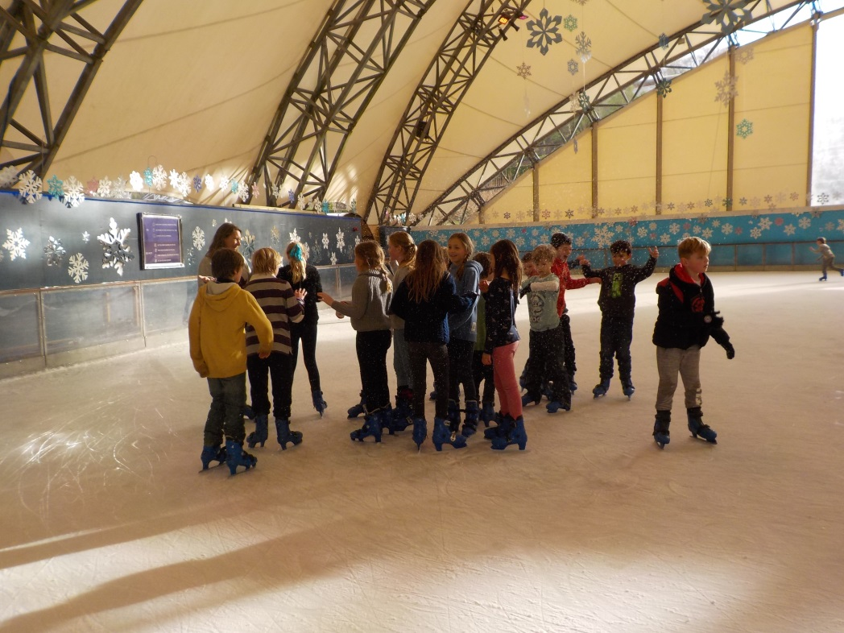
20.12.2017
Dear All,
I hope that everyone has enjoyed the Autumn term and will have a restful Christmas Break (as if!). I would like to thank everyone for the brilliant support you have given to the school in different ways. Notably, the PTA has brought in some great ideas, raised money and given extra pairs of hands to the many jobs that need doing. It’s made a real difference to the children. The support given during the Ofsted inspection was great too and we are happy with the way things went. There are so many ways in which we are given support and I know that all of the staff here are very grateful for everything you do.
Happy Christmas from all the staff!
Pre-School
Virg has found that the polytunnel provides an ideal indoor/outdoor space for her group to work in. The extra space, outdoor learning opportunities and positive response from the children has convinced her to move her group out there.

New Building
The new community building is going well but will not be finished until Easter. After this we will look at the garden area in front of the building and, at the same time, we aim to improve the parking situation.

Granting Requests for Leave during Term Time
Over the years, the pressure on schools to increase attendance rates increased.
Leave from school can only be granted under genuinely exceptional circumstances. Applications must be made in writing, using the ‘Request for Leave During Term Time Form’ which is available, on request, from the office. Holidays cannot be authorised on the basis of reducing the cost of the holiday. If leave is taken, without authorisation then a fine may be administered. This would be £60 per parent, per child of compulsory school age.

Parking
Please could everyone avoid parking on the school field and exercise particular caution when dropping off and picking up.

Ofsted
On Tuesday 5th December the school had a section 8 inspection with one inspector for one day. We are pleased with the way the inspection went. It was great to see the whole community pull together so well to show how proud we are of our school. The report should be available on line in the near future.
PTO
New Governors
Dave Gourley has been appointed as a trust governor, while Sarah Swash was appointed parent governor. I would like to thank Chunky Penhaul and Elizabeth Hatchelt for the time that they have given up to support the school as governors. Chunky has been a governor at the school for over 20 years!

Next Term’s Project: How can we convince our community to help provide homes for wildlife.
We will look at houses for bees, hedgehogs and birds and will persuade using writing and film. We may well look into what we can do about plastics too.

Double Your Bubble Wrap.
After Christmas, we may well have a good use for used bubble wrap for the purpose of insulation in the polytunnel. We will not be able to use the bubble wrap envelopes; only the bubble wrap itself.

Lambs In Spring
We may well have lambs to look after in the spring. The children get a lot from this experience and the animals seem to enjoy the company too. Unfortunately, we cannot keep the lambs for ever, and will eventually have to return to the farm, where they will follow their normal destiny.

Picking Children Up After School
Please let us know, in the office, if your child is to be picked up by anyone apart from the normal person. We cannot hand over the child to a different person without prior arrangement.

Please could we respectfully ask that children are always directly supervised when on the school site after school. There are many hazards on the school site including ponds, tools in the polytunnel, cars in the field and car park, the stream etc. While we know that the opportunities to learn and play at Trythall are fantastic, we also recognise the importance of minimising risks. We ask children to be in clear sight of their parents so that they can be kept safe. If parents/carers choose to let their children use the school site, after meeting their children, then they have responsibility for the children’s safety.

Children from Class 2 and 3 are only released from class when we see that their parents/carers have arrived. Children in Class 1 are released from class to meet their parents in the main (tarmac) playground. We ask the children not to leave this area until they have met their parents/carers.

We have told the children that parents/carers can supervise them on the climbing frame, ensuring that they play safely and do not stand on top of the monkey bars or net. However, the climbing structure is out of use for the moment. The annual safety inspection will soon be carried out.

Diary Dates
Thurs 4th January 2018 – Staff Training Day
Fri 5th January – Staff Training Day
Mon 8th January - Children return to school for the start of the Spring term
Half Term – Week Beginning 12th February
Last day of Term- 29th March

More details and dates will be released at the beginning of the new term.

Kind regards,

M.Strevens

M. Strevens
Headteacher

