Trythall CP School
New Mill, Penzance
Cornwall. TR20 8XR
(01736) 362021
email: secretary@trythall.cornwall.sch.uk

23.1.2015
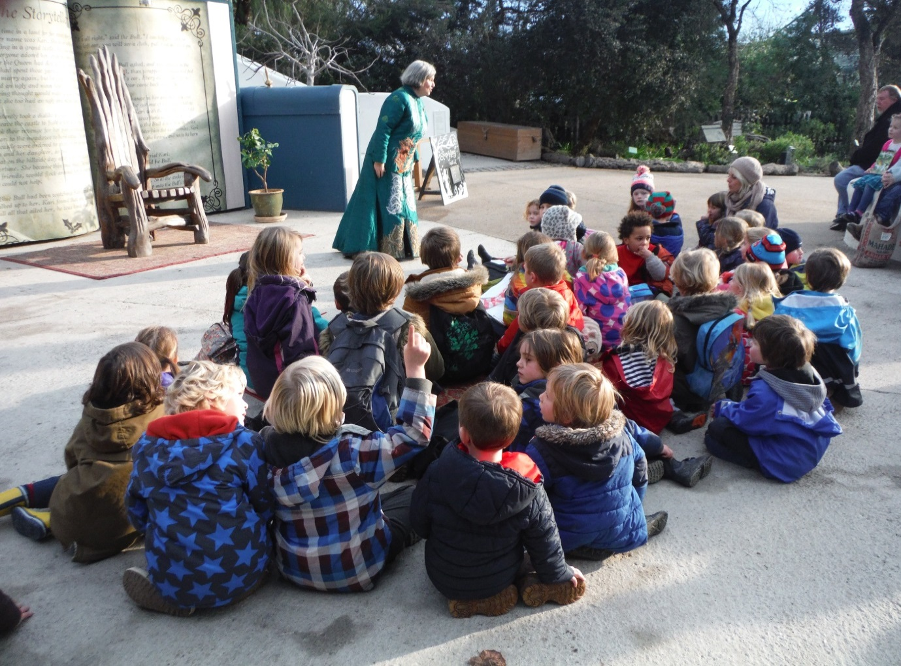Children enjoy finding out about learning spaces at Eden.

Dear Parents,
Despite the lack of sunlight and plummeting temperatures, there is a great buzz around the school at the moment. The children are really enjoying their project work and it’s nice to see the whole school work together on our aim of developing a new improved outdoor area.

On Thursday afternoons Dax Ansell and Lyn (Tuula’s Mum), who both have a lot of useful skills and experience are working with us on our exciting project. Every Thursday afternoon, the whole school works outside followed by gardening club which is now our biggest club! If you can spare some time on Thursdays please come along- it’s great fun and you don’t have to commit to the whole afternoon or every week. Rhiannon (Noah, Ludo and Amos’s Mum) has been doing a great job every week in gardening club but some extra help would improve the adult: child ratios and further improve everybody’s experiences.

Two Year Olds
We have taken the decision to extend our pre-school provision with the aim of providing places for 2 year olds. The main barrier, in the past, was a lack of space and facilities to deal with the increased numbers in pre-school. However, The Local Authority were impressed with our Early Years provision and have agreed to fund a (well insulated) timber framed building, designed for purpose, on the current site of the PE shed/bottle greenhouse. This is a very exciting opportunity for the school and we hope to get the children involved in the building too!

Sport This Term
Maria De Francesca, a professional dance teacher, is working with all children on Monday afternoons and the learning opportunities are excellent. They are also benefitting from high quality tennis coaching, provided by Penzance Tennis Club on the same afternoon.

Cardigan of Love Appeal
Thanks to Lizzie for getting the school involved in the Cardigan of Love appeal. As well as helping these people in need, this has been a good opportunity to think about global issues , possible causes and solutions. We have expressed an interest in supporting any similar projects. The photos of the children, who received the warm clothes, are displayed in the window in the foyer.

I –Pads
The Ipads are now in school and we are beginning to use them. The children’s great enthusiasm has been matched by their effectiveness as a learning tool. We will be able to investigate further the value of these devices when the required apps have been installed.

Site Safety
All car parks can be dangerous places and children need to be given a reasonable level of supervision in this area. Parents/Carers also need to be aware of the possibility that, if unsupervised, children could venture into the car park, or other areas on or around the school grounds, where hazards may exist. Drivers also need to show caution: great care needs to be taken, especially when reversing vehicles. Gates around the school car park and playground should also be kept shut.

Governor Vacancy
Rebecca Bridges, who was a parent governor has done a fantastic job and we are very grateful to her for giving up her time. Unfortunately, due to new work commitments she will no longer be able to give up the time required. There is therefore a vacancy and the process of electing a new governor will soon be started. Nomination papers will be circulated to all parents week beginning 26th January and vote will then be held, should there be more than one candidate.

Information Sharing
We have worked hard on this area and we hope you notice the difference. Diary dates are given at the bottom of this letter giving notice of the appropriate events. Dates for parent consultations are included.

Email
Some parents have suggested that emails could be used, in addition to text messages, to circulate information. We intend to trial this approach after half term. Although we have email addresses for some parents, we have no way of knowing if they are up to date. If you would like to receive emails, please could you ensure that Lucy has a current e-mail address. There may well be teething problems- so please be patient.

Children’s Absence
Absence rates have improved this academic year and are now above 95%. We will continue to issue awards certificates, for children who have full attendance for a half term period.

Feedback
Thank you for the feedback given so far. Please continue to send in your comments/views as they are always welcome.

Diary Dates
Tuesday 10th February Class 2 visit to SITA Recycling Centre at Bodmin
Friday 13th February Class 2 visit to Truro Museum
Monday 16th – Fri 20th inc. February Half Term
Wednesday 4th March Parents meetings – p.m.
Wednesday 25th March Easter Hats celebration 10 a.m. School Hall
Friday 27th March Break up for Easter Holiday
Monday 13th April Start of Summer Term

Kind regards

M.Strevens

Mat Strevens
Headteacher

School Feedback Form Parent/Carers name: __________________

Your thoughts or ideas

