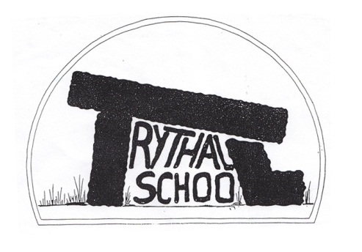
Trythall CP School
New Mill, Penzance
Cornwall. TR20 8XR
(01736) 362021
email: secretary@trythall.cornwall.sch.uk

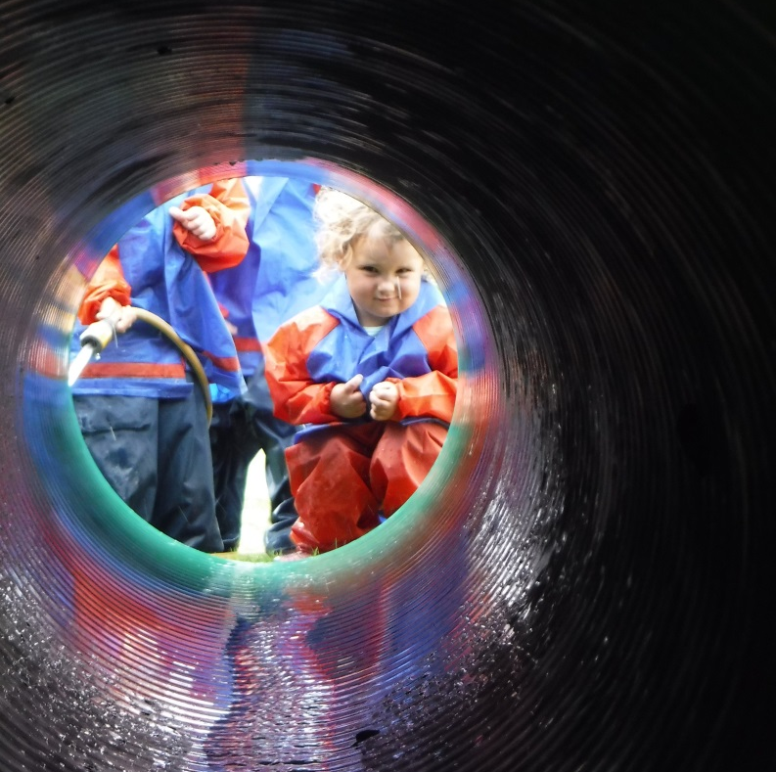

27th November, 2015
Dear Parents
Vikings and Roman Afternoon
The day was a great success, particularly as there was such a high turnout from parents. It was great to see so many people involved. The teachers started planning the project a long time ago and came up with the project. Then they spent a lot of time with the children working towards the big day. We aim to carry on with this approach in future as it seems to work well. All of our projects are bespoke, you won’t find them in any text book so I think that the teachers deserve a lot of credit for the work that this involves.
The project for next term is called: How can we paint a picture of West Penwith? It will start with the visit of Sue Lewington (author and artist) on 6th January.
Bad Weather
Just a note to remind you of our procedures should we have severe weather. In the event of the school having to close, the information will be broadcast on Radio Cornwall and Pirate FM. Lucy will telephone you on the first day of closure and will send a text and email message on any subsequent days.

Attached is the latest guide for Parents and Guardians on School Emergency Closures produced by Cornwall Council.
Money raised
The poppy appeal raised £81.78 while the children in need day raised £85.30. Well done to everyone who helped raise the money and to those who contributed.

Absence from School/ Holidays
The department for education now say that absence below 90% represents persistent absenteeism. We are therefore doing what we can to encourage high attendance rates.
- Holidays in the term time should be avoided unless there is a real reason why the holiday cannot be taken outside term time (I am told that getting a trip at a lower cost is not acceptable).
- Any from school apart from illness must be pre- authorised in writing by the Headteacher
Christmas Cards
This year the school will produce Christmas cards, based on the children’s artwork, to raise money. This money will be split 25% going to ACE (Aiding Conservation Through Education), 25% going to Cancer Research and 50% to go towards the cost of the children’s Christmas Panto trip. The art produced by children at Trythall is truly exceptional and I feel sure that friends and relatives will be delighted with these cards so you may want to make a bulk purchase! They are due to go on sale at school from early December.

Christmas Hamper
Once again we will be holding a raffle in Zennor Village Hall after the Christmas Performance to raise funds to support Sumitra the Indian girl we support through Action aid. All donations for a festive food hamper will be gratefully received – there is a box in the foyer in which to place items.

Clubs
There will be no clubs during the last week of term or the first week of term

Swimming
Next term the children will work on swimming for distance with certificates distributed stating the distance that each child can swim.

E-Safety
As I am sure you know, this area has an ever increasing importance. The children are taught about how to stay safe on-line. Information for parents can be found at: www.thinkuknow.co.uk
One important piece of advice that is coming through is that young people should be monitored on the internet and should not be left on their own with a computer in their room.
Safety in the Building/ Signing In
In order to keep everyone safe we need to ensure that everybody signs the visitor book unless you are just make a short visit (eg to drop off your child in the morning).

Diary Dates
Fri 4th Dec Swimming Groups to Trevaylor Manor to sing to the residents 2 p.m.
Mon 7th Christmas Production Rehearsal Zennor Church AM
Tues 8th Christmas Performance Zennor Church 2 p.m. followed by light refreshments in the Village Hall
Wed 9th Pantomime –Duffy Beats the Devil at the Acorn Theatre (Class 1 and 2)
Thurs 10th Children’s Christmas Lunch
Mon 14th (Film – Inside Out) Savoy Cinema, Penzance (Class 1 and 2)
Tues 15th KS2 Ice Skating at The Eden Project
Wed 16th Reception and KS1 Play on Ice at The Eden Project
Pre-school Christmas Party
Thurs 17th Christmas Party for the children followed by Disco 4 – 6 p.m.
Fri 18th Break up for Christmas Holidays
Tues 5th Jan Start of Spring Term

Yours sincerely
M. R. Strevens
Headteacher

