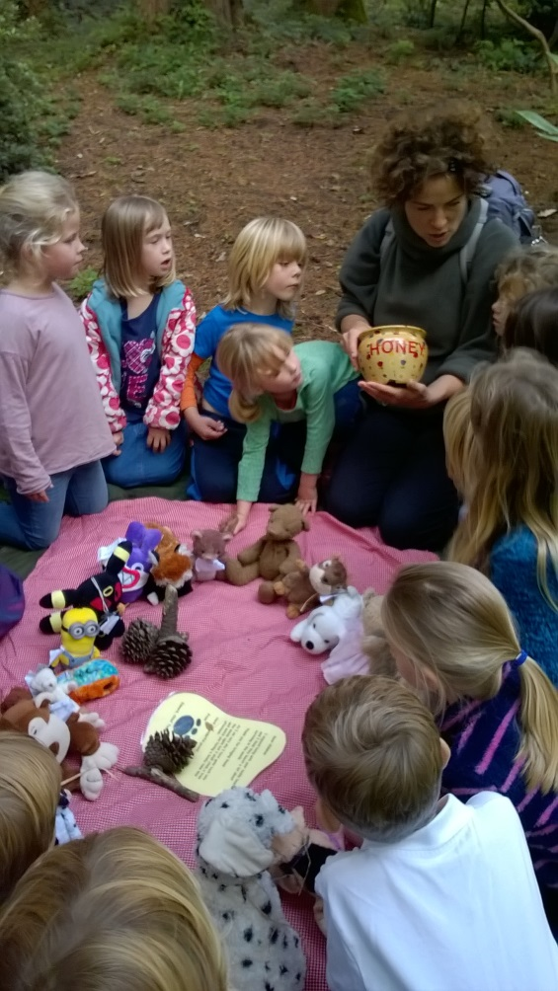
Dear All,
I hope that everyone has had a brilliant Summer and enjoyed coming back to school. I have certainly enjoyed really exciting activities made possible by an exceptional group of children (and adults!).
It was lovely to see that the children have carried on with their successes that were coming thick and fast before the Summer.
Competition Winners
In July we heard that Ebb was runner up in Blue Peter art competition, Tyler won a poster design competition and the Year 6 team were second in a competition to design a mathematical poster.
So far in the Autumn term, Sofia and Isla Wilson were winner and runner up respectively in the Chris Riddell, design a character competition. Sammy won an ipod by winning the Pirate FM secret sound competition at Humphry Davy School.
Well done to the winners but also to all the other children at Trythall who consistently produce such a high standard of work.
Teddy Bear’s picnic with Amy.

Pre-School
Pre-school is nearly full so please book places ASAP. We are looking forward to completing the new pre-school area and community building part funded by the National Lottery. The re-design of the garden area will create a lovely space for the little ones to play and learn in and should also provide some extra parking spaces.
Virg has found that the polytunnel provides an ideal indoor/outdoor space for her group to work in. The extra space, outdoor learning opportunities and positive response from the children has convinced her to move her group out there.

Parking
The hump on the entrance to the field is still quite fierce so please drive over it carefully. It is best to park on the areas beside our football pitch rather than on it.

Challenge Partner Review
A team of three educational professionals, including a lead person who is a trained OFSTED inspector, will be reviewing the school between 18th and 20th October. This is a useful opportunity to have some independent guidance on what the school’s strengths weaknesses are.

Parent Surveys
We would be grateful if you could complete the attached parent survey which will help us self-evaluate and plan actions for school improvement. Please return to Lucy by Tuesday 17th October.

Acceptable Use Policy and E-safety
As you know, technology can offer fantastic opportunities but also dangers for our children. To help keep children safe, we would be grateful if you could read through the policy with your child to help them understand it then return the forms, signed, to Lucy. The Reception/KS 1 policies need to be signed by parent/carer and child while the KS2 version only requires a signature from the child.
A copy of our Be Smart on the Internet poster(guidance for children and adults) is also attached.
Parent Governor
There is a vacancy for a parent governor on the Trythall School Governing Board. If you think that you could bring something to this role and have time to attend the meetings (normally twice a term, Wednesdays after school), then perhaps this might be for you. The elections will be held soon after Half Term.

I would like to thank Elizabeth Hatchelt for giving her time, as a governor, over the last four years, making such a positive contribution to the school.

Medicine
All medicines should be brought to the school office and a form completed before school staff can administer any medication to children.

Instruments
There may be an opportunity for children to have keyboard lessons at Trythall if there is enough take up. Please let Lucy know if you are interested.

Drum Kit for Sale
There is a nice drum kit in the hall that might sell for about £150 on ebay. If you would like to give us £100 for it by Tuesday 17th October, it’s yours!

Parents Meetings on Tuesday, 31st October
Please book a ten minute slot when the booking form is put out in the foyer on Tuesday, 17th October. It is, occasionally, difficult to end these meetings on time, but also, it is frustrating when things get behind and parents have to wait. This time we are going to try really hard to stick to the timings. This will mean that the meetings will be restricted to 10 minutes. If, when the 10 minutes is up, you feel that you need more time to discuss important issues, please arrange another time to meet with the teacher perhaps the following week.

Friends of Trythall School/PTA
Several parents/carers have expressed an interest in forming a group that could work together for the benefit of the children. We thought it would be good if there was a meeting to discuss possibilities. If you think you might be interested, please could you let Lucy know your availability for week beginning 30th October. It might be good to meet up at pick up or drop off time. Lucy will contact everyone with the finalised date and will make a room available with tea/coffee biscuits.

Locally Produced Product Show 8th November
The children have been learning about how food is transported all over the world and how this can add to environmental problems. You are invited to their end of project show in which they will perform and sell some products made from locally sourced or recycled materials.

Children and After School Supervision
Please could we respectfully ask that children are supervised when on the school site after school. We ask children to be in sight of their parents so that they can be kept safe. We have told the children that parents can supervise them on the climbing frame ensuring that they play safely and do not stand on top of the monkey bars. Children should not use the rope swing unless a member of Trythall staff is watching because some parents/carers may not be aware of the risks or rules for safe use.

Diary Dates
Mon 16th Oct – Class 1 Bernard William Concert St Mary’s Church, Penzance 2 p.m.
Wed 18th - Fri 20th Oct - Challenge Partners at School
Mon 23rd - Fri 27th Oct - Half Term Break
Tues 31st Oct - Parent Meetings PM
Wed 8th Nov - Whole School Trade Fair and Show at school
Tues 21st Nov - Tempest Photographers Individual and Family Group Photographs
Thurs 30th Nov – Whole School Christmas Making Day
Tues 12th Dec – Christmas Performance at Zennor Church
Wed 13th Dec - Class 3 Play on Ice at The Eden Project
Thurs 14th Dec – Class 2 Ice Skating at The Eden Project
Fri 15th Dec – Class 1 Ice Skating at The Eden Project
Mon 18th Dec – Children’s Christmas Party and Disco
Tues 19th Dec - Christmas Lunch
Wed 20th Dec – Last Day of Autumn Term
Thurs 4th January 2018 – Staff Training Day
Fri 5th January – Staff Training Day
Mon 8th January - Children return to school for the start of the Spring term

More details will be given for some of these events on separate letters.

Kind regards

M.Strevens

Mat Strevens
Headteacher

