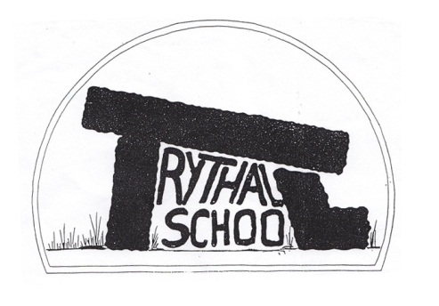
Trythall CP School
New Mill, Penzance
Cornwall. TR20 8XR
(01736) 362021
email: secretary@trythall.cornwall.sch.uk

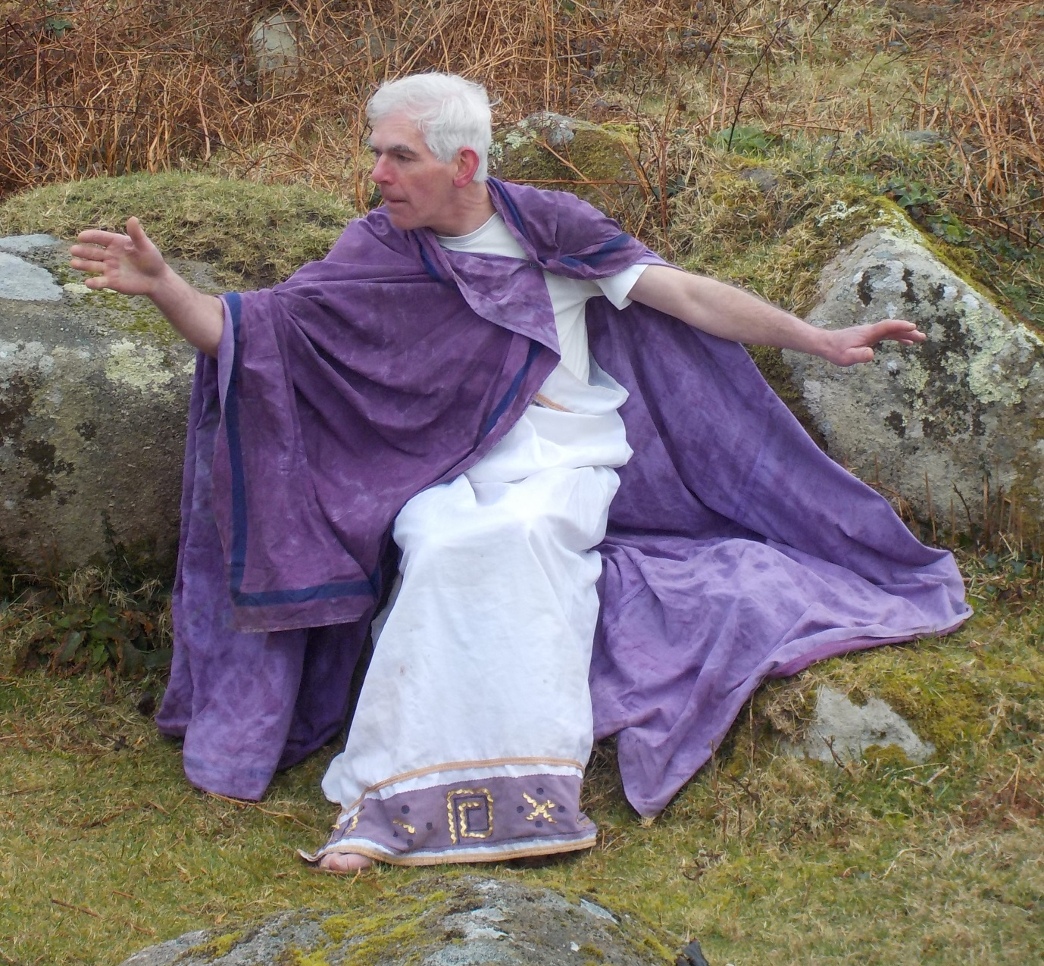
Strabo (Mark Harrandon) visits from Ancient Greece to talk to our children at the iron age settlement at Trevean Farm.
18.3.16
Dear Parents
As the Spring term ends, everyone can be really proud of what we have achieved this term. We can also look forward to a great Summer term with yet another topic, Golowan and Summer Performance/Barbecue.

This Term’s Project: A Portrait of West Penwith
The children have worked hard and produced some beautiful work. Sue Lewington, who visited this week to have a look at their progress, was thrilled with their efforts and gave us some advice on the way forward. Now each child will produce their own book. One book, containing a selection of work from all the children at the school will be published.
All work will be displayed at Circa 21 (Esme and Alan’s shop), Market Jew Street, between 18.4.16 and 23.4.16.
Next Term’s Project: How Can We Feed Hungry People
We hope to have a focus on growing food, making food and eating food. The children will grow and cook food for themselves, for the garden open day and for the Barbecue/Performance. The performance may be based on the ‘White Horse of Zennor’.

Volunteering in the Easter Break
31st March Garden Volunteer Day: We hope to get the polytunnel ready for more growing as well as one or 2 other outdoor jobs. The children will prepare some food for lunch but must be accompanied by their parents. We will be there 9 to 5 but please give up any time that you have, even if it’s only half an hour- it makes a real difference for the children. No skills required.
Helping make our special book: A Portrait of West Penwith. Please contact Lucy if you have any time to help put the book together.

Playing on the School Grounds
I am really pleased to see that children are keen to play on our grounds before and after school and proud of how hard everyone has worked to make this possible. Play, with friends, is so important for children. Unfortunately, we have experienced a range of problems eg large stones left in the climbing frame impact zone; equipment broken or not replaced, damage to trees/plants etc.
It would, genuinely, make me quite sad to have to take away access to the school gardens after school so I would be grateful if everyone could:
- Ensure children are directly supervised and in view of the responsible adult
- Ensure children know which adult is looking after them
- Ensure that children don’t ride bikes through the gardens or on busy playgrounds
- Ensure children stay off the school field and car park
- Avoid fighting with sticks or running around with sticks or tools
- Avoid taking equipment
- Ensure anything they use is replaced in the correct place
Sorry it sounds like a list of moans but, if we all do our bit, the children will benefit from having the freedom to play sensibly and a well-kept garden that we can use for play and learning.

The disco for the children will be held next Monday 21st March from 4 – 6 p.m. in the school hall. Children may wish to bring in party clothes to change into at the end of the school day. We would suggest that each child brings in £1.00 and hand it into the office on arrival in the morning. This will cover the refreshments, raffle and a small contribution towards the disco.
Just a reminder that next Wednesday, 25th March is our Easter Celebrations. Children in Class 2 are invited to make a Easter hat, and the Class 1 children to make themed hats which they have agreed with Shelley . Hats need to be brought into school on Wednesday morning. You are invited to come along to the school hall at 10 a.m. for some musical entertainment and the hat parade. Light refreshments will be served and a raffle held, proceeds of which will go towards our Actionaid Sponsorship. Any donations of raffle prizes included any of the cakes will be much appreciated.

Academies
You may well have heard on the news that all schools will have to become academies. Although we have never been keen on the idea, we are making sure that we keep up to date about the best options in the interests of the school and community.

Diary Dates
Mon 21st March Easter Disco for Children 4pm-6pm
Wed 23rd March Easter Hats 10am
Thurs 24th Break up for Easter Holiday
Mon 11th April Commencement of the Summer Term
Mon 2ns May School closed – May Day Bank Holiday
Thurs 5th May School closed as it is being used for Police and Crime Commissioner Elections
Week Beg 9th May SATs Week for Year 6
Mon 30th May – Fri 3rd June Half-term
Thurs 23rd June School closed for voting
Sat 25th June Mazey Day
Sun 3rd July Newmill Gardens Open Day
Fri 8th July School closed for staff training
Fri 15th July Barbecue and Performance Evening
Thurs 21st July Last day of Summer Term

Yours sincerely
M. R. Strevens
Headteacher

