Trythall School
Life Skills Curriculum
2022

TT

NATIONAL CURRICULUM EXPECTATION AND INFORMATION
Subject/Area of Learning: Life Skills Year Groups: EYFS to Y6

This document gives staff information from the National Curriculum about each subject area. At Trythall School Life Skills covers the following subjects, topics and themes:
- PSHE
- Citizenship
- Relationships and Sex Education (RSE)
- Careers Education
- Economic Wellbeing and Financial Stability
- Healthy Lifestyles
- Safety – Physical & Online Safety
- Emotional Wellbeing and Mental Health
- Drugs, Alcohol & Tobacco Education
- Anti-bullying and positive relationships
- Spiritual, Moral, Social and Cultural Education
- Belonging and Identity
As stated by the PSHE Association, Personal, Social, Health and Economic (PSHE) education is a school subject through which pupils develop the knowledge, skills and attributes they need to manage their lives, now and in the future. It helps children and young people to stay healthy and safe, while preparing them to make the most of life and work. When taught well, PSHE education also helps pupils to achieve their academic potential.
Most of PSHE education became statutory for all schools from September 2020 under the Children and Social Work Act 2017. This includes Relationships Education at key stages 1 and 2, Relationships and Sex Education (RSE) at key stages 3 and 4, and Health Education in both primary and secondary phases.
We have chosen to use the PSHE Association Thematic models to base our Life Skills teaching and learning upon. All pupils receive one lesson of Life Skills a week, with continuous provision, experiences and exposure throughout all areas of the curriculum and school life.
This PSHE Association programme builder takes a thematic approach to primary PSHE education, covering all three core themes of the Programme of Study (Health and Wellbeing; Relationships; and Living in the Wider World) over the school year, with three topics per half term. This approach allows different year groups to work on similar themes at the same time, building a spiral programme year on year, whilst offering flexibility in terms of medium term planning. The colour-coded topic areas can be adapted to meet planning requirements, pupils’ stage of development and needs and also to reflect the context of the school and local community.

SMSC STATEMENT:

Our Life Skills curriculum is planned and implemented with active promotion of British Values and positive reflection of the Protected Characteristics as presented in the Equality Act 2010.

LINKS TO CHILD PROTECTION & SAFEGUARDING:

As per the expectations set in KCSiE 2022, our pupils are taught about online safety through our Life Skills curriculum, including as part of statutory Relationships and Sex Education (RSE). We take a personalised and contextualised approach for more vulnerable children, e.g. victims of abuse, SEND.
Please see the School's Safeguarding and Child Protection Policy , Online Safety Policy and RSE Policy for more information.

CONTENT
During key stages 1 and 2, PSHE education offers both explicit and implicit learning opportunities and experiences which reflect pupils’ increasing independence and physical and social awareness, as they move through the primary phase. It builds on the skills that pupils started to acquire during the Early Years Foundation stage (EYFS) to develop effective relationships, assume greater personal responsibility and manage personal safety, including online. PSHE education helps pupils to manage the physical and emotional changes at puberty, introduces them to a wider world and enables them to make an active contribution to their communities.
Core Theme |  | Theme/Topic
1 | Health and Wellbeing | Healthy lifestyles (physical wellbeing)  Mental Health  Ourselves, growing and changing  Keeping safe  Drugs, alcohol and tobacco
2 | Relationships | Families and close positive relationships  Friendships  Managing hurtful behaviour and bullying  Safe relationships  Respecting self and others
3 | Living in the Wider World | Shared responsibilities  Communities  Media literacy & digital resilience  Economic wellbeing: Money  Economic wellbeing: Aspirations, work and career

Relationships and Sex Education:
KS1 & KS2
Families and people who care for me
Caring friendships
Respectful relationships
Online relationships
Being safe
Mental Wellbeing
Internet Safety and Harms
Physical health and fitness
Healthy Eating
Drugs, Alcohol & Tobacco
Health & Prevention
Basic First Aid
Changing Adolescent Body

Lessons parents can withdraw their children from are highlighted in pink in the LTP.
Primary schools
Parents’ do not have the right to withdraw their children from relationships education. Parents’ have the right to withdraw their children from the non-statutory components of sex education within RSE.

This Curriculum Overview and development of our Life Skills Curriculum as been informed by the following guidance:
- Keeping Children Safe in Education
- Relationships Education, Relationships and Sex Education (RSE) and Health Education
- Respectful School Communities
- Behaviour and Discipline in Schools
- Equalities Act 2010
- SEND code of practice: 0 to 25 years
- Mental Health and Behaviour in Schools
- Preventing and Tackling Bullying including cyberbullying
- Sexual violence and sexual harassment between children in schools
- The Equality and Human Rights Commission Advice and Guidance
- Promoting Fundamental British Values as part of SMSC in schools
- PSHE Association
- SCARF

LIFE SKILLS, CHILD PROTECTION & SAFEGUARDING
From KCSiE September 2022, pg 33: Opportunities to teach safeguarding
Statement from KCSiE 2022 | Where coverage can be found in the Trythall School Life Skills Curriculum
128. Governing bodies and proprietors should ensure that children are taught about how to keep themselves and others safe, including online. It should be recognised that effective education will be tailored to the specific needs and vulnerabilities of individual children, including children who are victims of abuse, and children with special educational needs or disabilities. | How to keep themselves safe permeates throughout the Life Skills Curriculum.  ONLINE SAFETY -  Relationships:  Healthy relationships, Emotional Wellbeing,  Living in the Wider World:  Media literacy and digital resilience, including Safer Internet Day, Digital literacy  Health & Wellbeing:  Keeping Safe, Physical health & wellbeing  Acceptable Use Policies  Computing Curriculum
129. In schools, relevant topics will be included within Relationships Education (for all primary pupils), and Relationships and Sex Education (for all secondary pupils) and Health Education (for all primary and secondary pupils). In teaching these subjects schools must have regard to the statutory guidance. | Health & Wellbeing: Growing and Changing  Relationships
130. Schools and colleges play a crucial role in preventative education. Preventative education is most effective in the context of a whole-school or college approach that prepares pupils and students for life in modern Britain and creates a culture of zero tolerance for sexism, misogyny/misandry, homophobia, biphobic and sexual violence/harassment. The school/college will have a clear set of values and standards, upheld and demonstrated throughout all aspects of school/college life. These will be underpinned by the school/college’s behaviour policy and pastoral support system, as well as by a planned programme of evidence-based RSHE delivered in regularly timetabled lessons and reinforced throughout the whole curriculum. Such a programme should be fully inclusive and developed to be age and stage of development appropriate (especially when considering the needs of children with SEND and other vulnerabilities).  This program will tackle at an age-appropriate stages issues such as:  • healthy and respectful relationships  • boundaries and consent  • stereotyping, prejudice and equality  • body confidence and self-esteem  • how to recognise an abusive relationship, including coercive and controlling  behaviour  • the concepts of, and laws relating to- sexual consent, sexual exploitation, abuse,  grooming, coercion, harassment, rape, domestic abuse, so called honour-based  violence such as forced marriage and Female Genital Mutilation (FGM), and how  to access support, and  • what constitutes sexual harassment and sexual violence and why these are  always unacceptable. | See KCSiE breakdown analysis of curriculum document.
131. The Department has produced a one-stop hub for teachers which can be  accessed here: Teaching about relationships sex and health (Gov.uk). This includes  teacher training modules on the RSHE topics and non-statutory implementation  guidance. Further guidance focused on teaching relationships education specifically to prevent sexual harassment and sexual violence will be published in Spring 2022. | Units completed in Life Skills well as wider curriculum such as Computing, Science and Mental Health/Well being activities.
132. The following resources, plus many more listed in Annex B, may also help schools and colleges understand and teach about safeguarding:  • DfE advice for schools: teaching online safety in schools  • UK Council for Internet Safety (UKCIS)37 guidance: Education for a connected  world  • UKCIS guidance: Sharing nudes and semi-nudes: advice for education settings  working with children and young people  • The UKCIS external visitors guidance will help schools and colleges to ensure the  maximum impact of any online safety sessions delivered by external visitors  • National Crime Agency's CEOP education programme: Thinkuknow  • Public Health England: Every Mind Matters  • Harmful online challenges and online hoaxes - this includes advice on preparing  for any online challenges and hoaxes, sharing information with parents and carers  and where to get help and support. | Shared in Child Protection Policy and Procedures Sept 2022
133. Whilst it is essential that governing bodies and proprietors ensure that appropriate filters and monitoring systems are in place, they should be careful that “over blocking” does not lead to unreasonable restrictions as to what children can be taught with regard to online teaching and safeguarding.

TERMLY OVERVIEW

 | Autumn Term |  |  | Spring Term |  |  | Summer Term
 | Relationships |  |  | Living in the Wider World |  |  | Health and Wellbeing
 | Sept | Oct | Nov/Dec | Jan | Feb | March | May | June | July
 | Families and friendships | Safe relationships | Respecting ourselves and others | Belonging to a community | Media literacy and digital resilience | Money and work | Physical health and wellbeing | Growing and changing | Keeping safe
PSHE Association Objectives | Close positive relationships  KS1: R1 – R5  KS2: R1 – R9  Friendships  KS1: R6 – R9  KS2: R10 – R18 | Safe Relationships; Relationship Values; Forming & Maintaining Respectful Relationships; Consent  KS1: R13 – 20  KS2: R22 – R29 | Managing hurtful behaviour  KS1: R10 – R12  KS2: R19 – R21  KS1: R21 – R25  KS2: R30 – R34 | Rights & Responsibilities  Communities  Diversity  Rule of Law  KS1: L1 – L6  KS2: L1 – L10 | KS1: L7 – L9  KS2: L11 – L16 | Economic Wellbeing, Aspirations, work & career  KS1: L10 – L17  KS2: L17 – L32 | Healthy Lifestyles (physical); Mental Health; Self-concept; Drugs etc  KS1: H1-H10  KS2: H1-H14  KS1:H11-H20  KS2: H15-H24 | Growing & Changing; Puberty  KS1: H21-H27  KS2: H25-H36 | KS1: H28-H37  KS2: H37-H36—50
PH Events –annual/rolling | International Day of Democracy  School Council - Democracy Week?  World First Aid Day  International Day of Peace | Black History Month  World Values Day  World Mental Health Day | Anti-Bullying Week  International Day  of Tolerance  Rights & Responsibilities Day  World Kindness Day  Human Rights Day  Remembrance Day | Safer Internet Day  Chinese New Year  International Day of Women and Girls in Science  Fairtrade Fortnight  Children’s Mental Health Week | World Religion Day | International Women’s Day  Random Acts of Kindness Day  Shakespeare Week  International Day of Forests | PP: May: Elmer Day  Science Week  Mental Awareness Week  International Day of Families  One World, Many People Week? | World Oceans Day  World Environment Day  Global Day of Parents  Grandparents Day  International RSE Day  Healthy Eating Week | National Hygiene Week  World Friendship Day  PP: People Who Help Us Day  P: Enterprise Project  Pupil Consultation & Review
EYFS | School rules; Talk about their own families; Make sense of own life-story and family history. | Building constructive and respectful relationships with others. | See themselves as a valuable individual. | Familiar communities; special places. | Using digital devices; using the internet with support to gain information. | Working towards simple goals; expressing likes and dislikes; jobs known to them. | Healthy foods; exercise; managing emotions. | Expressing own feelings; showing resilience and perseverance; EYFS journey (Nursery – Reception) | Understanding rules and how they keep us safe; stranger danger.  Pupil Consultation & Review
Year 1 | Roles of different people; families; feeling cared for | Recognising privacy; staying safe; seeking permission | How behaviour affects others; being polite and respectful | What rules are;  caring for others’  needs; looking after  the environment | Using the internet and digital devices; communicating online | Strengths and  interests; jobs in the  community | Keeping healthy; food and exercise, hygiene routines; sun safety | Recognising what makes them unique and special; feelings; managing when things go wrong | How rules and age restrictions help us; keeping safe online  Pupil Consultation & Review
Year  2&3  A | Making friends; feeling lonely and getting help | Managing secrets; resisting pressure and getting help; recognising hurtful behaviour | Recognising things in common and differences; playing and working cooperatively; sharing opinions | Belonging to a group; roles and responsibilities; being the same and different in the community | The internet in everyday life; online content and information | What money is; needs and wants; looking after money | Why sleep is important; medicines and keeping healthy; keeping teeth healthy; managing feelings and asking for help | Growing older; naming body parts; moving class or year | Safety in different environments; risk and safety at home; emergencies  Pupil Consultation & Review
Year  2& 3 B | What makes a family; features of family life | Personal boundaries; safely responding to others; the impact of hurtful behaviour | Recognising respectful behaviour; the importance of self-respect; courtesy and being polite | The value of rules and laws; rights, freedoms and responsibilities | How the internet is used; assessing information online | Different jobs and skills; job stereotypes; setting personal goals | Health choices and habits; what affects feelings; expressing feelings | Personal strengths and achievements; managing and reframing setbacks | Risks and hazards; safety in the local environment and unfamiliar places  Pupil Consultation & Review
Year 4/5/6 A | Positive friendships, including online | Responding to hurtful behaviour; managing confidentiality; recognising risks online | Respecting differences and similarities; discussing difference sensitively | What makes a community; shared responsibilities | How data is shared and used | Making decisions about money; using and keeping money safe | Maintaining a balanced lifestyle; oral hygiene and dental care | Personal identity; recognising individuality and different qualities; mental wellbeing | Medicines and household products; drugs common to everyday life  Pupil Consultation & Review
Year 4/5/6 B | Managing friendships and peer influence | Physical contact and feeling safe | Responding respectfully to a wide range of people; recognising prejudice and discrimination | Protecting the environment; compassion towards others | How information online is targeted; different media types, their role and impact | Identifying job interests and aspirations; what influences career choices; workplace stereotypes | Healthy sleep habits; sun safety; medicines, vaccinations, immunisations and allergies | Physical and emotional changes in puberty; external genitalia; personal hygiene routines; support with puberty  *Teach separate to Year 4/6 each year | Keeping safe in different situations, including responding in emergencies, first aid  Pupil Consultation & Review
Year 4/5/6  C | Attraction to others; romantic relationships; civil partnership and marriage | Recognising and managing pressure; consent in different situations | Expressing opinions and respecting other points of view, including discussing topical issues | Valuing diversity; challenging discrimination and stereotypes | Evaluating media sources; sharing things online | Influences and attitudes to money; money and financial risks | What affects mental health and ways to take care of it; managing change, loss and bereavement; managing time online | Changes and challenges; puberty;  human reproduction,conception:increasing independence; managing  Transitions  *Teach separate to y4/5 each year | Keeping personal information safe; regulations and choices; drug use and the law; drug use and the media  Pupil Consultation & Review

YEAR GROUP INFORMATION
EYFS
Area | EYFS Areas of Learning links  (provision to include COEL ideals, language development, equality of opportunities and cultural capital awareness) | In this unit of work, pupils learn: | Suggested resources, teaching and learning materials | Cross-curricular, school community links,  inc British Values (BV)  Equality Act/Diversity (EA/D)
School rules; Talk about their own families; Make sense of own life-story and family history. | - Communication & Language: Listening and Speaking  - Personal, social and emotional development: Self-regulation  - Understanding the World: Past and present  - Understanding the World: People, Culture & Communities | - To talk about their immediate families.  - How their family is different to the families of their peers.  - The school and class rules  - The class routines and boundaries  - Personal space and personal boundaries | Unit: New beginnings | Teacher Hub | Oak National Academy (thenational.academy)  https://teachers.thenational.academy/units/circle-of-love-51a4  Our Family - CBeebies - BBC  Unit: Circle of life | Teacher Hub | Oak National Academy (thenational.academy)  JoJo & Gran Gran - CBeebies - BBC | BV: Mutual respect and tolerance  BV: Individual Liberty  BV: Democracy  EA/D
Building constructive and respectful relationships with others. | - Personal, social and emotional development: Building relationships  - Communication & Language: Listening and Speaking  - Understanding the World: People, Culture & Communities | - To build relationships with peers with support  - To begin to talk to others about how they are feeling  - To start to resolve conflicts with others in an appropriate manner with support  - To begin to understand that some parts of our bodies are private and shouldn’t be shown to other.  - To begin to talk about the 5 PANTS rules. | Guidance for early years and childcare settings (nspcc.org.uk)  Undressed (lgfl.net) | BV: Mutual respect and tolerance
See themselves as a valuable individual. | - Personal, social and emotional development: Managing self  - Personal, social and emotional development: Self-regulation  - Communication & Language: Listening and Speaking  - Personal, social and emotional development: Building relationships | - Talk about their likes and dislikes.  - Discuss their goals and aspirations.  - What they want to be when they grow up.  - Similarities and differences between themselves and others  - To express their emotions in an appropriate way.  - Celebrating achievements and successes.  - Naming body parts  - My body belongs to me  - Talk about who to speak to if they feel worried about anything | My Body Belongs to Me PowerPoint (twinkl.co.uk) | Whole School Anti-Bullying event  BV: Mutual respect and tolerance  BV: Individual Liberty
Familiar communities; special places. | - Communication & Language: Listening and Speaking  - Understanding the World: People, Culture & Communities | - Different religions and cultures.  - Celebrations and festivals that they take part in.  - Celebrations and festivals that some people take part in their local community | Unit: Circle of trust | Teacher Hub | Oak National Academy (thenational.academy)  Unit: Same and different | Teacher Hub | Oak National Academy (thenational.academy) | BV: Mutual respect and tolerance
Using digital devices; using the internet with support to gain information. | - Communication & Language: Listening and Speaking  - Understanding the World: People, Culture & Communities | - Being safe online  - What to do if they see something they feel is not right  - Exploring age appropriate resources / devices.  - How the internet can help us gain new information | Jessie & Friends: online safety education for 4-7s (thinkuknow.co.uk) | Whole School Safer Internet Day Event
Working towards simple goals; expressing likes and dislikes; jobs known to them | - Communication & Language: Listening and Speaking  - Understanding the World: People, Culture & Communities  - Personal, social and emotional development: Managing self | - Talk about their likes and dislikes.  - Discuss their goals and aspirations.  - What they want to be when they grow up.  - People who help us  - Visits from people of different professions. |  | BV: Individual Liberty
Healthy foods; exercise; managing emotions. | - Communication & Language: Listening and Speaking  - Personal, social and emotional development: Managing self  - Personal, social and emotional development: Self-regulation  - Personal, social and emotional development: Building relationships  - Physical Development: Gross and Fine Motor Development | - Talking about and expressing how they feel.  - Resolving conflicts with others.  - Ways of managing our emotions appropriately.  - Healthy eating  - Healthy living  - How exercise affects our bodies.  - Why exercise is important  - Managing person hygiene  - Managing own personal needs  - Knowing our own bodies and who to speak to if we have an accident. | Unit: Squeaky clean | Teacher Hub | Oak National Academy (thenational.academy)  Free education resources for teaching young people aged 3-16 years about where food comes from, cooking and healthy eating, and teacher training. - Food A Fact Of Life  Super Mood Movers - Fit and well - BBC Teach  My World Kitchen - CBeebies - BBC  CBeebies - Oti's Boogie Beebies (bbc.co.uk) | PE lessons  Design Technology - Food
Expressing own feelings; showing resilience and perseverance; EYFS journey (Nursery – Reception) | - Communication & Language: Listening and Speaking  - Personal, social and emotional development: Managing self  - Personal, social and emotional development: Self-regulation | - Talking about and expressing how they feel.  - Resolving conflicts with others.  - How to be resilient in the face of challenges  - What is perseverance?  - Transition from Nursery – Reception  - New beginnings | Elmer Day  May = Mental Health Awareness Month. See annual theme  Child Safety Week – 7th to 13th June  Child Safety Week | Child Accident Prevention Trust (capt.org.uk)  Unit: Circle of life | Teacher Hub | Oak National Academy (thenational.academy)  Coronavirus Support for Early Years | Coronavirus support for Nursery | Anna Freud Centre  KS1 PSHE: Believe with Naomi Wilkinson - BBC Teach  Pupil Consultation & Review | BV: Individual Liberty
Understanding rules and how they keep us safe; stranger danger | - Communication & Language: Listening and Speaking  - Personal, social and emotional development: Managing self  - Personal, social and emotional development: Self-regulation | - The school and class rules  - The class routines and boundaries  - Staying safe  - Strangers & safe strangers  - Who do you speak to if you are worried or concerned?  - Inappropriate behaviour and what to do if you see it  - Who to talk to if you are worried  - Understanding and managing their own risk | Unit: Staying safe | Teacher Hub | Oak National Academy (thenational.academy)  Get Well Soon - CBeebies - BBC | BV: Rule of Law

Year 1
Area | Programme of Study References: PSHE Association | In this unit of work, pupils learn: | Suggested resources, teaching and learning materials | Cross-curricular, school community links,  inc British Values (BV)  Equality Act/Diversity (EA/D)
Families and friendships  Roles of different people; families; feeling cared for | R1. about the roles different people (e.g. acquaintances, friends and relatives) play in our lives  R2. to identify the people who love and care for them and what they do to help them feel cared for  R3. about different types of families including those that may be different to their own  R4. to identify common features of family life  R5. that it is important to tell someone (such as their teacher) if something about their family makes them unhappy or worried | •about people who care for them, e.g. parents, siblings, grandparents, relatives, friends, teachers  •the role these different people play in children’s lives and how they care for them  •what it means to be a family and how families are different, e.g. single parents, same-sex parents, etc.  •about the importance of telling someone — and how to tell them — if they are worried about something in their family | 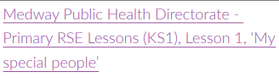  Resources on One Drive  Unit: Happy Families | Teacher Hub | Oak National Academy (thenational.academy)  Super Mood Movers - Friends and family - BBC Teach  Our Family - CBeebies - BBC | BV: Mutual respect and tolerance  BV: Individual Liberty  EA/D  Enrichment Menu Choices
Safe relationships  Recognising privacy; staying safe; seeking permission | R10. that bodies and feelings can be hurt by words and actions; that people can say hurtful things online.  R13. to recognise that some things are private and the importance of respecting privacy; that parts of their body covered by underwear are private.  R15. how to respond safely to adults they don’t know  R16. about how to respond if physical contact makes them feel uncomfortable or unsafe  R17. about knowing there are situations when they should ask for permission and also when their permission should be sought | •about situations when someone’s body or feelings might be hurt and whom to go to for help  •about what it means to keep something private, including parts of the body that are private  •to identify different types of touch and how they make people feel (e.g. hugs, tickling, kisses and punches)  •how to respond if being touched makes them feel uncomfortable or unsafe  •when it is important to ask for permission to touch others  •how to ask for and give/not give permission | World Mental Health Day  Undressed (lgfl.net)  Talk PANTS & Join Pantosaurus - The Underwear Rule | NSPCC  PANTS resources for schools and teachers | NSPCC Learning  Unit: Stop, think, stay safe! | Teacher Hub | Oak National Academy (thenational.academy) | PE lessons
Respecting ourselves and others  How behaviour affects others; being polite and respectful | R21. about what is kind and unkind behaviour, and how this can affect others  R22. about how to treat themselves and others with respect; how to be polite and courteous | •what kind and unkind behaviour mean in and out school  •how kind and unkind behaviour can make people feel  •about what respect means  •about class rules, being polite to others, sharing and taking turns | Anti-bullying Week resources for academic year.  Anti-Bullying Alliance | United against bullying  International Day of Tolerance | Whole School Anti-Bullying event  Themed linked assemblies  BV: Mutual respect and tolerance  EA/D  PE lessons
Belonging to a community  What rules are; caring for others’ needs; looking after the environment | L1. about what rules are, why they are needed, and why different rules are needed for different situations  L2. how people and other living things have different needs; about the responsibilities of caring for them  L3. about things they can do to help look after their environment | •about examples of rules in different situations, e.g. class rules, rules at home, rules outside  •that different people have different needs  •how we care for people, animals and other living things in different ways  •how they can look after the environment, e.g. recycling | 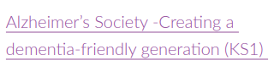School teaching resources | Alzheimer's Society (alzheimers.org.uk)  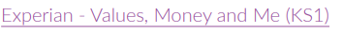  Homepage | Values, Money & Me (valuesmoneyandme.co.uk)  PSHE KS1: Super Mood Movers - Taking care of our world - BBC Teach  PSHE KS1/KS2: What Makes Me, Me? And Other Interesting Questions - BBC Teach | BV: Rule of Law  BV: Mutual respect and tolerance  EA/D  PE lessons  Enquiry Lessons  Enrichment Menu Choices
Media literacy and Digital resilience  Using the internet and digital devices; communicating online | L7. about how the internet and digital devices can be used safely to find things out and to communicate with others  L8. about the role of the internet in everyday life | •how and why people use the internet  •the benefits of using the internet and digital devices  •how people find things out and communicate safely with others online | Key Stage 1 PSHE resources for teachers | CBBFC  Review of Trythall School Acceptable Use Policies  Home - Safer Internet Day | Whole School Safer Internet Day Event  Themed linked assemblies  Computing lessons –
Money and Work  Strengths and interests; jobs in the community | L14. that everyone has different strengths  L16. different jobs that people they know or people who work in the community do  L17. about some of the strengths and interests someone might need to do different jobs | •that everyone has different strengths, in and out of school  •about how different strengths and interests are needed to do different jobs  •about people whose job it is to help us in the community  •about different jobs and the work people do | Key Stage 1 PSHE resources for teachers | CBBFC  Science Week  International Women’s Day Study of Female Scientist | Enrichment Menu Choices
Physical health and Mental wellbeing  Keeping healthy; food and exercise;hygiene routines; sun safety | H1. about what keeping healthy means; different ways to keep healthy  H2. about foods that support good health and the risks of eating too much sugar  H3. about how physical activity helps us to stay healthy; and ways to be physically active everyday  H5. simple hygiene routines that can stop germs from spreading  H8. how to keep safe in the sun and protect skin from sun damage  H9. about different ways to learn and play; recognising the importance of knowing when to take a break from time online or TV  H10. about the people who help us to stay physically healthy | •what it means to be healthy and why it is important  •ways to take care of themselves on a daily basis  •about basic hygiene routines, e.g. hand washing  •about healthy and unhealthy foods, including sugar intake  •about physical activity and how it keeps people healthy  •about different types of play, including balancing indoor, outdoor and screen-based play  •about people who can help them to stay healthy, such as parents, doctors, nurses, dentists, lunch supervisors  •how to keep safe in the sun | May = Mental Health Awareness Month. See annual theme  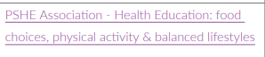  Resources on One Drive  Child Safety Week – 7th to 13th June  Child Safety Week | Child Accident Prevention Trust (capt.org.uk)  Elmer Day  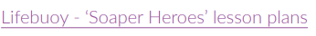  Lifebuoy's Soaper Heroes UK - for Primary Schools - National Schools Partnership  Unit: Stop the spread! | Teacher Hub | Oak National Academy (thenational.academy)  CBeebies - Daydreams (bbc.co.uk)  Get Well Soon - CBeebies - BBC | Science lessons  PE lessons  Design Technology – Food  Enquiry Lessons  Enrichment Menu Choices
Growing and changing  Recognising what makes them unique and special; feelings; managing when things go wrong | H11. about different feelings that humans can experience  H12. how to recognise and name different feelings  H13. how feelings can affect people’s bodies and how they behave  H14. how to recognise what others might be feeling  H15. to recognise that not everyone feels the same at the same time, or feels the same about the same things  H21. to recognise what makes them special  H22. to recognise the ways in which we are all unique  H23. to identify what they are good at, what they like and dislike  H24. how to manage when finding things difficult | •to recognise what makes them special and unique including their likes, dislikes and what they are good at  •how to manage and whom to tell when finding things difficult, or when things go wrong  •how they are the same and different to others  •about different kinds of feelings  •how to recognise feelings in themselves and others  •how feelings can affect how people behave | 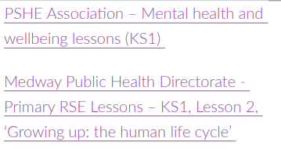  Resources on One Drve  Unit: Me, you and us! | Teacher Hub | Oak National Academy (thenational.academy)  Unit: It’s OK not to be OK! | Teacher Hub | Oak National Academy (thenational.academy)  Primary : Mentally Healthy Schools  Super Mood Movers - Coping with feelings - BBC Teach | BV: Mutual respect and tolerance  EA/D  PE lessons  Design Technology – Food  Enrichment Menu Choices
Keeping safe  How rules and age restrictions help us; keeping safe online | H28. about rules and age restrictions that keep us safe  H34. basic rules to keep safe online, including what is meant by personal information and what should be kept private; the importance of telling a trusted adult if they come across something that scares them | •how rules can help to keep us safe  •why some things have age restrictions, e.g. TV and film, games, toys or play areas  •basic rules for keeping safe online  •whom to tell if they see something online that makes them feel unhappy, worried, or scared | Key Stage 1 PSHE resources for teachers | CBBFC (updated Dec 2021)  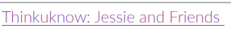  Jessie & Friends: online safety education for 4-7s (thinkuknow.co.uk)  Beach Safety (Added for location of school)  Youth Education - Helping You Teach Children Water Safety (rnli.org)  Super Mood Movers - Being happy and safe - BBC Teach  Pupil Consultation & Review | Computing lessons – see Computing LTP  BV: Rule of Law

Year 2 (covered in year A)
Area | Programme of Study References: PSHE Association | In this unit of work, pupils learn: | Suggested resources, teaching and learning materials | Cross-curricular, school community links,  inc British Values (BV)  Equality Act/Diversity (EA/D)
Families and friendships  Making friends; feeling lonely and getting help | R6. about how people make friends and what makes a good friendship  R7. about how to recognise when they or someone else feels lonely and what to do  R8. simple strategies to resolve arguments between friends positively  R9. how to ask for help if a friendship is making them feel unhappy  R24. how to listen to other people and play and work cooperatively | •how to be a good friend, e.g. kindness, listening, honesty  •about different ways that people meet and make friends  •strategies for positive play with friends, e.g. joining in, including others, etc.  •about what causes arguments between friends  •how to positively resolve arguments between friends  •how to recognise, and ask for help, when they are feeling lonely or unhappy or to help someone else | Democratic processes in creating the new academic year School Council (as appropriate)  Unit: Forever friends | Teacher Hub | Oak National Academy (thenational.academy)  Super Mood Movers - Friends and family - BBC Teach | BV: Mutual respect and tolerance  PE lessons – See PE LTP  Enrichment Menu Choices
Safe relationships  Managing secrets; resisting pressure and getting help; recognising hurtful behaviour | R11. about how people may feel if they experience hurtful behaviour or bullying  R12. that hurtful behaviour (offline and online) including teasing, name-calling, bullying and deliberately excluding others is not acceptable; how to report bullying; the importance of telling a trusted adult  R14. that sometimes people may behave differently online, including by pretending to be someone they are not  R18. about the importance of not keeping adults’ secrets (only happy surprises that others will find out about eventually)  R19. basic techniques for resisting pressure to do something they don’t want to do and which may make them unsafe  R20. what to do if they feel unsafe or worried for themselves or others; who to ask for help and vocabulary to use when asking for help; importance of keeping trying until they are heard | •how to recognise hurtful behaviour, including online  •what to do and whom to tell if they see or experience hurtful behaviour, including online  •about what bullying is and different types of bullying  •how someone may feel if they are being bullied  •about the difference between happy surprises and secrets that make them feel uncomfortable or worried, and how to get help  •how to resist pressure to do something that feels uncomfortable or unsafe  •how to ask for help if they feel unsafe or worried and what vocabulary to use | Anti-bullying Week resources for academic year.  Anti-Bullying Alliance | United against bullying  World Mental Health Day  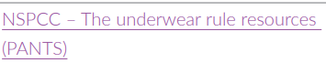  Undressed (lgfl.net)  Talk PANTS & Join Pantosaurus - The Underwear Rule | NSPCC  PANTS resources for schools and teachers | NSPCC Learning  Jessie & Friends: online safety education for 4-7s (thinkuknow.co.uk) | BV: Mutual respect and tolerance  PE lessons
Respecting ourselves and others  Recognising things in common and differences; playing and working cooperatively; sharing opinions | R23. to recognise the ways in which they are the same and different to others  R24. how to listen to other people and play and work cooperatively  R25. how to talk about and share their opinions on things that matter to them | •about the things they have in common with their friends, classmates, and other people  •how friends can have both similarities and differences  •how to play and work cooperatively in different groups and situations  •how to share their ideas and listen to others, take part in discussions, and give reasons for their views | 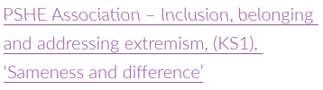  Resources on One Drive  Anti-bullying Week resources for academic year.  Anti-Bullying Alliance | United against bullying  International Day of Tolerance  Unit: I know my rights! | Teacher Hub | Oak National Academy (thenational.academy) | Whole School Anti-Bullying event  Themed linked assemblies  BV: Mutual respect and tolerance  PE lessons  EA/D
Belonging to a community  Belonging to a group; roles and responsibilities; being the same and different in the community | L2. how people and other living things have different needs; about the responsibilities of caring for them  L4. about the different groups they belong to  L5. about the different roles and responsibilities people have in their community  L6. to recognise the ways they are the same as, and different to, other people | •about being a part of different groups, and the role they play in these groups e.g. class, teams, faith groups  •about different rights and responsibilities that they have in school and the wider community  •about how a community can help people from different groups to feel included  •to recognise that they are all equal, and ways in which they are the same and different to others in their community | Unit: I know my rights! | Teacher Hub | Oak National Academy (thenational.academy)  PSHE KS1/KS2: What Makes Me, Me? And Other Interesting Questions - BBC Teach  Resources on One Drive  https://www.unicef.org.uk/rights-respecting-schools/resources/teaching-resources/ | RS lessons  Country/Continent Study  BV: Mutual respect and tolerance  PE lessons  Design Technology – Food  Enrichment Menu Choices
Media literacy and Digital resilience  The internet in everyday life; online content and information | L8. about the role of the internet in everyday life  L9. that not all information seen online is true | •the ways in which people can access the internet e.g. phones, tablets, computers  •to recognise the purpose and value of the internet in everyday life  •to recognise that some content on the internet is factual and some is for entertainment e.g. news, games, videos  •that information online might not always be true | https://www.cbbfc.co.uk/resources/key-stage-1-pshe-resource  Review of Trythall School Acceptable Use Policies  Home - Safer Internet Day  Key Stage 1 PSHE resources for teachers | CBBFC (updated Dec 2021) | Whole School Safer Internet Day Event  Themed linked assemblies  Computing lessons
Money and Work  What money is; needs and wants; looking after money | L10. what money is; forms that money comes in; that money comes from different sources  L11. that people make different choices about how to save and spend money  L12. about the difference between needs and wants; that sometimes people may not always be able to have the things they want  L13. that money needs to be looked after; different ways of doing this  L14. that everyone has different strengths  L15. that jobs help people to earn money to pay for things | •about what money is and its different forms e.g. coins, notes, and ways of paying for things e.g. debit cards, electronic payments  •how money can be kept and looked after  •about getting, keeping and spending money  •that people are paid money for the job they do  •how to recognise the difference between needs and wants  •how people make choices about spending money, including thinking about needs and wants | Homepage | Values, Money & Me (valuesmoneyandme.co.uk)  Science Week  International Women’s Day Study of Female Scientist  Money Teaching Resources | 5-8 years | MoneySense (mymoneysense.com) | Money Unit or review in Maths lessons
Physical health and Mental wellbeing  Why sleep is important; medicines and  keeping healthy; keeping teeth healthy; managing feelings and asking for help | H4. about why sleep is important and different ways to rest and relax  H6. that medicines (including vaccinations and immunisations and those that support allergic reactions) can help people to stay healthy  H7. about dental care and visiting the dentist; how to brush teeth correctly; food and drink that support dental health  H16. about ways of sharing feelings; a range of words to describe feelings  H17. about things that help people feel good (e.g. playing outside, doing things they enjoy, spending time with family, getting enough sleep)  H18. different things they can do to manage big feelings, to help calm themselves down and/or change their mood when they don’t feel good  H19. to recognise when they need help with feelings; that it is important to ask for help with feelings; and how to ask for it  H20. about change and loss (including death); to identify feelings associated with this; to recognise what helps people to feel better | •about routines and habits for maintaining good physical and mental health  •why sleep and rest are important for growing and keeping healthy  •that medicines, including vaccinations and immunisations, can help people stay healthy and manage allergies  •the importance of, and routines for, brushing teeth and visiting the dentist  •about food and drink that affect dental health  •how to describe and share a range of feelings  •ways to feel good, calm down or change their mood e.g. playing outside, listening to music, spending time with others  •how to manage big feelings including those associated with change, loss and bereavement  •when and how to ask for help, and how to help others, with their feelings | May = Mental Health Awareness Month. See annual theme  Child Safety Week – 7th to 13th June  Child Safety Week | Child Accident Prevention Trust (capt.org.uk)  Elmer Day  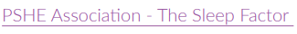  Ep 2 - Waking Up To The Importance Of Sleep... by PSHE Talks by The PSHE Association (soundcloud.com)  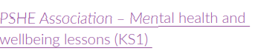  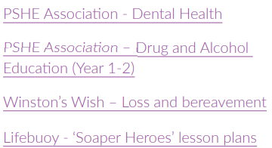  Drug and alcohol education | www.pshe-association.org.uk  Resources on One Drive  Free PSHE lessons on loss and bereavement | Winston's Wish (winstonswish.org)  BE AWARE OF ANY BEREAVEMENTS IN THE COHORT BEFORE PLANNING AND TEACHING  Lifebuoy's Soaper Heroes UK - for Primary Schools - National Schools Partnership  Super Mood Movers - Coping with feelings - BBC Teach  Super Mood Movers - Look after yourself - BBC Teach  CBeebies - Daydreams (bbc.co.uk)  Get Well Soon - CBeebies - BBC  CBeebies - Oti's Boogie Beebies (bbc.co.uk) | Science lessons  PE lessons  Design Technology – Food  Enrichment Menu Choices
Growing and changing  Growing older; naming body parts;  moving class or year | H20. about change and loss (including death); to identify feelings associated with this; to recognise what helps people to feel better  H25. to name the main parts of the body including external genitalia (e.g. vulva, vagina, penis, testicles)  H26. about growing and changing from young to old and how people’s needs change  H27. about preparing to move to a new class/year group | •about the human life cycle and how people grow from young to old  •how our needs and bodies change as we grow up  •to identify and name the main parts of the body including external genitalia (e.g. vulva, vagina, penis, testicles)  •about change as people grow up, including new opportunities and responsibilities  •preparing to move to a new class and setting goals for next year | 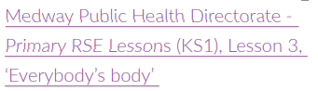  Resources on One Drive | PE lessons  Science lessons
Keeping safe  Safety in different environments; risk and safety at home; emergencies | H29. to recognise risk in simple everyday situations and what action to take to minimise harm  H30. about how to keep safe at home (including around electrical appliances) and fire safety (e.g. not playing with matches and lighters)  H31. that household products (including medicines) can be harmful if not used correctly  H32. ways to keep safe in familiar and unfamiliar environments (e.g. beach, shopping centre, park, swimming pool, on the street) and how to cross the road safely  H33. about the people whose job it is to help keep us safe  H35. about what to do if there is an accident and someone is hurt  H36. how to get help in an emergency (how to dial 999 and what to say)  H37. about things that people can put into their body or on their skin; how these can affect how people feel | •how to recognise risk in everyday situations, e.g. road, water and rail safety, medicines  •how to help keep themselves safe in familiar and unfamiliar environments, such as in school, online and ‘out and about’  •to identify potential unsafe situations, who is responsible for keeping them safe in these situations, and steps they can take to avoid or remove themselves from danger  •how to help keep themselves safe at home in relation to electrical appliances, fire safety and medicines/household products  •about things that people can put into their body or onto their skin (e.g. medicines and creams) and how these can affect how people feel  •how to respond if there is an accident and someone is hurt  •about whose job it is to keep us safe and how to get help in an emergency, including how to dial 999 and what to say | Child Safety Week – 7th to 13th June  Child Safety Week | Child Accident Prevention Trust (capt.org.uk)  Visiting speaker – People who help us?  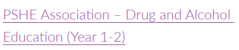  Drug and alcohol education | www.pshe-association.org.uk  Resources on One Drive  Beach Safety (Added for location of school)  Youth Education - Helping You Teach Children Water Safety (rnli.org)  Super Mood Movers - Being happy and safe - BBC Teach  Get Well Soon - CBeebies - BBC  Pupil Consultation & Review | Computing lessons –  Design Technology –  Enquiry Lessons  Enrichment Menu Choices

Year 3 (covered in year B)
Area | Programme of Study References: PSHE Association | In this unit of work, pupils learn: | Suggested resources, teaching and learning materials | Cross-curricular, school community links,  inc British Values (BV)  Equality Act/Diversity (EA/D)
Families and friendships  What makes a family; features of family life | R1. to recognise that there are different types of relationships (e.g. friendships, family relationships, romantic relationships, online relationships)  R6. that a feature of positive family life is caring relationships; about the different ways in which people care for one another  R7. to recognise and respect that there are different types of family structure (including single parents, same-sex parents, step-parents, blended families, foster parents); that families of all types can give family members love, security and stability  R8. to recognise other shared characteristics of healthy family life, including commitment, care, spending time together; being there for each other in times of difficulty  R9. how to recognise if family relationships are making them feel unhappy or unsafe, and how to seek help or advice | •to recognise and respect that there are different types of families, including single parents, same-sex parents, step-parents, blended families, foster and adoptive parents  •that being part of a family provides support, stability and love  •about the positive aspects of being part of a family, such as spending time together and caring for each other  •about the different ways that people can care for each other e.g. giving encouragement or support in times of difficulty  •to identify if/when something in a family might make someone upset or worried  •what to do and whom to tell if family relationships are making them feel unhappy or unsafe | Democratic processes in creating the new academic year School Council.  Resources on One Drive  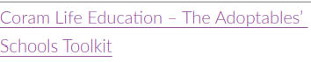  The Adoptables' Schools Toolkit (coramlifeeducation.org.uk) | BV: Mutual respect and tolerance  BV: Individual Liberty
Safe relationships  Personal boundaries; safely responding to others; the impact of hurtful behaviour | R19. about the impact of bullying, including offline and online, and the consequences of hurtful behaviour  R22. about privacy and personal boundaries; what is appropriate in friendships and wider relationships (including online);  R24. how to respond safely and appropriately to adults they may encounter (in all contexts including online) whom they do not know  R30. that personal behaviour can affect other people; to recognise and model respectful behaviour online | •What is appropriate to share with friends, classmates, family and wider social groups including online  •about what privacy and personal boundaries are, including online  •basic strategies to help keep themselves safe online e.g. passwords, using trusted sites and adultsupervision  •that bullying and hurtful behaviour is unacceptable in any situation  •about the effects and consequences of bullying for the people involved  •about bullying online, and the similarities and differences to face-to-face bullying  •what to do and whom to tell if they see or experience bullying or hurtful behaviour | Anti-bullying Week resources for academic year.  Anti-Bullying Alliance | United against bullying  World Mental Health Day  Review Trythall School Acceptable Use Policies | BV: Mutual respect and tolerance  PE lessons
Respecting ourselves and others  Recognising respectful behaviour; the  importance of self-respect; courtesy,  being polite | R30. that personal behaviour can affect other people; to recognise and model respectful behaviour online  R31. to recognise the importance of self-respect and how this can affect their thoughts and feelings about themselves; that everyone, including them, should expect to be treated politely and with respect by others (including when online and/or anonymous) in school and in wider society; strategies to improve or support courteous, respectful relationship | •to recognise respectful behaviours e.g. helping or including others, being responsible  •how to model respectful behaviour in different situations e.g. at home, at school, online  •the importance of self-respect and their right to be treated respectfully by others  •what it means to treat others, and be treated, politely  •the ways in which people show respect and courtesy in different cultures and in wider society | 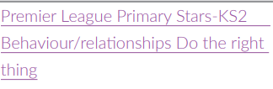  Premier League Primary Stars | Resources (plprimarystars.com)  Anti-bullying Week resources for academic year.  Anti-Bullying Alliance | United against bullying  International Day of Tolerance  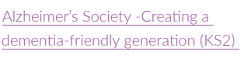  Dementia teaching resources | Alzheimer's Society (alzheimers.org.uk)  Super Mood Movers - Rights and respect - BBC Teach | Whole School Anti-Bullying event  Themed linked assemblies  BV: Mutual respect and tolerance  PE lessons  Enrichment Menu Choices  EA/D
Belonging to a community  The value of rules and laws; rights, freedoms and responsibilities | L1. to recognise reasons for rules and laws; consequences of not adhering to rules and laws  L2. to recognise there are human rights, that are there to protect everyone  L3. about the relationship between rights and responsibilities | •the reasons for rules and laws in wider society  •the importance of abiding by the law and what might happen if rules and laws are broken  •what human rights are and how they protect people  •to identify basic examples of human rights including the rights of children  •about how they have rights and also responsibilities  •that with every right there is also a responsibility e.g. the right to an education and the responsibility to learn | PSHE KS1/KS2: What Makes Me, Me? And Other Interesting Questions - BBC Teach  https://www.unicef.org.uk/rights-respecting-schools/resources/teaching-resources/  https://www.amnesty.org.uk/education-resources-childrens-human-rights  https://www.teachingenglish.org.uk/article/childrens-rights  https://www.youtube.com/watch?v=x9_IvXFEyJo | RS lessons  BV: Rule of Law  BV: Democracy  BV: Individual Liberty
Media literacy and Digital resilience  How the internet is used; assessing information online | L11. recognise ways in which the internet and social media can be used both positively and negatively  L12. how to assess the reliability of sources of information online; and how to make safe, reliable choices from search results | •how the internet can be used positively for leisure, for school and for work  •to recognise that images and information online can be altered or adapted and the reasons for why this happens  •strategies to recognise whether something they see online is true or accurate  •to evaluate whether a game is suitable to play or a website is appropriate for their age-group  •to make safe, reliable choices from search results  •how to report something seen or experienced online that concerns them e.g. images or content that worry them, unkind or inappropriate communication | Review of Trythall Acceptable Use Policies  Home - Safer Internet Day  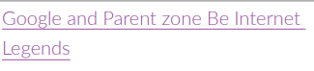  Order expert teaching resources | Parent Zone  Be Internet Legends - Toolkit (beinternetawesome.withgoogle.com) | Whole School Safer Internet Day Event  Themed linked assemblies  Computing lessons – see Computing LTP
Money and Work  Different jobs and skills; job stereotypes; setting personal goals | L25. to recognise positive things about themselves and their achievements; set goals to help achieve personal outcomes  L26. that there is a broad range of different jobs/careers that people can have; that people often have more than one career/type of job during their life  L27. about stereotypes in the workplace and that a person’s career aspirations should not be limited by them  L30. about some of the skills that will help them in their future careers e.g. teamwork, communication and negotiation | •about jobs that people may have from different sectors e.g. teachers, business people, charity work  •that people can have more than one job at once or over their lifetime  •about common myths and gender stereotypes related to work  •to challenge stereotypes through examples of role models in different fields of work e.g. women in STEM  •about some of the skills needed to do a job, such as teamwork and decision-making  •to recognise their interests, skills and achievements and how these might link to future jobs  •how to set goals that they would like to achieve this year e.g. learn a new hobby | Science Week  International Women’s Day  Study of Female Scientist  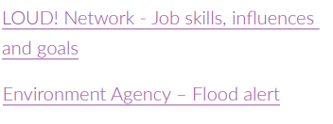  Linking career-related learning to PSHE | Primary Schools Toolkit (careersandenterprise.co.uk)  Environment Agency resources on Wordpress | BV: Mutual respect and tolerance  PE lessons  Enrichment Menu Choices
Physical health and Mental wellbeing  Health choices and habits; what affects  feelings; expressing feelings | H1. about what keeping healthy means; different ways to keep healthy  H2. about foods that support good health and the risks of eating too much sugar  H3. about how physical activity helps us to stay healthy; and ways to be physically active everyday  H4. about why sleep is important and different ways to rest and relax  H6. that medicines (including vaccinations and immunisations and those that support allergic reactions) can help people to stay healthy  H7. about dental care and visiting the dentist; how to brush teeth correctly; food and drink that support dental health | •about the choices that people make in daily life that could affect their health  •to identify healthy and unhealthy choices (e.g. in relation to food, exercise, sleep)  •what can help people to make healthy choices and what might negatively influence them  •about habits and that sometimes they can be maintained, changed or stopped  •the positive and negative effects of habits, such as regular exercise or eating too much sugar, on a healthy lifestyle  •what is meant by a healthy, balanced diet including what foods should be eaten regularly or just occasionally  •that regular exercise such as walking or cycling has positive benefits for their mental and physical health  •about the things that affect feelings both positively and negatively  •strategies to identify and talk about their feelings  •about some of the different ways people express feelings e.g. words, actions, body language  •to recognise how feelings can change overtime and become more or less powerful | May = Mental Health Awareness Month. See annual theme  On One Drive  Child Safety Week – 7th to 13th June  Child Safety Week | Child Accident Prevention Trust (capt.org.uk)  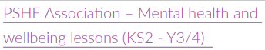  Mental health and emotional wellbeing PowerPoint lesson plans (pshe-association.org.uk)  Resources on One drive  Unit: Eat well, live well! | Teacher Hub | Oak National Academy (thenational.academy)  Free education resources for teaching young people aged 3-16 years about where food comes from, cooking and healthy eating, and teacher training. - Food A Fact Of Life  Primary : Mentally Healthy Schools  Super Mood Movers - Wellbeing - BBC Teach  Super Mood Movers - Look after yourself - BBC Teach | Science lessons – PE lessons  Design Technology – Food  Enquiry Lessons  Enrichment Menu Choices
Growing and changing  Personal strengths and achievements; managing and reframing setbacks | H27. to recognise their individuality and personal qualities  H.26 linked: explore own identity  H28. to identify personal strengths, skills, achievements and interests and how these contribute to a sense of self-worth  H29. about how to manage setbacks/perceived failures, including how to re-frame unhelpful thinking | •that everyone is an individual and has unique and valuable contributions to make  •to recognise how strengths and interests form part of a person’s identity  •how to identify their own personal strengths and interests and what they’re proud of (in school, out of school)  •to recognise common challenges to self -worth e.g. finding school work difficult, friendship issues  •basic strategies to manage and reframe setbacks e.g. asking for help, focusing on what they can learn from a setback, remembering what they are good at, trying again | 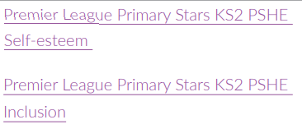  Premier League Primary Stars | Resources (plprimarystars.com)  Super Mood Movers - Change is life - BBC Teach  The Brain Lab - BBC Teach  PSHE KS2: Growth Mindset - BBC Teach  Mentally Healthy Schools teaching resources | Tes | BV: Individual Liberty  BV: Mutual respect and tolerance  PE lessons  Enquiry Lessons  Enrichment Menu Choices
Keeping safe  Risks and hazards; safety in the local environment and unfamiliar places | H38. how to predict, assess and manage risk in different situations  H39. about hazards (including fire risks) that may cause harm, injury or risk in the  home and what they can do reduce risks and keep safe  H41. strategies for keeping safe in the local environment or unfamiliar places (rail, water, road) and firework safety; safe use of digital devices when out and about | •how to identify typical hazards at home and in school  •how to predict, assess and manage risk in everyday situations e.g. crossing the road, running in the playground, in the kitchen  •about fire safety at home including the need for smoke alarms  •the importance of following safety rules from parents and other adults  •how to help keep themselves safe in the local environment or unfamiliar places, including road, rail, water and firework safety | Child Safety Week – 7th to 13th June  Child Safety Week | Child Accident Prevention Trust (capt.org.uk)  Visiting speaker – People who help us?  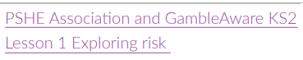  Resources on One Drive  Beach Safety (Added for location of school)  Youth Education - Helping You Teach Children Water Safety (rnli.org)  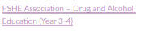  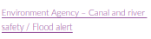  On One Drive  Pupil Consultation & Review | Computing lessons –  PE lessons  Science lessons  Enquiry Lessons  Enrichment Menu Choices

Year 4 (covered in year A)
Area | Programme of Study References: PSHE Association | In this unit of work, pupils learn: | Suggested resources, teaching and learning materials | Cross-curricular, school community links,  inc British Values (BV)  Equality Act/Diversity (EA/D)
Families and friendships  Positive friendships, including online | R10. about the importance of friendships; strategies for building positive friendships; how positive friendships support wellbeing  R11. what constitutes a positive healthy friendship (e.g. mutual respect, trust, truthfulness, loyalty, kindness, generosity, sharing interests and experiences, support with problems and difficulties); that the same principles apply to online friendships as to face-to-face relationships  R12. to recognise what it means to ‘know someone online’ and how this differs from knowing someone face-to-face; risks of communicating online with others not known face-to-face  R13. the importance of seeking support if feeling lonely or excluded  R18. to recognise if a friendship (online or offline) is making them feel unsafe or uncomfortable; how to manage this and ask for support if necessary | •about the features of positive healthy friendships such as mutual respect, trust and sharing interests  •strategies to build positive friendships  •how to seek support with relationships if they feel lonely or excluded  •how to communicate respectfully with friends when using digital devices  •how knowing someone online differs from knowing someone face to face and that there are risks in communicating with someone they don’t know  •what to do or whom to tell if they are worried about any contact online | Democratic processes in creating the new academic year School Council.  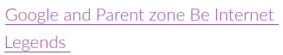  Order expert teaching resources | Parent Zone  Be Internet Legends - Toolkit (beinternetawesome.withgoogle.com) | BV: Mutual respect and tolerance  BV: Individual Liberty  PE lessons  Enrichment Menu Choices
Safe relationships  Responding to hurtful behaviour; managing confidentiality; recognising risks online | R20. strategies to respond to hurtful behaviour experienced or witnessed, offline and online (including teasing, name-calling, bullying, trolling, harassment or the deliberate excluding of others); how to report concerns and get support  R23. about why someone may behave differently online, including pretending to be someone they are not; strategies for recognising risks, harmful content and contact; how to report concerns  R27. about keeping something confidential or secret, when this should (e.g. a birthday surprise that others will find out about) or should not be agreed to, and when it is right to break a confidence or share a secret  R28. how to recognise pressure from others to do something unsafe or that makes them feel uncomfortable and strategies for managing this | •to differentiate between playful teasing, hurtful behaviour and bullying, including online  •how to respond if they witness or experience hurtful behaviour or bullying, including online  •recognise the difference between ‘playful dares’ and dares which put someone under pressure, at risk, or make them feel uncomfortable  •how to manage pressures associated with dares  •when it is right to keep or break a confidence or share a secret  •how to recognise risks online such as harmful content or contact  •how people may behave differently online including pretending to be someone they  are not  •how to report concerns and seek help if worried or uncomfortable about someone’s behaviour, including online | Anti-bullying Week resources for academic year.  Anti-Bullying Alliance | United against bullying  World Mental Health Day  Review Trythall School Acceptable Use Policies  Order expert teaching resources | Parent Zone  Be Internet Legends - Toolkit (beinternetawesome.withgoogle.com) | BV: Mutual respect and tolerance  PE lessons
Respecting ourselves and others  Respecting differences and similarities; discussing difference sensitively | R32. about respecting the differences and similarities between people and recognising what they have in common with others e.g. physically, in personality or background  R33. to listen and respond respectfully to a wide range of people, including those whose traditions, beliefs and lifestyle are different to their own | •to recognise differences between people such as gender, race, faith  •to recognise what they have in common with others e.g. shared values, likes and dislikes, aspirations  •about the importance of respecting the differences and similarities between people  •a vocabulary to sensitively discuss difference and include everyone | 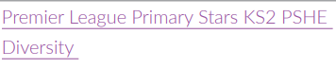  Premier League Primary Stars | Resources (plprimarystars.com)  Anti-bullying Week resources for academic year.  Anti-Bullying Alliance | United against bullying  International Day of Tolerance  PSHE KS2: Same but different - BBC Teach | Whole School Anti-Bullying event  Themed linked assemblies  BV: Mutual respect and tolerance  PE lessons  Design Technology – Food  Enrichment Menu Choices
Belonging to a community  What makes a community; shared responsibilities | L4. the importance of having compassion towards others; shared responsibilities we all have for caring for other people and living things; how to show care and concern for others  L6. about the different groups that make up their community; what living in a community means  L7. to value the different contributions that people and groups make to the community | •the meaning and benefits of living in a community  •to recognise that they belong to different communities as well as the school community  •about the different groups that make up and contribute to a community  •about the individuals and groups that help the local community, including through volunteering and work  •how to show compassion towards others in need and the shared responsibilities of caring for them | 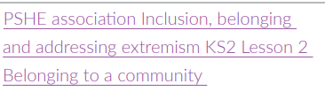  Resources on One Drive  KS2 Compassionate Class | RSPCA Education  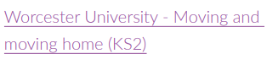  Resources on One Drive  Homepage | Values, Money & Me (valuesmoneyandme.co.uk)  Unit: All around me | Teacher Hub | Oak National Academy (thenational.academy)  https://www.unicef.org.uk/rights-respecting-schools/resources/teaching-resources/ | RS lessons  BV: Rule of Law  BV: Democracy  BV: Individual Liberty  PE lessons  Enrichment Menu Choices  St Pirans Day
Media literacy and Digital resilience  How data is shared and used | L13. about some of the different ways information and data is shared and used online, including for commercial purposes  L14. about how information on the internet is ranked, selected and targeted at specific individuals and groups; that connected devices can share information | •that everything shared online has a digital footprint  •that organisations can use personal information to encourage people to buy things  •to recognise what online adverts look like  •to compare content shared for factual purposes and for advertising  •why people might choose to buy or not buy something online e.g. from seeing an advert  •that search results are ordered based on the popularity of the website and that this can affect what information people access | Review of Trythall School Acceptable Use Policies  Home - Safer Internet Day | Whole School Safer Internet Day Event  Themed linked assemblies  Computing lessons
Money and Work  Making decisions about money; using and keeping money safe | L17. about the different ways to pay for things and the choices people have about this  L19. that people’s spending decisions can affect others and the environment (e.g. Fair trade, buying single-use plastics, or giving to charity)  L20. to recognise that people make spending decisions based on priorities, needs and wants  L21. different ways to keep track of money | •how people make different spending decisions based on their budget, values and needs  •how to keep track of money and why it is important to know how much is being spent  •about different ways to pay for things such as cash, cards, e-payment and the reasons for using them  •that how people spend money can have positive or negative effects on others e.g. charities, single use plastics | Science Week  International Women’s Day  Study of Female Scientist  Homepage | Values, Money & Me (valuesmoneyandme.co.uk)  Money Teaching Resources for Kids | 8-12 years | MoneySense (mymoneysense.com) | BV: Mutual respect and tolerance  EA/D
Physical health and Mental wellbeing  Maintaining a balanced lifestyle; oral  hygiene and dental care | H2. about the elements of a balanced, healthy lifestyle  H5. about what good physical health means; how to recognise early signs of physical illness  H11. how to maintain good oral hygiene (including correct brushing and flossing); why regular visits to the dentist are essential; the impact of lifestyle choices on dental care (e.g. sugar consumption/acidic drinks such as fruit juices, smoothies and fruit teas; the effects of smoking) | •to identify a wide range of factors that maintain a balanced, healthy lifestyle, physically and mentally  •what good physical health means and how to recognise early signs of physical illness  •that common illnesses can be quickly and easily treated with the right care e.g. visiting the doctor when necessary  •how to maintain oral hygiene and dental health, including how to brush and floss correctly  •the importance of regular visits to the dentist and the effects of different foods, drinks and substances on dental health | May = Mental Health Awareness Month. See annual theme  On One drive  On One Drive  Child Safety Week – 7th to 13th June  Child Safety Week | Child Accident Prevention Trust (capt.org.uk)  Unit: Eat well, live well! | Teacher Hub | Oak National Academy (thenational.academy)  Free education resources for teaching young people aged 3-16 years about where food comes from, cooking and healthy eating, and teacher training. - Food A Fact Of Life  Super Mood Movers - Look after yourself - BBC Teach | Science lessons  PE lessons  Design Technology – Food  Enquiry Lessons  Enrichment Menu Choices
Growing and changing  Personal identity; recognising individuality and different qualities; mental wellbeing | H6. about what constitutes a healthy diet; how to plan healthy meals; benefits to health and wellbeing of eating nutritionally rich foods; risks associated with not eating a healthy diet including obesity and tooth decay.  H25. about personal identity; what contributes to who we are (e.g. ethnicity, family, gender, faith, culture, hobbies, likes/dislikes)  H27. to recognise their individuality and personal qualities, linked to H.26. | •about personal identity and what contributes to it, including race, sex, gender, family, faith, culture, hobbies, likes/dislikes  •how to recognise, respect and express their individuality and personal qualities  •ways to boost their mood and improve emotional wellbeing  •about the link between participating in interests, hobbies and community groups and mental wellbeing | 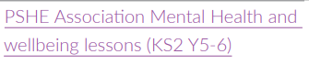  Mental health and emotional wellbeing PowerPoint lesson plans (pshe-association.org.uk)  Resources on One Drive  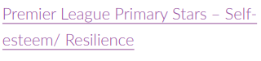  Premier League Primary Stars | Resources (plprimarystars.com)  Primary : Mentally Healthy Schools  The Brain Lab - BBC Teach  Mentally Healthy Schools teaching resources | Tes | BV: Individual Liberty  BV: Mutual respect and tolerance  PE lessons  Science lessons  Design Technology – Food  Enrichment Menu Choices
Keeping safe  Medicines and household products; drugs common to everyday life | H10. how medicines, when used responsibly, contribute to health; that some diseases can be prevented by vaccinations and immunisations; how allergies can be managed  H38. how to predict, assess and manage risk in different situations  H40. about the importance of taking medicines correctly and using household products safely, (e.g. following instructions carefully)  H46. about the risks and effects of legal drugs common to everyday life (e.g. cigarettes, e-cigarettes/vaping, alcohol and medicines) and their impact on health; recognise that drug use can become a habit which can be difficult to break | •the importance of taking medicines correctly and using household products safely  •to recognise what is meant by a ‘drug’  •that drugs common to everyday life (e.g. cigarettes, e-cigarettes/vaping, alcohol and medicines) can affect health and wellbeing  •to identify some of the effects related to different drugs and that all drugs, including medicines, may have side effects  •to identify some of the risks associated with drugs common to everyday life  •that for some people using drugs can become a habit which is difficult to break  •how to ask for help or advice | Child Safety Week – 7th to 13th June  Child Safety Week | Child Accident Prevention Trust (capt.org.uk)  Visiting speaker: Emergency Services?  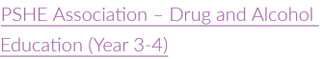  Drug and alcohol education | www.pshe-association.org.uk  Resources on Wordpress  Beach Safety (Added for location of school)  Youth Education - Helping You Teach Children Water Safety (rnli.org)  Pupil Consultation & Review | PE lessons  Science lessons

Year 5 (covered in year B)
Area | Programme of Study References: PSHE Association | In this unit of work, pupils learn: | Suggested resources, teaching and learning materials | Cross-curricular, school community links,  inc British Values (BV)  Equality Act/Diversity (EA/D)
Families and friendships  Managing friendships and peer influence | R14. that healthy friendships make people feel included; recognise when others may feel lonely or excluded; strategies for how to include them  R15. strategies for recognising and managing peer influence and a desire for peer approval in friendships; to recognise the effect of online actions on others  R16. how friendships can change over time, about making new friends and the benefits of having different types of friends  R17. that friendships have ups and downs; strategies to resolve disputes and reconcile differences positively and safely  R18. to recognise if a friendship (online or offline) is making them feel unsafe or uncomfortable; how to manage this and ask for support if necessary  R26. about seeking and giving permission (consent) in different situations | •what makes a healthy friendship and how they make people feel included  •strategies to help someone feel included  •about peer influence and how it can make people feel or behave  •the impact of the need for peer approval in different situations, including online  •strategies to manage peer influence and the need for peer approval e.g. exit strategies, assertive communication  •that it is common for friendships to experience challenges  •strategies to positively resolve disputes and reconcile differences in friendships  •that friendships can change over time and the benefits of having new and different types of friends  •how to recognise if a friendship is making them feel unsafe, worried, or uncomfortable  •when and how to seek support in relation to friendships | Democratic processes in creating the new academic year School Council.  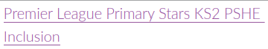  Premier League Primary Stars | Resources (plprimarystars.com) | BV: Mutual respect and tolerance  BV: Individual Liberty  PE lessons  Enrichment Menu Choices
Safe relationships  Physical contact and feeling safe | R9. how to recognise if family relationships are making them feel unhappy or unsafe, and how to seek help or advice  R25. recognise different types of physical contact; what is acceptable and unacceptable; strategies to respond to unwanted physical contact  R26. about seeking and giving permission (consent) in different situations  R27. about keeping something confidential or secret, when this should (e.g. a birthday surprise that others will find out about) or should not be agreed to, and when it is right to break a confidence or share a secret  R29. where to get advice and report concerns if worried about their own or someone else’s personal safety (including online) | •to identify what physical touch is acceptable, unacceptable, wanted or unwanted in different situations  •how to ask for, give and not give permission for physical contact  •how it feels in a person’s mind and body when they are uncomfortable  •that it is never someone’s fault if they have experienced unacceptable contact  •how to respond to unwanted or unacceptable physical contact  •that no one should ask them to keep a secret that makes them feel uncomfortable or try to persuade them to keep a secret they are worried about  •whom to tell if they are concerned about unwanted physical contact | Anti-bullying Week resources for academic year.  Anti-Bullying Alliance | United against bullying  World Mental Health Day  Review Trythall School Acceptable Use Policies | BV: Mutual respect and tolerance  PE lessons
Respecting ourselves and others  Responding respectfully to a wide range of people; recognising prejudice and discrimination | R20. strategies to respond to hurtful behaviour experienced or witnessed, offline and online (including teasing, name-calling, bullying, trolling, harassment or the deliberate excluding of others); how to report concerns and get support  R21. about discrimination: what it means and how to challenge it  R31. to recognise the importance of self-respect and how this can affect their thoughts and feelings about themselves; that everyone, including them, should expect to be treated politely and with respect by others (including when online and/or anonymous) in school and in wider society; strategies to improve or support courteous, respectful relationships | •to recognise that everyone should be treated equally  •why it is important to listen and respond respectfully to a wide range of people, including those whose traditions, beliefs and lifestyle are different to their own  •what discrimination means and different types of discrimination e.g. racism, sexism, homophobia  •to identify online bullying and discrimination of groups or individuals e.g. trolling and harassment | Anti-bullying Week resources for academic year.  Anti-Bullying Alliance | United against bullying  International Day of Tolerance  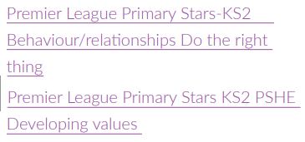  Premier League Primary Stars | Resources (plprimarystars.com)  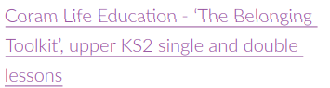  The Belonging Toolkit (coramlifeeducation.org.uk)  PSHE KS2: Same but different - BBC Teach | Whole School Anti-Bullying event  Themed linked assemblies  BV: Mutual respect and tolerance  PE lessons
Belonging to a community  Protecting the environment; compassion towards others | L4. the importance of having compassion towards others; shared responsibilities we all have for caring for other people and living things; how to show care and concern for others  L5. ways of carrying out shared responsibilities for protecting the environment in school and at home; how everyday choices can affect the environment (e.g. reducing, reusing, recycling; food choices  L19. that people’s spending decisions can affect others and the environment (e.g. Fair trade, buying single-use plastics, or giving to charity) | •about how resources are allocated and the effect this has on individuals, communities and the environment  •the importance of protecting the environment and how everyday actions can either support or damage it  •how to show compassion for the environment, animals and other living things  •about the way that money is spent and how it affects the environment  •express their own opinions about their responsibility towards the environment | 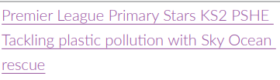  Premier League Primary Stars | Resources (plprimarystars.com)  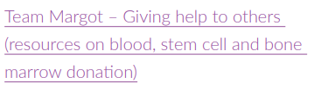  Giving To Help Others  Homepage | Values, Money & Me (valuesmoneyandme.co.uk)  Unit: Yes! It’s our world, our wonderful world! | Teacher Hub | Oak National Academy (thenational.academy) | RS lessons  BV: Rule of Law  BV: Democracy  BV: Individual Liberty  PE lessons  Enquiry Lessons  Enrichment Menu Choices
Media literacy and Digital resilience  How information online is targeted; different media types, their role and impact | L12. how to assess the reliability of sources of information online; and how to make safe, reliable choices from search results  L14. about how information on the internet is ranked, selected and targeted at specific individuals and groups; that connected devices can share information | •to identify different types of media and their different purposes e.g. to entertain, inform, persuade or advertise  •basic strategies to assess whether content online (e.g. research, news, reviews, blogs) is based on fact, opinion, or is biased  •that some media and online content promote stereotypes  •how to assess which search results are more reliable than others  •to recognise unsafe or suspicious content online  •how devices store and share information | Review ofTrythall School Acceptable Use Policies  Home - Safer Internet Day  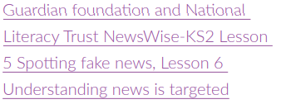  Newswise Unit Of Work | The Guardian  Order expert teaching resources | Parent Zone  Be Internet Legends - Toolkit (beinternetawesome.withgoogle.com)  Resources on One Drive | Whole School Safer Internet Day Event  Themed linked assemblies  Computing lessons
Money and Work  Identifying job interests and aspirations; what influences career choices; workplace stereotypes | L27. about stereotypes in the workplace and that a person’s career aspirations should not be limited by them  L28. about what might influence people’s decisions about a job or career (e.g. personal interests and values, family connections to certain trades or businesses, strengths and qualities, ways in which stereotypical assumptions can deter people from aspiring to certain jobs)  L29. that some jobs are paid more than others and money is one factor which may influence a person’s job or career choice; that people may choose to do voluntary work which is unpaid  L31. to identify the kind of job that they might like to do when they are older  L32. to recognise a variety of routes into careers (e.g. college, apprenticeship, university) | •to identify jobs that they might like to do in the future  •about the role ambition can play in achieving a future career  •how or why someone might choose a certain career  •about what might influence people’s decisions about a job or career, including pay, working conditions, personal interests, strengths and qualities, family, values  •the importance of diversity and inclusion to promote people’s career opportunities  •about stereotyping in the workplace, its impact and how to challenge it  •that there is a variety of routes into work e.g. college, apprenticeships, university, training | Science Week  International Women’s Day Study of Female Scientist  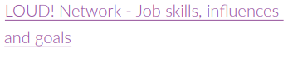  Linking career-related learning to PSHE | Primary Schools Toolkit (careersandenterprise.co.uk)  Unit: Money matters | Teacher Hub | Oak National Academy (thenational.academy)  PSHE KS2 / KS3: Spark - Fire up your future - BBC Teach | BV: Mutual respect and tolerance  Enquiry Lessons  Enrichment Menu Choices  EA/D
Physical health and Mental wellbeing  Healthy sleep habits; sun safety; medicines, vaccinations, immunisations and allergies | H8. about how sleep contributes to a healthy lifestyle; routines that support good quality sleep; the effects of lack of sleep on the body, feelings, behaviour and ability to learn  H9. that bacteria and viruses can affect health; how everyday hygiene routines can limit the spread of infection; the wider importance of personal hygiene and how to maintain it  H10. how medicines, when used responsibly, contribute to health; that some diseases can be prevented by vaccinations and immunisations; how allergies can be managed  H12. about the benefits of sun exposure and risks of overexposure; how to keep safe from sun damage and sun/heat stroke and reduce the risk of skin cancer | •how sleep contributes to a healthy lifestyle  •healthy sleep strategies and how to maintain them  •about the benefits of being outdoors and in the sun for physical and mental health  •how to manage risk in relation to sun exposure, including skin damage and heat stroke  •how medicines can contribute to health and how allergies can be managed  •that some diseases can be prevented by vaccinations and immunisations  •that bacteria and viruses can affect health  •how they can prevent the spread of bacteria and viruses with everyday hygiene  routines  •to recognise the shared responsibility of keeping a clean environment | May = Mental Health Awareness Month. See annual theme  Child Safety Week – 7th to 13th June  Child Safety Week | Child Accident Prevention Trust (capt.org.uk)  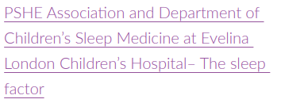  Resources on One Drive  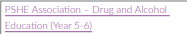  On Wordpress website (updated Dec 2021)  Lifebuoy's Soaper Heroes UK - for Primary Schools - National Schools Partnership  Updated Dec 2021 | Science lessons  PE lessons  Design Technology – Food Hygiene  Enquiry Lessons
Growing and changing  Physical and emotional changes in puberty; external genitalia; personal hygiene routines; support with puberty | H30. to identify the external genitalia and internal reproductive organs in males and females and how the process of puberty relates to human reproduction  H31. about the physical and emotional changes that happen when approaching and during puberty (including menstruation, key facts about the menstrual cycle  and menstrual wellbeing, erections and wet dreams)  H32. about how hygiene routines change during the time of puberty, the importance of keeping clean and how to maintain personal hygiene  H34. about where to get more information, help and advice about growing and changing, especially about puberty  H36. that for some people gender identity does not correspond with their biological sex | •how to identify external genitalia and reproductive organs  •about the physical and emotional changes during puberty  •key facts about the menstrual cycle and menstrual wellbeing, erections and wet dreams  •strategies to manage the changes during puberty including menstruation  •the importance of personal hygiene routines during puberty including washing regularly and using deodorant  •how to discuss the challenges of puberty with a trusted adult  •how to get information, help and advice about puberty  •that for some people their gender identity does not correspond with their biological sex | 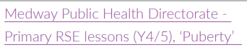  Resources on One Drive | BV: Individual Liberty  BV: Mutual respect and tolerance  Science lessons  PE lessons
Keeping safe  Keeping safe in different situations, including responding in emergencies, first aid | H38. how to predict, assess and manage risk in different situations  H43. about what is meant by first aid; basic techniques for dealing with common injuries²  H44. how to respond and react in an emergency situation; how to identify situations that may require the emergency services; know how to contact them and what to say | •to identify when situations are becoming risky, unsafe or an emergency  •to identify occasions where they can help take responsibility for their own safety  •to differentiate between positive risk taking (e.g. trying a challenging new sport) and dangerous behaviour  •how to deal with common injuries using basic first aid techniques  •how to respond in an emergency, including when and how to contact different emergency services | Child Safety Week – 7th to 13th June  Child Safety Week | Child Accident Prevention Trust (capt.org.uk)  Visiting speaker: Emergency Services?  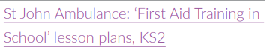  First Aid Lesson Plans | St John Ambulance (sja.org.uk)  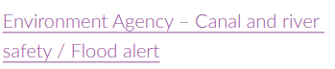  Resources on One Drive  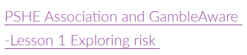  Resource on One Drive  Learn basic first aid - teaching resources | First aid champions (redcross.org.uk)  Beach Safety (Added for location of school)  Youth Education - Helping You Teach Children Water Safety (rnli.org)  Dr Emeka’s Essential First Aid - BBC Teach  Pupil Consultation & Review | PE lessons  Enquiry Lessons  Design Technology  Enrichment Menu Choices

Year 6 (covered in Year C - with exception of growing and changing unit covered each year)
Area | Programme of Study References: PSHE Association | In this unit of work, pupils learn: | Suggested resources, teaching and learning materials | Cross-curricular, school community links,  inc British Values (BV)  Equality Act/Diversity (EA/D)
Families and friendships  Attraction to others; romantic relationships; civil partnership and marriage | R1. to recognise that there are different types of relationships (e.g. friendships, family relationships, romantic relationships, online relationships)  R2. that people may be attracted to someone emotionally, romantically and sexually; that people may be attracted to someone of the same sex or different sex to them  R3. about marriage and civil partnership as a legal declaration of commitment made by two adults who love and care for each other, which is intended to be lifelong  R4. that forcing anyone to marry against their will is a crime; that help and support is available to people who are worried about this for themselves or others  R5. that people who love and care for each other can be in a committed relationship (e.g. marriage), living together, but may also live apart  R7. to recognise and respect that there are different types of family structure (including single parents, same-sex parents, step-parents, blended families, foster parents); that families of all types can give family members love, security and stability | •what it means to be attracted to someone and different kinds of loving relationships  •that people who love each other can be of any gender, ethnicity or faith  •about the qualities of healthy relationships that help individuals flourish  •ways in which couples show their love and commitment to one another, including those who are not married or who live apart  •what marriage and civil partnership mean e.g. a legal declaration of commitment made by two adults  •that people have the right to choose whom they marry or whether to get married  •that to force anyone into marriage is illegal  •how and where to report forced marriage or ask for help if they are worried | Democracy processes in creating the new academic year School Council.  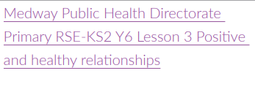  Resources on One Drive | BV: Mutual respect and tolerance  BV: Individual Liberty  EA/D
Safe relationships  Recognising and managing pressure; consent in different situations | R26. about seeking and giving permission (consent) in different situations  R28. how to recognise pressure from others to do something unsafe or that makes them feel uncomfortable and strategies for managing this  R29. where to get advice and report concerns if worried about their own or someone else’s personal safety (including online) | •to compare the features of a healthy and unhealthy friendship  •about the shared responsibility if someone is put under pressure to do something dangerous and something goes wrong  •strategies to respond to pressure from friends including online  •how to assess the risk of different online ‘challenges’ and ‘dares’  •how to recognise and respond to pressure from others to do something unsafe or that makes them feel worried or uncomfortable  •how to get advice and report concerns about personal safety, including online  •what consent means and how to seek and give/not give permission in different situations | Anti-bullying Week resources for academic year.  Anti-Bullying Alliance | United against bullying  World Mental Health Day  Review Trythall House Acceptable Use Policies  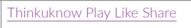  Play Like Share (thinkuknow.co.uk) | BV: Mutual respect and tolerance  PE lessons – See PE LTP
Respecting ourselves and others  Expressing opinions and respecting other points of view, including discussing topical issues | R30. that personal behaviour can affect other people; to recognise and model respectful behaviour online  R34. how to discuss and debate topical issues, respect other people’s point of view and constructively challenge those they disagree with | •about the link between values and behaviour and how to be a positive role model  •how to discuss issues respectfully  •how to listen to and respect other points of view  •how to constructively challenge points of view they disagree with  •ways to participate effectively in discussions online and manage conflict or disagreements | 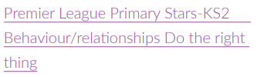  Premier League Primary Stars | Resources (plprimarystars.com)  Anti-bullying Week resources for academic year.  Anti-Bullying Alliance | United against bullying  International Day of Tolerance | Whole School Anti-Bullying event  Themed linked assemblies  BV: Mutual respect and tolerance  EA/D  Enquiry Lessons
Belonging to a community  Valuing diversity; challenging discrimination and stereotypes | L8. about diversity: what it means; the benefits of living in a diverse community; about valuing diversity within communities  L9. about stereotypes; how they can negatively influence behaviours and attitudes  towards others; strategies for challenging stereotypes  L10. about prejudice; how to recognise behaviours/actions which discriminate against others; ways of responding to it if witnessed or experienced  R21. about discrimination: what it means and how to challenge it | •what prejudice means  •to differentiate between prejudice and discrimination  •how to recognise acts of discrimination  •strategies to safely respond to and challenge discrimination  •how to recognise stereotypes in different contexts and the influence they have on attitudes and understanding of different groups  •how stereotypes are perpetuated and how to challenge this | 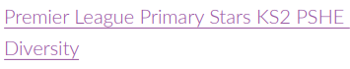  Premier League Primary Stars | Resources (plprimarystars.com)  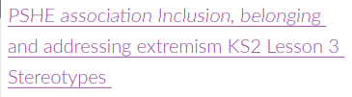  Resources on One Drive  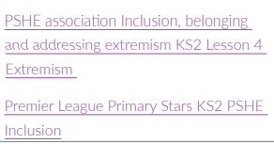  Premier League Primary Stars | Resources (plprimarystars.com)  PSHE KS2: L8R Youngers 1 - BBC Teach  https://www.amnesty.org.uk/education-resources-childrens-human-rights | RS lessons  BV: Rule of Law  BV: Democracy  BV: Individual Liberty  EA/D  PE lessons – See PE LTP  Enrichment Menu Choices
Media literacy and Digital resilience  Evaluating media sources; sharing things online | H37. reasons for following and complying with regulations and restrictions (including age restrictions); how they promote personal safety and wellbeing with reference to social media, television programmes, films, games and online gaming  L11. recognise ways in which the internet and social media can be used both positively and negatively  L13. about some of the different ways information and data is shared and used online, including for commercial purposes  L15. recognise things appropriate to share and things that should not be shared on social media; rules surrounding distribution of images  L16. about how text and images in the media and on social media can be manipulated or invented; strategies to evaluate the reliability of sources and identify misinformation | •about the benefits of safe internet use e.g. learning, connecting and communicating  •how and why images online might be manipulated, altered, or faked  •how to recognise when images might have been altered  •why people choose to communicate through social media and some of the risks and challenges of doing so  •that social media sites have age restrictions and regulations for use  •the reasons why some media and online content is not appropriate for children  •how online content can be designed to manipulate people’s emotions and encourage them to read or share things  •about sharing things online, including rules and laws relating to this  •how to recognise what is appropriate to share online  •how to report inappropriate online content or contact | Review of Trythall School Acceptable Use Policies  Home - Safer Internet Day  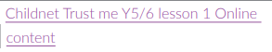  Trust Me - Childnet  Order expert teaching resources | Parent Zone  Be Internet Legends - Toolkit (beinternetawesome.withgoogle.com)  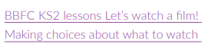  Key Stage 2 PSHE Resource | CBBFC  Resources on One Drive | Whole School Safer Internet Day Event  Themed linked assemblies  Computing lessons
Money and Work  Influences and attitudes to money; money and financial risks | L18. to recognise that people have different attitudes towards saving and spending money; what influences people’s decisions; what makes something ‘good  value for money’  L22. about risks associated with money (e.g. money can be won, lost or stolen) and ways of keeping money safe  L23. about the risks involved in gambling; different ways money can be won or lost through gambling-related activities and their impact on health, wellbeing and future aspirations  L24. to identify the ways that money can impact on people’s feelings and emotions | •about the role that money plays in people’s lives, attitudes towards it and what influences decisions about money  •about value for money and how to judge if something is value for money  •how companies encourage customers to buy things and why it is important to be acritical consumer  •how having or not having money can impact on a person’s emotions, health and wellbeing  •about common risks associated with money, including debt, fraud and gambling  •how money can be gained or lost e.g. stolen, through scams or gambling and how these put people at financial risk  •how to get help if they are concerned about gambling or other financial risks | Science Week  International Women’s Day  Study of Female Scientist  Female STEAM career visitor?  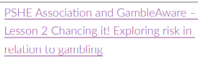  Resources on One Drive  Homepage | Values, Money & Me (valuesmoneyandme.co.uk)  Money Teaching Resources for Kids | 8-12 years | MoneySense (mymoneysense.com) | BV: Mutual respect and tolerance
Physical health and Mental wellbeing  What affects mental health and ways to  take care of it; managing change, loss  and bereavement; managing time online | H13. about the benefits of the internet; the importance of balancing time online with other activities; strategies for managing time online  H14. how and when to seek support, including which adults to speak to in and outside school, if they are worried about their health  H15. that mental health, just like physical health, is part of daily life; the importance of taking care of mental health  H20. strategies to respond to feelings, including intense or conflicting feelings; how to manage and respond to feelings appropriately and proportionately in different situations  H21. to recognise warning signs about mental health and wellbeing and how to seek support for themselves and others  H22. to recognise that anyone can experience mental ill health; that most difficulties can be resolved with help and support; and that it is important to discuss feelings with a trusted adult  H23. about change and loss, including death, and how these can affect feelings; ways of expressing and managing grief and bereavement  H24. problem-solving strategies for dealing with emotions, challenges and change, including the transition to new schools | •that mental health is just as important as physical health and that both need looking after  •to recognise that anyone can be affected by mental ill-health and that difficulties can be resolved with help and support  •how negative experiences such as being bullied or feeling lonely can affect mental wellbeing  •positive strategies for managing feelings  •that there are situations when someone may experience mixed or conflicting feelings  •how feelings can often be helpful, whilst recognising that they sometimes need to be overcome  •to recognise that if someone experiences feelings that are not so good (most or all of the time) – help and support is available  •identify where they and others can ask for help and support with mental wellbeing in and outside school  •the importance of asking for support from a trusted adult  •about the changes that may occur in life including death, and how these can cause conflicting feelings  •that changes can mean people experience feelings of loss or grief  •about the process of grieving and how grief can be expressed  •about strategies that can help someone cope with the feelings associated with change or loss  •to identify how to ask for help and support with loss, grief or other aspects of change  •how balancing time online with other activities helps to maintain their health and wellbeing  •strategies to manage time spent online and foster positive habits e.g. switching phone off at night  •what to do and whom to tell if they are frightened or worried about something they have seen online | May = Mental Health Awareness Month. See annual theme  Child Safety Week – 7th to 13th June  Child Safety Week | Child Accident Prevention Trust (capt.org.uk)  BE AWARE OF ANY BEREAVEMENTS IN THE COHORT BEFORE PLANNING AND TEACHING  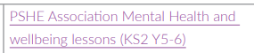  Resources on One Drive  Mental wellbeing | Overview | PHE School Zone  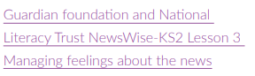  Newswise Unit Of Work | The Guardian  Free PSHE lessons on loss and bereavement | Winston's Wish (winstonswish.org)  Primary : Mentally Healthy Schools  Mentally Healthy Schools teaching resources | Tes | PE lessons  Enquiry Lessons  Enrichment Menu Choices
Growing and changing  Changes and challenges; puberty; increasing independence; managing  transitions | H24. problem-solving strategies for dealing with emotions, challenges and change, including the transition to new schools that increasing independence  H35. about the new opportunities and responsibilities may bring  H36. strategies to manage transitions between classes and key stages | •to recognise some of the changes as they grow up e.g. increasing independence  •about what being more independent might be like, including how it may feel  •about the transition to secondary school and how this may affect their feelings  •about how relationships may change as they grow up or move to secondary school/enter the Senior Prep  •practical strategies that can help to manage times of change and transition e.g. practising the bus route to secondary school  •what sexual intercourse is, and how it can be one part of an intimate relationship between consenting adults | 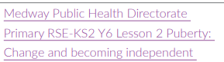  Resources on One Drive  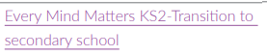  Mental wellbeing | Overview | PHE School Zone | BV: Individual Liberty  BV: Mutual respect and tolerance  Science lessons  PE lessons
Keeping safe  Keeping personal information safe; regulations and choices; drug use and the law; drug use and the media | H37. reasons for following and complying with regulations and restrictions (including age restrictions); how they promote personal safety and wellbeing with reference to social media, television programmes, films, games and online gaming  H42. about the importance of keeping personal information private; strategies for keeping safe online, including how to manage requests for personal information or images of themselves and others; what to do if frightened or worried by something seen or read online and how to report concerns, inappropriate content and contact  H46. about the risks and effects of legal drugs common to everyday life (e.g. cigarettes, e-cigarettes/vaping, alcohol and medicines) and their impact on health; recognise that drug use can become a habit which can be difficult to break  H47. to recognise that there are laws surrounding the use of legal drugs and that some drugs are illegal to own, use and give to others  H48. about why people choose to use or not use drugs (including nicotine, alcohol and medicines);  H49. about the mixed messages in the media about drugs, including alcohol and smoking/vaping  H50. about the organisations that can support people concerning alcohol, tobacco and nicotine or other drug use; people they can talk to if they have concerns | •how to protect personal information online  •to identify potential risks of personal information being misused  •strategies for dealing with requests for personal information or images of themselves  •to identify types of images that are appropriate to share with others and those which might not be appropriate  •that images or text can be quickly shared with others, even when only sent to one person, and what the impact of this might be  •what to do if they take, share or come across an image which may upset, hurt or embarrass them or others  •how to report the misuse of personal information or sharing of upsetting content/images online  •about the different age rating systems for social media, T.V, films, games and online gaming  •why age restrictions are important and how they help people make safe decisions about what to watch, use or play  •about the risks and effects of different drugs  •about the laws relating to drugs common to everyday life and illegal drugs  •to recognise why people choose to use or not use drugs, including nicotine, alcohol and medicines as well as illegal drugs  •about the organisations where people can get help and support concerning drug use  •how to ask for help if they have concerns about drug use  •about mixed messages in the media relating to drug use and how they might influence opinions and decisions | Child Safety Week – 7th to 13th June  Child Safety Week | Child Accident Prevention Trust (capt.org.uk)  Visiting speaker: Emergency Services?  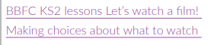  Key Stage 2 PSHE Resource | CBBFC  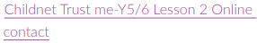  Trust Me - Childnet  Order expert teaching resources | Parent Zone  Be Internet Legends - Toolkit (beinternetawesome.withgoogle.com)  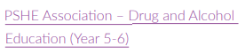  Resources on One Drive  Resources on One Drive  Beach Safety (Added for location of school)  Youth Education - Helping You Teach Children Water Safety (rnli.org)  PSHE KS2: L8R Youngers 1 - BBC Teach  Pupil Consultation & Review | Computing lessons  PE lessons  BV: Rule of Law

NATIONAL CURRICULUM EXPECTATIONS
Subject/Area of Learning: Relationships & Sex Education
By the end of Primary School:
Strand/Area | Pupils should know
Families and people who care for me | • that families are important for children growing up because they can give love, security and stability.  • the characteristics of healthy family life, commitment to each other, including in times of difficulty, protection and care for children and other family members, the importance of spending time together and sharing each other’s lives.  • that others’ families, either in school or in the wider world, sometimes look different from their family, but that they should respect those differences and know that other children’s families are also characterised by love and care.  • that stable, caring relationships, which may be of different types, are at the heart of happy families, and are important for children’s security as they grow up.  • that marriage represents a formal and legally recognised commitment of two people to each other which is intended to be lifelong.  • how to recognise if family relationships are making them feel unhappy or unsafe, and how to seek help or advice from others if needed.
Caring friendships | • how important friendships are in making us feel happy and secure, and how people choose and make friends.  • the characteristics of friendships, including mutual respect, truthfulness, trustworthiness, loyalty, kindness, generosity, trust, sharing interests and experiences and support with problems and difficulties.  • that healthy friendships are positive and welcoming towards others, and do not make others feel lonely or excluded.  • that most friendships have ups and downs, and that these can often be worked through so that the friendship is repaired or even strengthened, and that resorting to violence is never right.  • how to recognise who to trust and who not to trust, how to judge when a friendship is making them feel unhappy or uncomfortable, managing conflict, how to manage these situations and how to seek help or advice from others, if needed.
Respectful relationships | • the importance of respecting others, even when they are very different from them (for example, physically, in character, personality or backgrounds), or make different choices or have different preferences or beliefs.  • practical steps they can take in a range of different contexts to improve or support respectful relationships.  • the conventions of courtesy and manners.  • the importance of self-respect and how this links to their own happiness.  • that in school and in wider society they can expect to be treated with respect by others, and that in turn they should show due  respect to others, including those in positions of authority.  about different types of bullying (including cyberbullying), the impact of bullying, responsibilities of bystanders (primarily  reporting bullying to an adult) and how to get help.  • what a stereotype is, and how stereotypes can be unfair, negative or destructive.  • the importance of permission-seeking and giving in relationships with friends, peers and adults.
Online relationships | • that people sometimes behave differently online, including by pretending to be someone they are not.  • that the same principles apply to online relationships as to face-toface relationships, including the importance of respect for others online including when we are anonymous.  • the rules and principles for keeping safe online, how to recognise risks, harmful content and contact, and how to report them.  • how to critically consider their online friendships and sources of information including awareness of the risks associated with people they have never met.  • how information and data is shared and used online.
Being safe | what sorts of boundaries are appropriate in friendships with peers and others (including in a digital context).  • about the concept of privacy and the implications of it for both children and adults; including that it is not always right to keep  secrets if they relate to being safe.  • that each person’s body belongs to them, and the differences between appropriate and inappropriate or unsafe physical, and other, contact.  • how to respond safely and appropriately to adults they may encounter (in all contexts, including online) whom they do not know.  • how to recognise and report feelings of being unsafe or feeling bad about any adult.  • how to ask for advice or help for themselves or others, and to keep trying until they are heard.  • how to report concerns or abuse, and the vocabulary and confidence needed to do so.  • where to get advice e.g. family, school and/or other sources.

Mental Wellbeing | • that mental wellbeing is a normal part of daily life, in the same way as physical health.  • that there is a normal range of emotions (e.g. happiness, sadness, anger, fear, surprise, nervousness) and scale of emotions that all humans experience in relation to different experiences and situations.  • how to recognise and talk about their emotions, including having a varied vocabulary of words to use when talking about their own and others’ feelings.  • how to judge whether what they are feeling and how they are behaving is appropriate and proportionate.  • the benefits of physical exercise, time outdoors, community participation, voluntary and service-based activity on mental wellbeing and happiness.  • simple self-care techniques, including the importance of rest, time spent with friends and family and the benefits of hobbies and interests.  • isolation and loneliness can affect children and that it is very important for children to discuss their feelings with an adult and seek support.  • that bullying (including cyberbullying) has a negative and often lasting impact on mental wellbeing.  • where and how to seek support (including recognising the triggers for seeking support), including whom in school they should speak to if they are worried about their own or someone else’s mental wellbeing or ability to control their emotions (including issues arising  online).  • it is common for people to experience mental ill health. For many people who do, the problems can be resolved if the right support is made available, especially if accessed early enough.
Internet Safety and Harms | • that for most people the internet is an integral part of life and has many benefits.  • about the benefits of rationing time spent online, the risks of excessive time spent on electronic devices and the impact of positive and negative content online on their own and others’ mental and physical wellbeing.  • how to consider the effect of their online actions on others and know how to recognise and display respectful behaviour online and the importance of keeping personal information private.  • why social media, some computer games and online gaming, for example, are age restricted.  • that the internet can also be a negative place where online abuse, trolling, bullying and harassment can take place, which can have a negative impact on mental health.  • how to be a discerning consumer of information online including understanding that information, including that from search engines, is ranked, selected and targeted.  • where and how to report concerns and get support with issues online.
Physical health and fitness | • the characteristics and mental and physical benefits of an active lifestyle.  • the importance of building regular exercise into daily and weekly routines and how to achieve this; for example walking or cycling to school, a daily active mile or other forms of regular, vigorous exercise.  • the risks associated with an inactive lifestyle (including obesity).  • how and when to seek support including which adults to speak to in school if they are worried about their health.
Healthy Eating | • what constitutes a healthy diet (including understanding calories and other nutritional content).  • the principles of planning and preparing a range of healthy meals.  • the characteristics of a poor diet and risks associated with unhealthy eating (including, for example, obesity and tooth decay) and other behaviours (e.g. the impact of alcohol on diet or health).
Drugs, Alcohol & Tobacco | the facts about legal and illegal harmful substances and associated risks, including smoking, alcohol use and drug-taking
Health & Prevention | • how to recognise early signs of physical illness, such as weight loss,  or unexplained changes to the body.  • about safe and unsafe exposure to the sun, and how to reduce the risk of sun damage, including skin cancer.  • the importance of sufficient good quality sleep for good health and that a lack of sleep can affect weight, mood and ability to learn.  • about dental health and the benefits of good oral hygiene and dental flossing, including regular check-ups at the dentist.  • about personal hygiene and germs including bacteria, viruses, how they are spread and treated, and the importance of handwashing.  • the facts and science relating to allergies, immunisation and vaccination.
Basic First Aid | how to make a clear and efficient call to emergency services if necessary.  • concepts of basic first-aid, for example dealing with common injuries, including head injuries.
Changing Adolescent Body | • key facts about puberty and the changing adolescent body, particularly from age 9 through to age 11, including physical and emotional changes.  • about menstrual wellbeing including the key facts about the menstrual cycle.

DfE RSE, HEALTH & NATIONAL CURRICULUM SCIENCE INFORMATION/OVERVIEW

Year | Statutory Science  Animals, including humans/Living things and their habitats | Planned Statutory Health | Planned Statutory Relationships content | Planned Sex Education content
1 | identify, name, draw and label the basic parts of the human body and say which part of the body is associated with each sense | H1. about what keeping healthy means; different ways to keep healthy; H2. about foods that support good health and the risks of eating too much sugar; H3. about how physical activity helps us to stay healthy; and ways to be physically active everyday; H5. simple hygiene routines that can stop germs from spreading; H8. how to keep safe in the sun and protect skin from sun damage; H9. about different ways to learn and play; recognising the importance of knowing when to take a break from time online or TV; H10. about the people who help us to stay physically healthy  H11. about different feelings that humans can experience; H12. how to recognise and name different feelings; H13. how feelings can affect people’s bodies and how they behave; H14. how to recognise what others might be feeling; H15. to recognise that not everyone feels the same at the same time, or feels the same about the same things; H21. to recognise what makes them special ; H22. to recognise the ways in which we are all unique; H23. to identify what they are good at, what they like and dislike ; H24. how to manage when finding things difficult  H28. about rules and age restrictions that keep us safe; H34. basic rules to keep safe online, including what is meant by personal information and what should be kept private; the importance of telling a trusted adult if they come across something that scares them | R1. about the roles different people (e.g. acquaintances, friends and relatives) play in our lives; 2. to identify the people who love and care for them and what they do to help them feel cared for; R3. about different types of families including those that may be different to their own; R4. to identify common features of family life ; R5. that it is important to tell someone (such as their teacher) if something about their family makes them unhappy or worried  R10. that bodies and feelings can be hurt by words and actions; that people can say hurtful things online.; R13. to recognise that some things are private and the importance of respecting privacy; that parts of their body covered by underwear are private.; R15. how to respond safely to adults they don’t know; R16. about how to respond if physical contact makes them feel uncomfortable or unsafe; R17. about knowing there are situations when they should ask for permission and also when their permission should be sought  R21. about what is kind and unkind behaviour, and how this can affect others ; R22. about how to treat themselves and others with respect; how to be polite and courteous | n/a
2 | notice that animals, including humans, have offspring which grow into adults  The focus at this stage should be on questions that help pupils to recognise growth; they should not be expected to understand how reproduction occurs.  The following examples might be used: egg, chick, chicken; egg, caterpillar, pupa, butterfly; spawn, tadpole, frog; lamb, sheep. Growing into adults can include reference to baby, toddler, child, teenager, adult. | H4. about why sleep is important and different ways to rest and relax; H6. that medicines (including vaccinations and immunisations and those that support allergic reactions) can help people to stay healthy; H7. about dental care and visiting the dentist; how to brush teeth correctly; food and drink that support dental health; H16. about ways of sharing feelings; a range of words to describe feelings; H17. about things that help people feel good (e.g. playing outside, doing things they enjoy, spending time with family, getting enough sleep); H18. different things they can do to manage big feelings, to help calm themselves down and/or change their mood when they don’t feel good ; H19. to recognise when they need help with feelings; that it is important to ask for help with feelings; and how to ask for it; H20. about change and loss (including death); to identify feelings associated with this; to recognise what helps people to feel better  H20. about change and loss (including death); to identify feelings associated with this; to recognise what helps people to feel better; H25. to name the main parts of the body including external genitalia (e.g. vulva, vagina, penis, testicles); H26. about growing and changing from young to old and how people’s needs change; H27. about preparing to move to a new class/year group  H29. to recognise risk in simple everyday situations and what action to take to minimise harm; H30. about how to keep safe at home (including around electrical appliances) and fire safety (e.g. not playing with matches and lighters); 31. that household products (including medicines) can be harmful if not used correctly; H32. ways to keep safe in familiar and unfamiliar environments (e.g. beach, shopping centre, park, swimming pool, on the street) and how to cross the road safely; H33. about the people whose job it is to help keep us safe; H35. about what to do if there is an accident and someone is hurt  H36. how to get help in an emergency (how to dial 999 and what to say); H37. about things that people can put into their body or on their skin; how these can affect how people feel | R6. about how people make friends and what makes a good friendship; R7. about how to recognise when they or someone else feels lonely and what to do  R8. simple strategies to resolve arguments between friends positively; R9. how to ask for help if a friendship is making them feel unhappy; R24. how to listen to other people and play and work cooperatively  R11. about how people may feel if they experience hurtful behaviour or bullying; R12. that hurtful behaviour (offline and online) including teasing, name-calling, bullying and deliberately excluding others is not acceptable; how to report bullying; the importance of telling a trusted adult; R14. that sometimes people may behave differently online, including by pretending to be someone they are not; R18. about the importance of not keeping adults’ secrets (only happy surprises that others will find out about eventually)  R19. basic techniques for resisting pressure to do something they don’t want to do and which may make them unsafe ; R20. what to do if they feel unsafe or worried for themselves or others; who to ask for help and vocabulary to use when asking for help; importance of keeping trying until they are heard  R23. to recognise the ways in which they are the same and different to others; R24. how to listen to other people and play and work cooperatively; R25. how to talk about and share their opinions on things that matter to them | n/a
3 |  | H1. about what keeping healthy means; different ways to keep healthy; 2. about foods that support good health and the risks of eating too much sugar; H3. about how physical activity helps us to stay healthy; and ways to be physically active everyday; H4. about why sleep is important and different ways to rest and relax ; H6. that medicines (including vaccinations and immunisations and those that support allergic reactions) can help people to stay healthy;  H7. about dental care and visiting the dentist; how to brush teeth correctly; food and drink that support dental health  H27. to recognise their individuality and personal qualities; H28. to identify personal strengths, skills, achievements and interests and how these contribute to a sense of self-worth; H29. about how to manage setbacks/perceived failures, including how to re-frame unhelpful thinking  H38. how to predict, assess and manage risk in different situations; H39. about hazards (including fire risks) that may cause harm, injury or risk in the home and what they can do reduce risks and keep safe; H41. strategies for keeping safe in the local environment or unfamiliar places (rail, water, road) and firework safety; safe use of digital devices when out and about | R1. to recognise that there are different types of relationships (e.g. friendships, family relationships, romantic relationships, online relationships); R6. that a feature of positive family life is caring relationships; about the different ways in which people care for one another; R7. to recognise and respect that there are different types of family structure (including single parents, same-sex parents, step-parents, blended families, foster parents); that families of all types can give family members love, security and stability; R8. to recognise other shared characteristics of healthy family life, including commitment, care, spending time together; being there for each other in times of difficulty; R9. how to recognise if family relationships are making them feel unhappy or unsafe, and how to seek help or advice  R19. about the impact of bullying, including offline and online, and the consequences of hurtful behaviour  R22. about privacy and personal boundaries; what is appropriate in friendships and wider relationships (including online); R24. how to respond safely and appropriately to adults they may encounter (in all contexts including online) whom they do not know  R30. that personal behaviour can affect other people; to recognise and model respectful behaviour online  R30. that personal behaviour can affect other people; to recognise and model respectful behaviour online  R31. to recognise the importance of self-respect and how this can affect their thoughts and feelings about themselves; that everyone, including them, should expect to be treated politely and with respect by others (including when online and/or anonymous) in school and in wider society; strategies to improve or support courteous, respectful relationship | n/a
4 |  | H2. about the elements of a balanced, healthy lifestyle; H5. about what good physical health means; how to recognise early signs of physical illness; H11. how to maintain good oral hygiene (including correct brushing and flossing); why regular visits to the dentist are essential; the impact of lifestyle choices on dental care (e.g. sugar consumption/acidic drinks such as fruit juices, smoothies and fruit teas; the effects of smoking)  H6. about what constitutes a healthy diet; how to plan healthy meals; benefits to health and wellbeing of eating nutritionally rich foods; risks associated with not eating a healthy diet including obesity and tooth decay.; H25. about personal identity; what contributes to who we are (e.g. ethnicity, family, gender, faith, culture, hobbies, likes/dislikes); H26. that for some people gender identity does not correspond with their biological sex; H27. to recognise their individuality and personal qualities  H10. how medicines, when used responsibly, contribute to health; that some diseases can be prevented by vaccinations and immunisations; how allergies can be managed; H38. how to predict, assess and manage risk in different situations ;H40. about the importance of taking medicines correctly and using household products safely, (e.g. following instructions carefully); H46. about the risks and effects of legal drugs common to everyday life (e.g. cigarettes, e-cigarettes/vaping, alcohol and medicines) and their impact on health; recognise that drug use can become a habit which can be difficult to break | R10. about the importance of friendships; strategies for building positive friendships; how positive friendships support wellbeing; R11. what constitutes a positive healthy friendship (e.g. mutual respect, trust,  truthfulness, loyalty, kindness, generosity, sharing interests and experiences, support with problems and difficulties); that the same principles apply to online friendships as to face-to-face relationships; R12. to recognise what it means to ‘know someone online’ and how this differs from knowing someone face-to-face; risks of communicating online with others not known face-to-face; R13. the importance of seeking support if feeling lonely or excluded; R18. to recognise if a friendship (online or offline) is making them feel unsafe or uncomfortable; how to manage this and ask for support if necessary  R20. strategies to respond to hurtful behaviour experienced or witnessed, offline and online (including teasing, name-calling, bullying, trolling, harassment or the deliberate excluding of others); how to report concerns and get support; R23. about why someone may behave differently online, including pretending to be someone they are not; strategies for recognising risks, harmful content and contact; how to report concerns; R27. about keeping something confidential or secret, when this should (e.g. a birthday surprise that others will find out about) or should not be agreed to, and when it is right to break a confidence or share a secret; R28. how to recognise pressure from others to do something unsafe or that makes them feel uncomfortable and strategies for managing this  R32. about respecting the differences and similarities between people and recognising what they have in common with others e.g. physically, in personality or background ; R33. to listen and respond respectfully to a wide range of people, including those whose traditions, beliefs and lifestyle are different to their own | n/a
5 | describe the life process of reproduction in some plants and animals.  Pupils should find out about different types of reproduction, including sexual and asexual reproduction in plants, and sexual reproduction in animals.  describe the changes as humans develop to old age.  Pupils should draw a timeline to indicate stages in the growth and development of humans. They should learn about the changes experienced in puberty. Pupils could work scientifically by researching the gestation periods of other animals and comparing them with humans; by finding out and recording the length and mass of a baby as it grows. | H8. about how sleep contributes to a healthy lifestyle; routines that support good quality sleep; the effects of lack of sleep on the body, feelings, behaviour and ability to learn; H9. that bacteria and viruses can affect health; how everyday hygiene routines can limit the spread of infection; the wider importance of personal hygiene and how to maintain it; H10. how medicines, when used responsibly, contribute to health; that some diseases can be prevented by vaccinations and immunisations; how allergies can be managed  H12. about the benefits of sun exposure and risks of overexposure; how to keep safe from sun damage and sun/heat stroke and reduce the risk of skin cancer  H30. to identify the external genitalia and internal reproductive organs in males and females and how the process of puberty relates to human reproduction; H31. about the physical and emotional changes that happen when approaching and during puberty (including menstruation, key facts about the menstrual cycle  and menstrual wellbeing, erections and wet dreams); H32. about how hygiene routines change during the time of puberty, the importance of keeping clean and how to maintain personal hygiene; H34. about where to get more information, help and advice about growing and changing, especially about puberty  H38. how to predict, assess and manage risk in different situations; H43. about what is meant by first aid; basic techniques for dealing with common injuries²; H44. how to respond and react in an emergency situation; how to identify situations that may require the emergency services; know how to contact them and what to say; | R14. that healthy friendships make people feel included; recognise when others; may feel lonely or excluded; strategies for how to include them;  R15. strategies for recognising and managing peer influence and a desire for peer approval in friendships; to recognise the effect of online actions on others; R16. how friendships can change over time, about making new friends and the benefits of having different types of friends; R17. that friendships have ups and downs; strategies to resolve disputes and reconcile differences positively and safely; R18. to recognise if a friendship (online or offline) is making them feel unsafe or uncomfortable; how to manage this and ask for support if necessary; R26. about seeking and giving permission (consent) in different situations  R9. how to recognise if family relationships are making them feel unhappy or unsafe, and how to seek help or advice; R25. recognise different types of physical contact; what is acceptable and unacceptable; strategies to respond to unwanted physical contact  R26. about seeking and giving permission (consent) in different situations; R27. about keeping something confidential or secret, when this should (e.g. a birthday surprise that others will find out about) or should not be agreed to, and when it is right to break a confidence or share a secret; R29. where to get advice and report concerns if worried about their own or someone else’s personal safety (including online)  R20. strategies to respond to hurtful behaviour experienced or witnessed, offline and online (including teasing, name-calling, bullying, trolling, harassment or the deliberate excluding of others); how to report concerns and get support; R21. about discrimination: what it means and how to challenge it  R31. to recognise the importance of self-respect and how this can affect their thoughts and feelings about themselves; that everyone, including them, should expect to be treated politely and with respect by others (including when online and/or anonymous) in school and in wider society; strategies to improve or support courteous, respectful relationships | n/a
6 | recognise that living things produce offspring of the same kind, but normally offspring vary and are not identical to their parents | H13. about the benefits of the internet; the importance of balancing time online with other activities; strategies for managing time online; H14. how and when to seek support, including which adults to speak to in and outside school, if they are worried about their health; H15. that mental health, just like physical health, is part of daily life; the importance of taking care of mental health; H20. strategies to respond to feelings, including intense or conflicting feelings; how to manage and respond to feelings appropriately and proportionately in different situations  H21. to recognise warning signs about mental health and wellbeing and how to seek support for themselves and others; H22. to recognise that anyone can experience mental ill health; that most difficulties can be resolved with help and support; and that it is important to discuss feelings with a trusted adult H23. about change and loss, including death, and how these can affect feelings; ways of expressing and managing grief and bereavement; H24. problem-solving strategies for dealing with emotions, challenges and change, including the transition to new schools  H24. problem-solving strategies for dealing with emotions, challenges and change, including the transition to new schools; H35. about the new opportunities and responsibilities that increasing independence may bring; H36. strategies to manage transitions between classes and key stages;  H37. reasons for following and complying with regulations and restrictions (including age restrictions); how they promote personal safety and wellbeing with reference to social media, television programmes, films, games and online gaming; H42. about the importance of keeping personal information private; strategies for keeping safe online, including how to manage requests for personal information or images of themselves and others; what to do if frightened or worried by something seen or read online and how to report concerns, inappropriate content and contact; H46. about the ; risks and effects of legal drugs common to everyday life (e.g. cigarettes, e-cigarettes/vaping, alcohol and medicines) and their impact on health; recognise that drug use can become a habit which can be difficult to break; H47. to recognise that there are laws surrounding the use of legal drugs and that some drugs are illegal to own, use and give to others; H48. about why people choose to use or not use drugs (including nicotine, alcohol and medicines); H49. about the mixed messages in the media about drugs, including alcohol and smoking/vaping; H50. about the organisations that can support people concerning alcohol, tobacco and nicotine or other drug use; people they can talk to if they have concerns | R1. to recognise that there are different types of relationships (e.g. friendships, family relationships, romantic relationships, online relationships); R2. that people may be attracted to someone emotionally, romantically and sexually; that people may be attracted to someone of the same sex or different sex to them; that gender identity and sexual orientation are different; R3. about marriage and civil partnership as a legal declaration of commitment made by two adults who love and care for each other, which is intended to be lifelong; R4. that forcing anyone to marry against their will is a crime; that help and support is available to people who are worried about this for themselves or others; R5. that people who love and care for each other can be in a committed relationship (e.g. marriage), living together, but may also live apart; R7. to recognise and respect that there are different types of family structure (including single parents, same-sex parents, step-parents, blended families, foster parents); that families of all types can give family members love, security and stability  R26. about seeking and giving permission (consent) in different situations; R28. how to recognise pressure from others to do something unsafe or that makes them feel uncomfortable and strategies for managing this ; R29. where to get advice and report concerns if worried about their own or someone else’s personal safety (including online)  R30. that personal behaviour can affect other people; to recognise and model respectful behaviour online  R34. how to discuss and debate topical issues, respect other people’s point of view and constructively challenge those they disagree with | H33. about the processes of reproduction and birth as part of the human life cycle; how babies are conceived and born; how babies need to be cared for¹ (Pupils are often aware that sexual intercourse does not always result in a baby and they may already be aware of or have heard about some common methods of contraception (e.g. condoms, the contraceptive pill or avoiding sexual intercourse.

TEACHER GUIDANCE TO ASSIST IN PLANNING HIGH QUALITY PSHE EDUCATION LESSONS
PSHE Association Guidance
This checklist is designed to support teachers both in planning ‘from scratch’ and in reviewing, amending, adapting or updating lesson plans. It may also be used as a tool to monitor or review the quality of PSHE lessons. By using this checklist teachers will ensure that lessons are well-structured, demonstrate progression and are inclusive of the needs of all pupils.
Does the lesson plan provide opportunities for the teacher to gauge pupils’ starting point (in terms of knowledge, skills, understanding, attitudes, values and beliefs)? Is there flexibility within the plan to adapt it as necessary once their starting point has been established?
Will the lesson connect with previous or future learning? Will the lesson fit in with the rest of the topic/theme/unit/medium term planning, etc?
Does the beginning of the lesson start with the establishment or re-visiting of ground rules for the group and have the pupils had the opportunity to contribute to them? Do pupils have access to a question box for them to submit questions they may have during or at the end of the lesson and which they may not like to ask in front of their peers?
Are the learning objectives clear and the intended learning outcomes explicit, to both the pupils and the teacher? Is the subject matter relevant, appropriate and meaningful to the pupils (matched to their personal, social and emotional needs)? Will they be able to see the point of what they are doing and the reasons for doing it?
• Learning objectives= what the lesson is intending to teach about/how to..
• Learning outcomes =what the pupils will leave the lesson knowing, understanding, being able to say or do
Is there a clear structure to the lesson (an obvious beginning, middle and ending)?
Are the lesson activities well-matched to the learning objectives? Will they help to achieve the intended outcome? For all pupils?
If images are used, has permission been obtained to use them? Has school/local authority/academy chain policy or publishers’ guidance been followed?
Are there opportunities for pupils’ progress to be assessed through the activities they are doing? Is assessment for learning an integral part of the lesson plan and are there opportunities for pupils to reflect on the learning and what it means in their lives? How will pupils and/or teacher evidence the progress made from the starting point?
Does the lesson include differentiation, including for learners with SEND? (Is this more than just being able to access the lesson content via modification of materials?) Is the learning outcome matched to their social, emotional and learning needs?
Does the lesson include differentiation for more able learners? (Is there sufficient challenge in their learning outcomes so that they remain engaged and can demonstrate that they have extended their learning?
Does the content of the lesson reflect and support the school’s ethos/aims?
Will pupils find the learning compelling and will both the teacher and pupils enjoy the lesson, whilst achieving the learning objectives?
Does it support pupils’ SMSC development? (Could it provide inspection evidence?

ASSESSMENT
Assessment is as central to effective teaching and learning in PSHE education as it is in any other subject. It is therefore important to understand the process of, and reasons for, assessing learning in PSHE.
Assessment refers to gauging what has been learned and what still needs to be learned. It therefore differs from evaluation, which is about the process: how well activities worked, how useful resources were, how interesting students found the lesson, and so on. Teachers have tended to find evaluation easier in PSHE education than assessment but both are central to an effective programme.
Learning in PSHE education should be assessed for several reasons:
• It is important for pupils to have opportunities to reflect on their learning, especially when that learning relates directly to the individual’s identity – their personal qualities, attitudes, skills, attributes, achievements and influences.
• It is important for teachers to feel confident that learning has taken place, to be able to demonstrate progress, and to identify future learning needs.
• Assessment increases pupils’ motivation and improves learning, as their increased awareness of their own progress and development illustrates the value of their learning.
• It allows the leadership team, parents, governors and school inspectors to see the impact PSHE education is having for pupils and for whole-school outcomes, such as Ofsted and ISI judgements on personal development, safeguarding, SMSC development and the promotion of fundamental British values. Without assessing PSHE education all you can do is describe provision; you cannot show its impact.
• The Department for Education (DfE) states in the statutory guidance for Relationships, Sex and Health education that “schools should have the same high expectations of the quality of pupils’ work in these subjects as for other curriculum areas”.
Personal attributes, so central to PSHE education, are arguably the hardest aspects of learning to assess. It is difficult for teachers to accurately assess a pupil’s self-confidence or sense of their own identity and values. However, pupils themselves will be able to judge, for instance, whether they feel more confident, or have a firmer sense of their own beliefs and opinions than they did before a particular series of lessons. Such personal reflection in PSHE education lessons is essential, so ensuring pupils have time and space within the lessons to reflect on this, either privately or through discussion, is a vital part of the assessment process. Assessing learning in PSHE education must therefore use a combination of teacher assessment and pupil self- and peer assessment.
It would be inappropriate for assessment in PSHE education to be about grades, or about passing or failing. The model of assessment that is most meaningful in PSHE education is ipsative assessment. Ipsative assessment compares where a pupil is at the end of a lesson or series of lessons against where they were before the lesson(s), in a similar way to an athlete measuring today’s performance against their own previous performance. So the benchmark against which progress is measured is the pupil’s own starting point, not the performance of others or the requirements of an exam syllabus. This gives us the following model for assessing any learning in PSHE education:
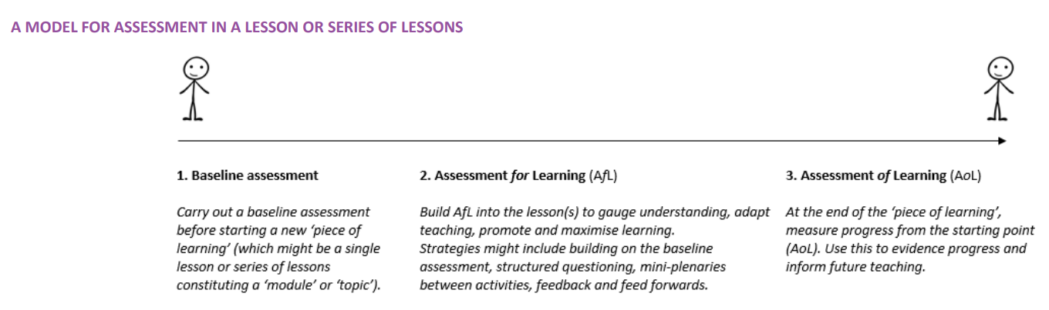
Baseline assessment PSHE education covers issues and areas of life which children and young people will be affected by in different ways and at different times. As such we cannot make any assumptions based on pupils’ age or year group about their existing knowledge, understanding, attributes, skills, strategies, beliefs and attitudes. So to assess learning and progress effectively, it is important to carry out a baseline assessment before teaching anything new. As pupils’ learning in topics such as healthy eating, online safety, relationships and so on will come from a number of sources, we can only see whether they have made progress in their learning if we have established the knowledge, understanding, attributes, skills, strategies, beliefs and attitudes they had before any new teaching took place.
The learning we wish to assess will relate to the pupils’ attributes and skills, as well as their knowledge and understanding related to the topic. Pupils’ existing knowledge and understanding is often the easiest learning to assess but whilst gauging pupils’ existing skills, strategies, attitudes, beliefs and attributes can never be an exact science, there are activities that provide an insight into their starting point.
Some examples of activities that lend themselves well to baseline assessment in PSHE education are outlined below. The elements of learning for which they are more or less useful will of course depend upon the exact nature of the activity and its context, so these are given for guidance only and are not definitive.
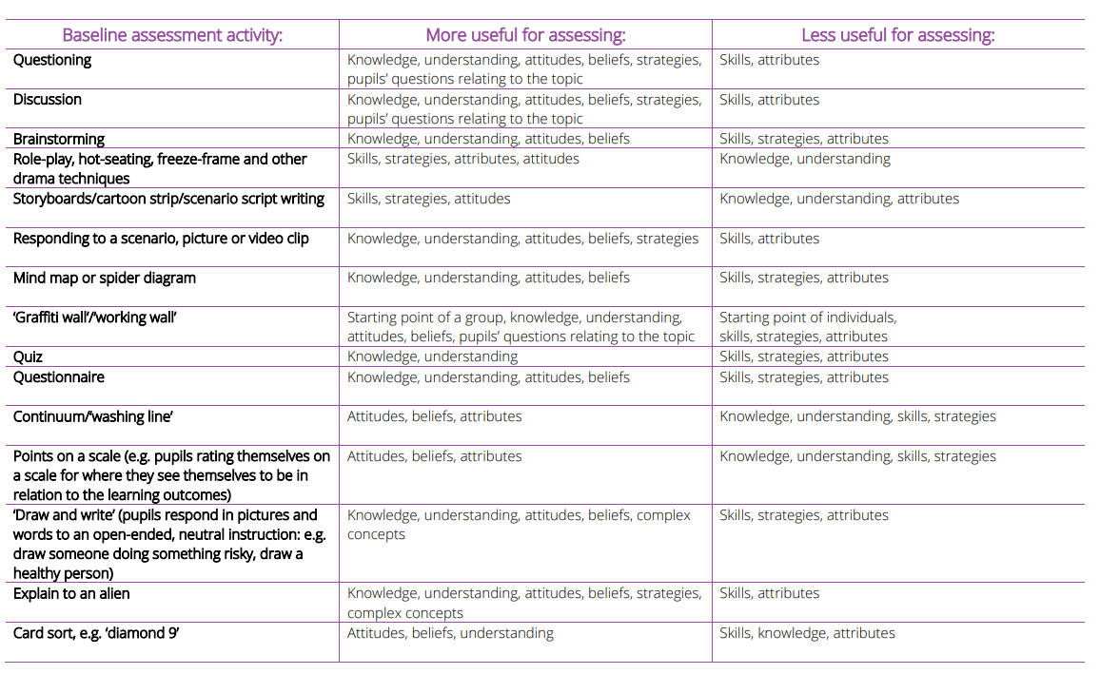

Assessing progress over the course of a lesson or series of lessons At the end of the lesson or series of lessons, pupils should have opportunities to demonstrate the progress they have made from their starting point assessed in the baseline activity. Possibly the simplest and most effective way of demonstrating progress is to either repeat, or better still, revisit the original baseline activity. Some baseline assessment activities (such as mind-maps, ‘draw and write’, ‘explain to an alien’), lend themselves very well to a simple revisit where each pupil uses a different colour to add to their baseline activity and make any changes they now want to make, allowing the pupil and teacher to clearly see how far they have come in their learning. In other cases, pupils might repeat the activity or carry out a completely different activity. Taking the examples of baseline activities above, the table below indicates possible ways of revisiting or using those activities to demonstrate progress at the end of the lesson or series of lessons. Again this is not a definitive list and activities should always be used flexibly to meet the needs of pupils and the learning objectives.
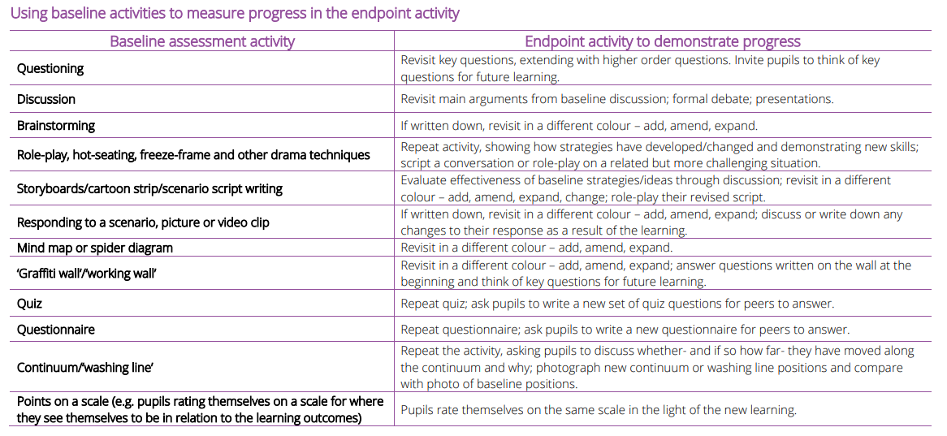
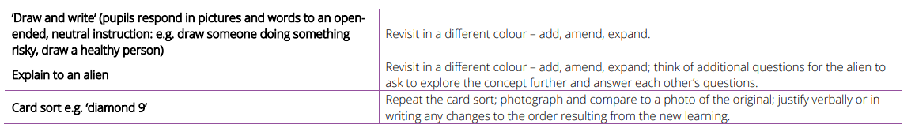
Additional ideas for endpoint activities to demonstrate learning:
• Presentations
• Producing resources and materials to teach younger pupils
• Leading a discussion or other learning activity with younger pupils
• Producing a blog or podcast
• Keeping a journal, diary or log of times when they have demonstrated a particular skill or attribute during the week All the activities above provide assessment evidence in their own right and where a baseline activity has been revisited it is usually very easy to demonstrate progress. However, you might also want to measure and record attainment more formally. If this is the case, you will need success criteria to measure the pupils’ work against. These might take the form of ‘I can…’ statements, or a set of descriptors for ‘working towards…/developing’, ‘working at.../attaining…’ or ‘working beyond…/exceeding’ the intended learning outcome. The terminology is less important than the process and will differ from school to school.
At Trythall School we use the PSHE Association generic I can statements to assess pupil attainment and progress. These are completed by teachers throughout the year and shared with the Head Teacher at the end of each term. They are stored in the cohort files.

PROGRESSION & KEY VOCABULARY
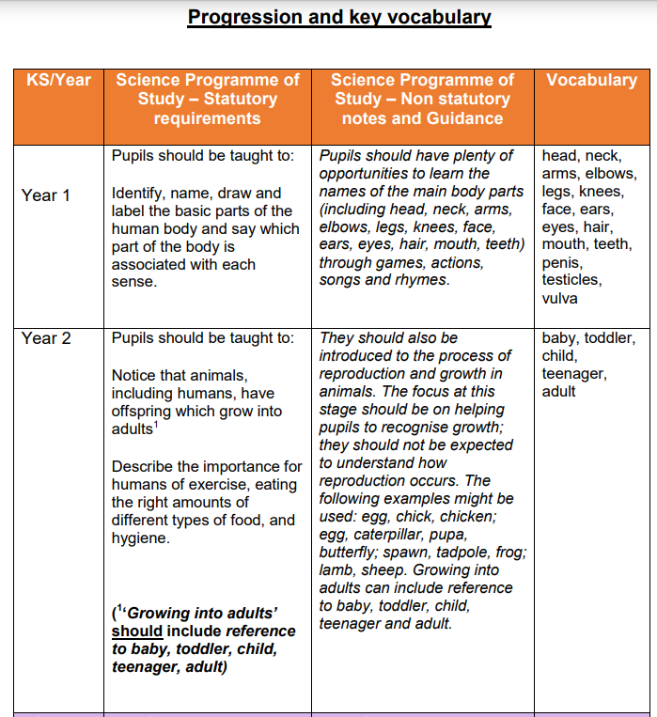
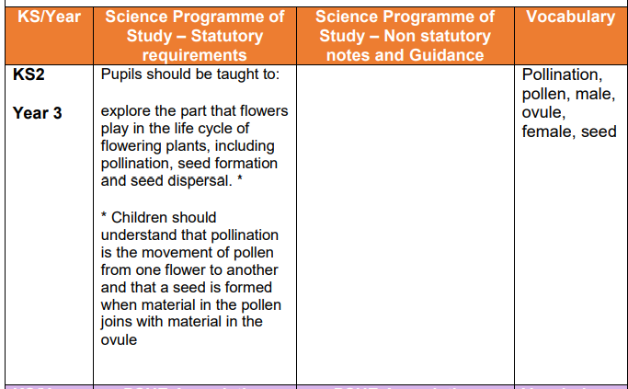
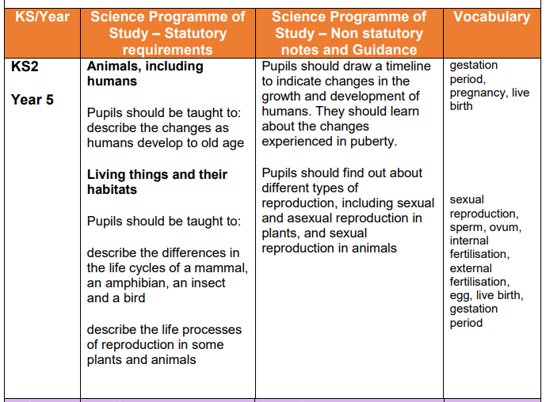
Taken from Joint Briefing and Policy Statement on Human Development and Reproduction in the Primary Curriculum, Association for Science Education & PSHE Association, March 2015

