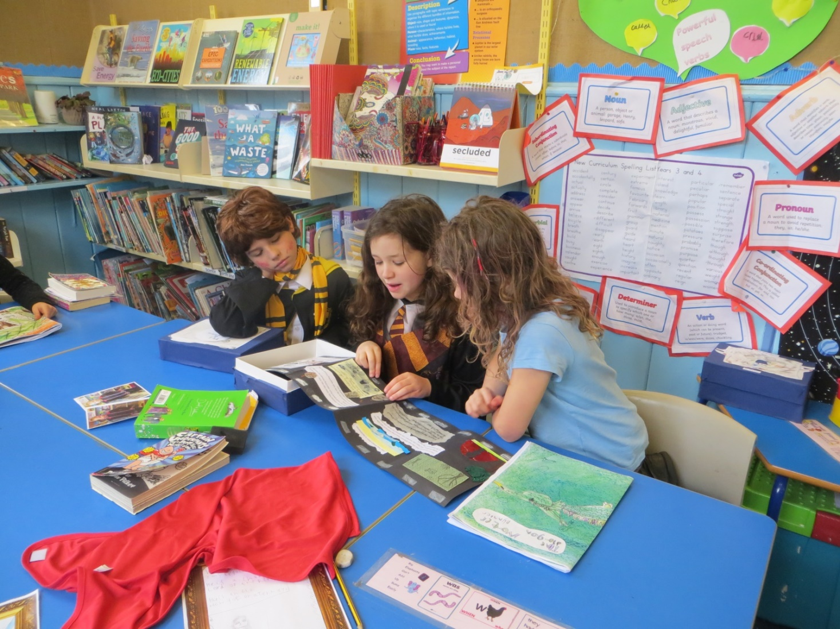

Magical moments as the children shared their books on World Book Day.

Dear Parents/Carers, 9th March 2020

World Book Day
The children had a lovely time on World Book Day last week. The costumes were lovely and every child has written a book which they have shared with the other children at school. I hope that they enjoyed sharing them with their families too when they brought them home. Thanks to all the teachers for their efforts and Emma, who leads literacy- it makes a difference to the children and their enthusiasm for reading and writing.

Swimming Galas
The children have worked really hard at their swimming and won a record number of medals at the Penwith Swimming Galas - well done everyone. Thank you to Rob for organising all of the teams and motivating the children.

New Wildflower Growing Area
Our production of wildflowers for Long-horned Bees is threatening to take over. Fortunately, we have gained funding to build a growing area on the field. It will be green netting rather than clear plastic and automatic watering for the Summer.

Tree Planting
Beside the gate at the top of the field, there is a new tree nursery. The children have now planted nearly 500 small trees here. After a year or two’s growth they will be planted out somewhere permanently.

Also, Amy collected acorns and horse-chestnuts and every child has started one off in a pot. Probably six or so will be planted at Trythall and we will have to think about where the others might go.

Several volunteers came in during the half –term break and helped us to plant another 100 hedging trees along the border of the field. I would like to thank everyone that came along.

In the last decade, the school has planted over a thousand small trees for hedging etc so, at some point, we will have to find some other areas to plant trees.

Climate Change
The children have learned about things that they can do to affect climate change and are working hard to achieve the 10 commitments on the green charter.

They know that there are things that we can all do. They also know how important it is that governments take action- particularly in cutting emissions and stopping the frightening amounts of deforestation taking place.

Everything that we do is in line with scientific opinion eg we talk about how people make efforts to eat less red meat (as advised by scientists and the NHS). However, we have not tried to persuade the children that they need to go vegan.

We have also made it clear to the children that farmers and fisherman play a very important role in food production and that some methods are more sustainable than others. They know that the problem of climate change is a challenge for everybody and blaming people is not usually helpful.

After finding out about the problems, the children are actually very positive about the changes that are being made. They are enjoying the bus, using their bikes and can see the benefits of local holidays.

Every family in Penwith has been given a copy of the booklet ‘Climate Change Explained’ which is supported by St Ives Town Council, Hayle Town Council, St Just-in-Penwith Town Council, Penzance Council, Mounts Bay Rotary Club and the Penwith Education Trust. I hope that you find this useful.

Getting to School
More children are using the bus than ever and this is a really positive step. Lots of other families have started using other forms of green transport. The children would like to hold a meeting with parents to discuss the ‘barriers’ to using sustainable transport eg buses too expensive; roads too busy/steep for bikes.

Some of the people from Newmill have expressed concern about drivers going too quickly through the village. Please drive slowly and carefully in the roads around the school. As well as avoiding accidents, it helps families to feel safer to ride bikes or walk in the area.

Speaking Out- Fridays for Future
It’s not for everyone, but many of the children like to take part in the school strikes often taking the opportunity to make banners and prepare speeches. The next strike is on Friday 13th March. Any children that don’t take part will be given activities to do in school.

The children that have been have been great ambassadors to the school and for young people in general often working with radio and TV. The work of these children is helping to encourage governments to listen to the scientific advice. Also to remind them of their responsibilities to cut emissions and look after the natural environment so that we are not taking a risk with our children’s future.

Coronovirus
While the science shows that coronavirus is unlikely to be life threatening to children. Nethertheless, the children are doing everything they can to protect adults from this virus. It seems a shame that we didn’t listen to the warnings from the scientists, years before, about how we could protect ourselves from viruses like this.

What Can You Do Now?

Posters are displayed around the school showing some of the latest advice.

To minimise the risk of spreading the virus, we would like to ask parents to take the following steps:
- Only come into the school building if absolutely necessary (we can spot parents outside at pick up)
- If you do come in, please make sure that the first thing that you do is wash your hands thoroughly
- Ensure that your child is given their own drinks bottle in their bag and their water is refreshed daily.
- Make sure that your contact details are up-to-date.

The staff and children are doing what they can to minimise the risks at school. The children are doing their best to stick to the advice on hand washing which is quite difficult e.g. trying to get children to wash their hands four or five times per day.

If at some future date, there are school closures, we want to be prepared, so we are investigating ways of setting work for children while they are at home.

Climbing Frame/Septic Tank
Due to the heavy rainfall and an antiquated system, water has overflowed from our septic tank into the bottom end of the garden. As a result, we have had to close this area off, meaning that children cannot use the climbing frame yet. We hope to find a solution soon but the septic tank may have to be replaced at some point with a more modern system.

And Finally- a sign of the times perhaps?
We take it as a compliment when, from time to time, the children forget where they are and call us Mum or Dad. But for the first time, a teacher was called Alexa this week, I’m not sure that’s quite the same.

Yours sincerely,

M. Strevens

Headteacher

Diary Dates:
Fri 27th March – Last day of the Spring Term
Tues 14th April – First day of the Summer Term
Fri 8th May – Early May Bank Holiday
Mon 25 - Fri 29st May – Half Term Break

