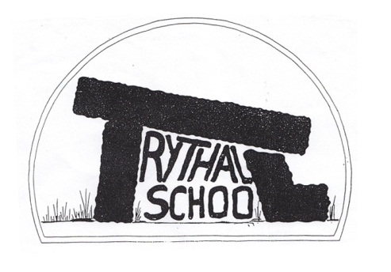
Trythall CP School
New Mill, Penzance
Cornwall. TR20 8XR
(01736) 362021
email: secretary@trythall.cornwall.sch.uk

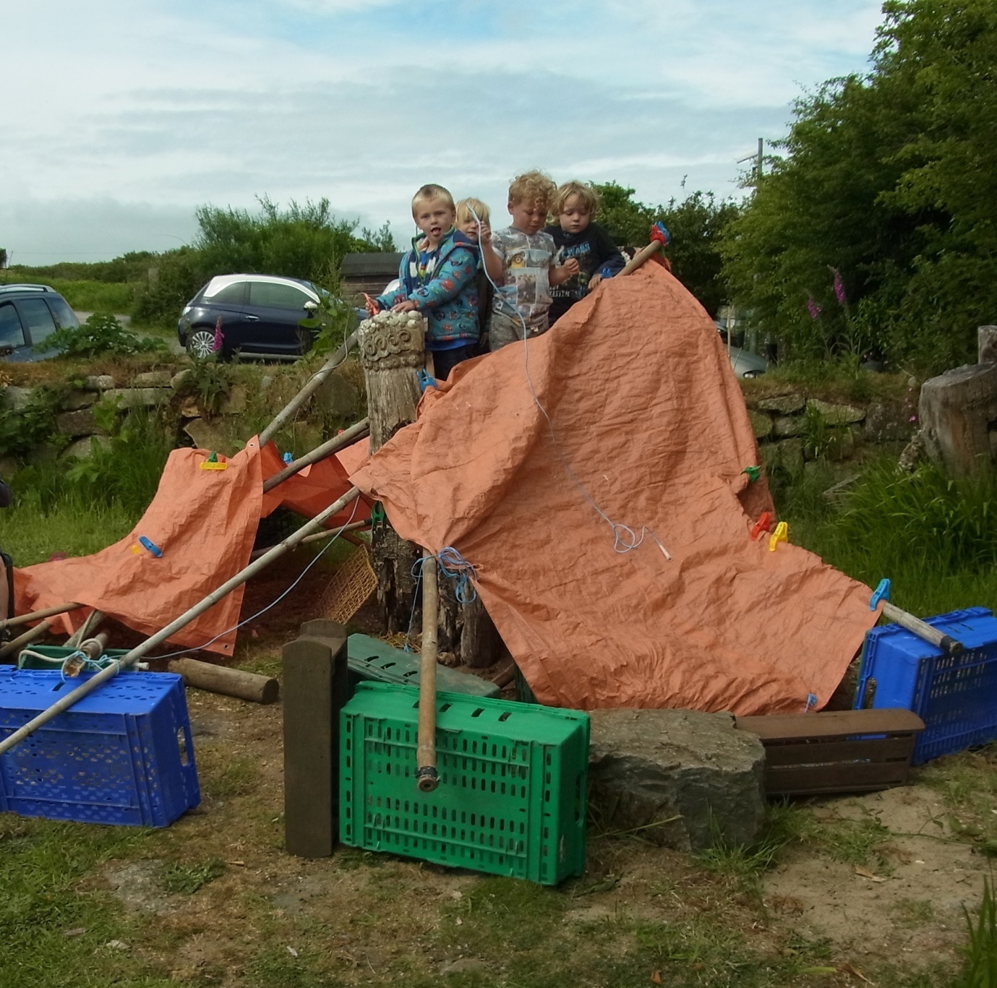
Pre-schoolers build a house
11.07.16

Dear Parents
Great to see so many things going on in another busy Summer Term. It was also great to have such a successful Challenge Partner visit and to have Outdoor Learning confirmed as an area of excellent practice.

Pollination Project
Our progress has been very good with some successful actions taking place:
- Planting of pollinator friendly plants
- Visits from Dave Kilner (Learning Through Landscapes) and Jan (Wildlife Trust)
- Visit from Owen Smith (Plymouth University and OPAL) on Monday
- Visit to Treveal Woods (Wednesday KS2) to look at moths with the National Trust

Our next step is to map out and survey some areas that we want to improve to see how many pollinators we have visiting at the moment.
This project should be very exciting over the next 3 years.

OFSTED etc.
We need to be successful in OFSTED in order to continue to have the choice to deliver education in the way that we do at Trythall. Failure in Ofsted is likely to result in forced academisation and an increased focus on preparing children for the national tests. In order to do well in Ofsted and avoid extra inspections, we must have good SATs results and a high level of attendance. While our SATs results have been good, our attendance levels have often dipped to concerning levels.

6 Ways to Help the School (and your children)
We are very lucky for the help and support we get from the children, parents and wider community. Some parents have asked if there might be any ways in which they could help the school. So, just so that everyone knows, here are 6.

- Listen to your child read several times a week to help them make progress in English.
- Help them with their maths targets (eg learning tables at home).
- Ensure that their attendance is good.
- Volunteer to help (listening to readers, gardening etc).
- Promoting the school.
- Encouraging your child to have a positive attitude towards schools and learning (and even the SATs tests!).

Year 6 Cake Sale
Rhiannon has come forward with an idea to raise money for school funds. Year 6 will cook cakes at home which they will sell for a modest price on Tues 19th July. If it works well, we may ask a different year group to do a similar thing next term.

Challenge Partners Review
The school had a Challenge Partner review 6-8th June which went extremely well, confirming that we are a securely good school. The team agreed with our own judgements about the school based on Ofsted criteria recognising that school improvement strategies, outcomes for pupils and the quality of teaching and learning are all good. In addition, it was confirmed that learning outside the classroom is an area of excellent practice. It was good to see that the hard work and dedication of all of our staff was recognised. The children were also brilliant, showing how much they learned and enjoyed school. The support of parents also makes a great difference to our success. Thank you to everyone for the help and for the lovely children.

New Class structure
From time to time, small schools have to change their class structure as numbers of children in different year groups change. Next year, Trythall will have the following structure:
Classes for 2016/2017

 | teacher | Year groups | number | Classroom
Class 3 | Sue Lloyd | reception | 12 | Sharing the conservatory/ classroom with pre-school.
Class 2 | Emma Cape | Years 1,2 and 3 | 22 | Working in the hall which will be equipped as a classroom.
Class 1 | Fiona/Mat | Years 4,5 and 6 | 25 | Working in the classroom beside the library.

There will be more teaching assistant support for Classes 2 and 3 while Class 1 will split into 2 classes for maths.

Work, as always, will provide the right level of challenge for all pupils. We believe that we can achieve this more efficiently, with the new structure.

Barbecue and Performance
Our Summer Barbecue and performance will take place this coming Friday, 15th July from 6.30 p.m. onwards. Our performance of The White Horse of Zennor will be at 7 p.m.
We will have the usual stalls: cakes, second hand books and raffle for which your contributions will be much appreciated. Last year we created a jar stall, which was really successful and we would like to repeat this. Please can children fill a jar with sweets, biscuits, toys stationary etc. and bring them into school by Friday morning. Thank you.
If you have any ideas for a stall/sideshow that you would like to organise and run please see myself or Lucy.
A range of refreshments and a licenced bar will be available.
Newmill Gardens Open day
This was a great day for ACE with over £3,000 being made for charity. We are all very proud to have taken part in this effort which will make a difference to several Ugandan schools.
The children worked hard to produce delicious salads, pizza, elderflower cordial and blackberry flapjacks - all from ingredients that they grew and harvested (or foraged) themselves. They also produced some lovely pieces of work to sell. Thank you to everyone for helping on the day and to those who donated cakes to sell alongside the children’s food.

Climbing Structure/Monkey Bars
Children must be constantly watched by an adult if they use these. They should not get on top of the monkey bars and they should climb up themselves rather than being lifted. Minor injuries are likely when using this type of equipment.

New Swing
Children should only use this when watched closely by an adult. There is a risk that they could fall into the playground so: only one child should stand on the hedge at one time. Children should not try to get up the tree to get a higher swing.

Top Class Teaching Arrangements
Fiona is not at work at the moment. We plan to use supply teachers to cover this class for the moment.

This Term’s Project: How Can We Feed Hungry People
The children have grown a lot of vegetables this term and will be producing food for the barbecue/performance this coming Friday.

School uniform
Sweatshirts, cardigans and fleeces with the Trythall logo are available online at: www.schoolwearforless.com

If purchasing new PE Kit for September black shorts or jogging bottoms, a white t-shirt and a pair of trainers for outdoor use would be preferable. This makes it easy for children and staff to distinguish between normal clothes and PE kit. For health and safety reasons earrings need to be removed or covered for P.E. lessons.

PE kit should be in school from Monday to Friday.
Please name all your child’s belongings before coming to school to reduce the amount of lost property!

Clubs Next Term
There will be no clubs next week. They will recommence week beginning Monday, 12th September.

School Dinners
The price of school dinners from September has been increased to £2.30 per meal. Children in Reception, Year 1 and 2 will continue to be eligible for Universal Free School Meals.

Diary Dates
Fri 15th July Barbecue and Performance Evening
Thurs 21st July Last day of Summer Term
Mon 5th Sept Staff training day
Tues 6th Sept First day of the Autumn term for the children

Yours sincerely
M. R. Strevens
Headteacher

