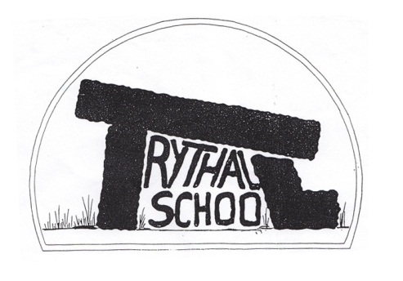
Trythall CP School
New Mill, Penzance
Cornwall. TR20 8XR
(01736) 362021
email: secretary@trythall.cornwall.sch.uk

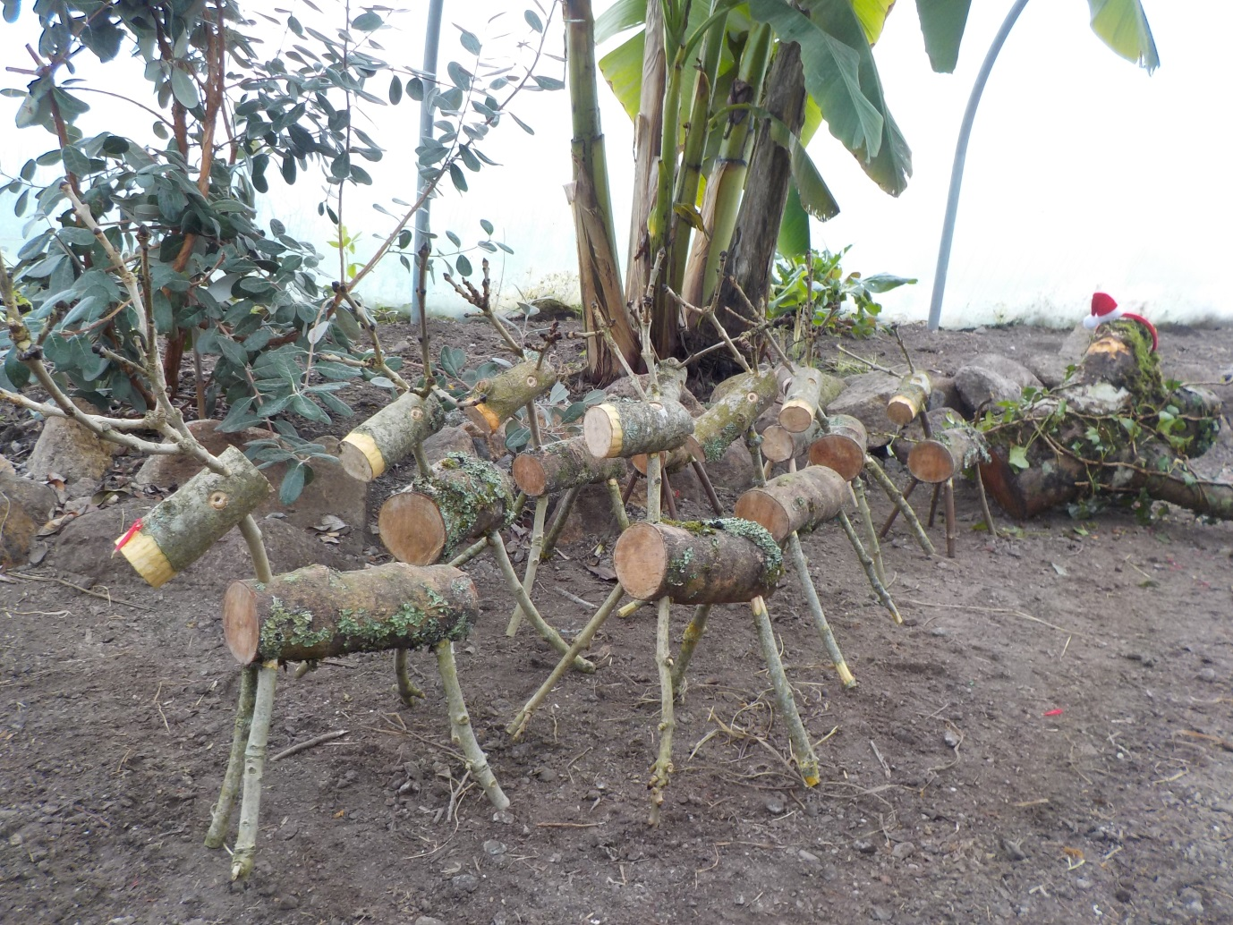

7.1.16
Dear Parents
A very happy new year to you all from all the staff at Trythall. We hope you had a great Christmas.

Asthma – Important Changes
The school will hold emergency inhalers in the office but you need to fill in the new updated forms to enable us to do this. We would therefore be grateful if all parents of children who need inhalers could collect the appropriate paperwork from the office and complete it as soon as possible.
New Curriculum Assessment
Along with the changes in the curriculum, the STA (Standards and Testing Authority) has changed the way in which schools make assessments of children. Children are assessed in three bands: working towards the expected standard; working at the expected standard; working at greater depth than the expected standard. Children cannot move to a new band unless they have completed all the requirements of the current band. This is significant because there is now a greater emphasis for spelling and handwriting in primary schools.
For example, if a child writes exceptionally well but has weaker handwriting or spelling skills they cannot be judged as working at the higher level.
Class 1 maths
We have changed the routine for maths teaching in Class 1. The class will now be split between myself and Fiona for maths sessions. This will reduce the size of the maths groups and help us to ensure that all children have a level of challenge that meets their mathematical ability.
Trainee Teacher
I would like to welcome Jo Pipkin to Trythall, who is working as a trainee teacher in Class 2.
Rabbits
Betty, our fun-loving rabbit, has returned with a litter of five kits. They will live in the new rabbit area which is near the chicken house. Children should only go into this area when accompanied by a member of school staff.
Bad Weather procedures: a reminder
Just a note to remind you of our procedures should we have severe weather. In the event of the school having to close, the information will be broadcast on Radio Cornwall and Pirate FM. Lucy will telephone you on the first day of closure and will send a text and email message on any subsequent days.

The latest guide for Parents and Guardians on School Emergency Closures (distributed before Christmas) is displayed in the foyer (further copies available from the office on request).
Christmas Fundraising
Thank you for buying so many Christmas cards from the school and taking part in the raffle. We sold nearly 900 cards, raising £117. The raffle at Zennor Village Hall raised £107.

Swimming
This term the children will work on swimming for distance with certificates distributed stating the distance that each child can swim.

Volunteer Driver Forms
If you help transport our children to swimming etc. could you please complete a 2016 Volunteer Driver Form – available from the office. We really appreciate those of you who help with transport, as without this support transporting our children can be difficult on occasions.

Class 1 (Juniors) Trip to Marine Aquarium
The juniors will have the chance of an overnight trip to the Marine Aquarium on Thursday 4th February. This will be an exciting opportunity but is likely to cost £50 per child. This figure will be reduced for children in receipt of pupil premium. It would be lovely if the whole class could go. More details will follow

Diary Dates
Thurs 4th Feb Class 1 visit the Marine Aquarium (Plymouth)
Mon 15th Feb – Fri 19th Feb Half-term
Tues 1st March Parent Meetings in the afternoon
Wed 23rd March Easter Hats
Thurs 24th Break up for Easter Holiday
Mon 11th April Commencement of the Summer Term
Thurs 5th May School closed as it is being used for Police and Crime Commissioner Elections

Yours sincerely
M. R. Strevens
Headteacher

