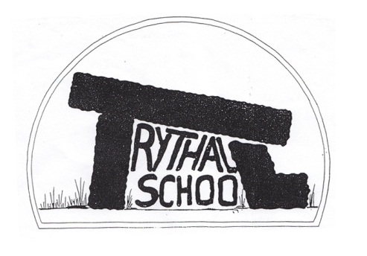
Trythall CP School
New Mill, Penzance
Cornwall. TR20 8XR
(01736) 362021
email: secretary@trythall.cornwall.sch.uk

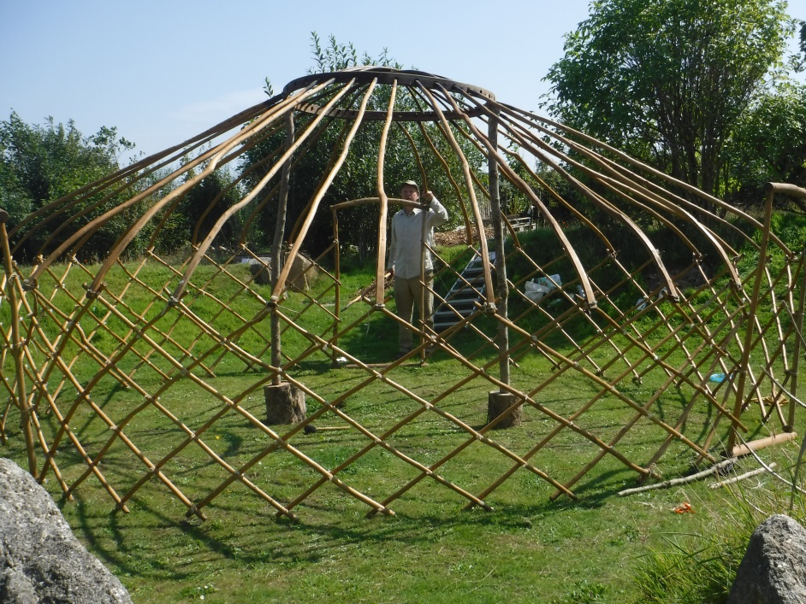
Colin putting up the yurt
14.10.2016

Dear Parents
Welcome back everyone. The children have made a great start to this term and are so enthusiastic about their work. Thank you everyone.

Boot up on Tuesday 18th October
To raise money for The Cornwall Wildlife Trust, we are taking part in the ‘Wear Your Wellies for Wildlife’ event. Children will take part in special fun outdoor activities wearing wellies and are invited to donate £1:00 to the Wildlife Trust. Class 1 and 2 will spend the day at Trevaylor woods while Reception and preschool will be having muddy fun on site.

School Immunisations
Kernow Health will be offering (flu) immmunisations as part of the National Immunisation Schedule (Primary). Childhood influenza (flu) via nasal spray will be offered to years 1 to 3 children. More information will be given closer to the time. For more information please do not hesitate to contact Lucy.

Keeping Children Safe
Information on safeguarding can be found on the school website.
Mat Strevens is the Designated Child Protection Officer
Lucy Uren is the Deputy Designated Child Protection Officer

PANTS Resource
Created by the NSPCC, PANTS is intended to educate children about how to keep their private parts private. We will use the resource at school but you may wish to use it at home also. On the site you will find information sections for parents and for foster carers. These areas are covered at school as part of our Sex and Relationships education programme.

You can access the resource at:
https://www.nspcc.org.uk/preventing-abuse/keeping-children-safe/underwear-rule/

New Swing
Children should only use this when watched closely by an adult. There is a risk that they could fall into the playground so: only one child should stand on the hedge at one time. Children should not try to get up the tree to get a higher swing.

New Staff
We have some great new staff this term who are working so hard for the benefit of the children:
Claire Stephens teaches class 1.
Louise Summers teaching assistant in class 1
Aimee Lees teaching assistant in class 2

Adjusted Roles
Georgia is teaching assistant in class 3 (reception)
Jeanette is taking on a teaching assistant role in class 1
Virg Davies is leading the THRIVE initiative and some areas of Special Educational Needs.
Intervention Sessions for children are normally delivered by: Emma, Virg, Jeanette and Louise.

This Term’s Project: Inventors
The children have been working hard, finding out about inventors and inventions and are making some fantastic inventions for themselves. We hope that you will be able to come to our inventors show after half term.

Parents’ Meetings
We now offer parents’ meetings every term. One of the aims of this is to frequently provide useful information about learning as the year goes along, rather than waiting until the end of school year.

Would you like to be a Parent Governor?
A vacancy now exists for a parent governor. Nomination forms will come out after half term and (if more than one person is nominated) a ballot is held.

Contact Information
Please keep us up to date with any changes. A new data checking sheet will be coming out after half term.

Kit for School
PE Kit is: black shorts or jogging bottoms, a white t-shirt and a pair of trainers. For health and safety reasons earrings need to be removed or covered for P.E. lessons. PE kit should be in school from Monday to Friday.

Football boots can be used for after school football club but should not be used for school PE. Children must have their own shin pads for after school football club.

Children should always have suitable clothes including a waterproof coat for school trips.

Please name all your child’s belongings before coming to school to reduce the amount of lost property!

Sawing Help
We hope to make Christmas reindeers (or something similar) again this year. It’s fun to saw up all the wood, but very time consuming and even more fun with help. If you are able to give up any time to help in the week beginning 21st November, we would be very grateful.

Diary Dates
Tues 18th Oct – Wear your Wellies for Wildlife event
Mon 24th Oct to Fri 28th Oct – Half term break
Wed 9th Nov – Inventor’s Show (pm)
Mon 28th Nov – Christmas Making Day
Wed 7th Dec – Christmas Production – Zennor Church 2 p.m.
Mon 12th Dec – Children’s Christmas Party and Disco – 6pm finish
Tues 13th Dec – Years 3,4,5, and 6 Skating at The Eden Project
Wed 14th Dec – Reception, Year 1 and 2 Play on Ice at The Eden Project
Thurs 15th Dec – Christmassy Christmas Show at The Acorn Theatre, Reception – Year 6

More dates will be added during the term.

Yours sincerely

M. R. Strevens
Headteacher

