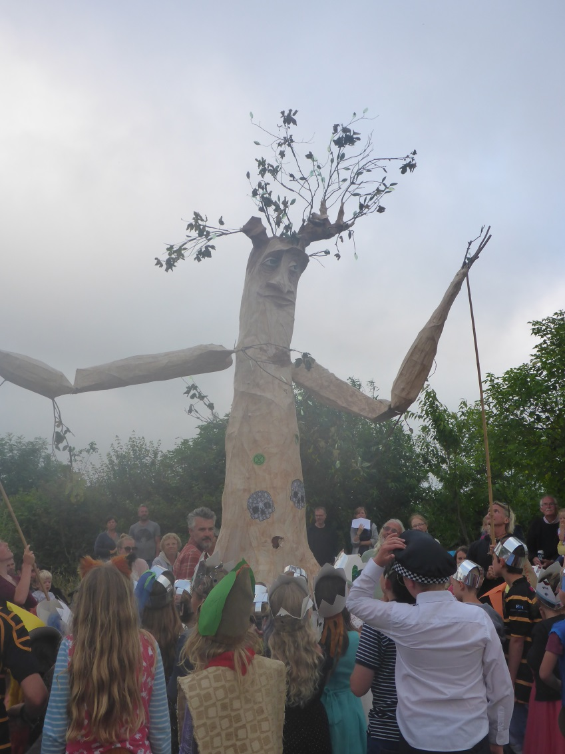

Tree, in our performance, said to look like Sylvester Stallone

Dear Parents/Carers 5th September, 2019

Performance
Thanks to everyone for coming to the our brilliant bbq and performance in July. Everyone worked so hard together to make sure it was a really special evening- not least the children who behaved well, had fun and delivered a great performance. A great success in terms of the enjoyment and the amount of money raised (£1300+). An amazing achievement considering that the date had been changed due to bad weather. So many adults helped with this but special thanks must go to the PTA for the efforts they put in. We even had some camping out on the field.

New Climbing Frame
A new climbing structure and tree house structure have been put in over the Summer by a Company called Earth Wrights, who built the structures at Heartlands. The funding has been provided by the money that comes from the ‘sugar tax’. We cannot use the structures yet as we need to put the sand under the climbing structure and then get both structure inspected. After that, the risk assessment can be completed and the staff and children trained on how to use the structures safely.

We would be really grateful if parents could volunteer to help with preparing the ground and wheel barrowing the sand down from the car park to the climbing frame. Of course, the children will help too but we will have 20 tonnes to move. Having used our wheelbarrows, I would recommend bringing your own if possible.
For the moment, please do not let your children near the tree house or climbing structure as we have not, yet, applied the necessary safety checks to either and there is no impact surface below the climbing structure.

Climate Emergency Talk
As you know children and staff at Trythall have long campaigned for concrete action on climate change.
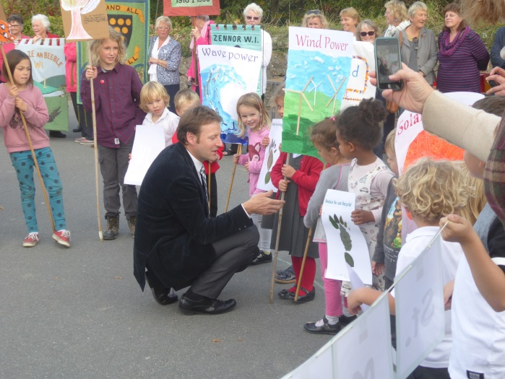

We know that our climate change protest, back in 2017, had a significant effect on Derek Thomas when he visited and may well have influenced his votes in parliament.
Now, with news on the environment seemingly worse every day, the children and staff at Trythall are even more determined to take action and the children have declared a ‘climate emergency’. On Tuesday 10th September, Virg will give a basic, factual talk for the parents at 3.20 p.m. The talk will include some of the findings and projections of the October 2018 Intergovernmental Panel on Climate Change report and the May 2019 UN (IPBES)biodiversity report.
We feel sure that the parents at Trythall, care as deeply as the children about the world, and hope to have a good turn out. I am sure that everyone will find the information and any discussions interesting.
The talk is not intended for children but they will be able to take part in some sports activities on the field/playground while the parents are in the talk. It should last about 40 minutes.

NSPCC Visit
On 18th September the NSPCC will visit Trythall to deliver their ‘Speak Out.Stay Safe’ sessions to all children, year 1 to year 6. More details have been sent to parents which will be followed up with further information after the sessions have been delivered to the children.

Football Team
Last year, our team enjoyed many more fixtures than in previous years. It is great to see that so many children want to practice and play for the team. Although it is not possible for everyone to get to play for the team we have decided to be clear about how we choose players for school football fixtures:
Friendlies: Children from years 4, 5 and 6 who regularly come to practice will have an equal chance to play for this team and an equal time on the pitch.
Competitive Fixtures: Teams will be selected on ability
In other sports, there are some events (eg swimming) where the best players are selected, and other events where we will be able to give more children a go. It’s not easy to make these decisions. We want everyone to enjoy and take part in sport but also to give children a chance to excel in a competitive environment where appropriate.

Paying For School Meals
Caterlink will now provide our school meals and, at the same time, we would like to make the transition to Parent Pay. More details to follow on this. I would be surprised if there are no teething problems. Hopefully, in the long run, this will make things easier and help reduce unnecessary journeys to school.

Welcome
We welcome our new Teaching Assistant – Cristina who is now working in Class 3. I know she is looking forward to working with Reception and Year 1 this year.

Picking Children Up After School
Please let us know, in the office, if your child is to be picked up by anyone apart from the normal person. We cannot hand over the child to a different person without prior arrangement.

Yours sincerely,

M. Strevens

Headteacher

Diary Dates:
Tues 10th Sept Climate Change Talk for Parents – 3.20 p.m.
Thurs 17th Oct Staff Training Day
Fri 18th Oct Staff Training Day
Week Beginning 21st Oct Half Term
Fri 20th Dec Last day of the Autumn term

