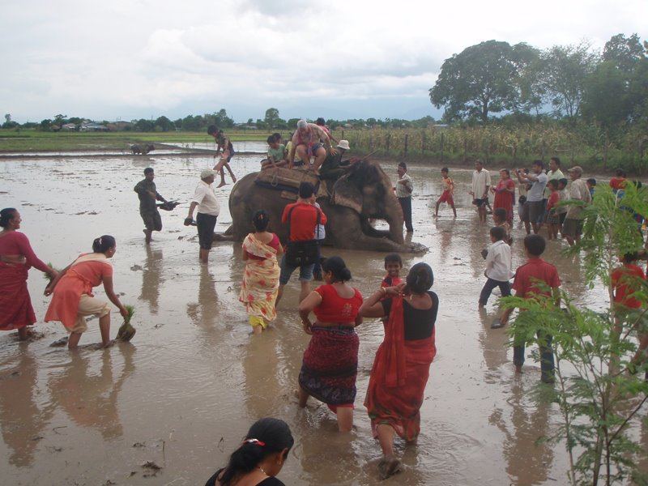
International Mud Day is celebrated all over the World

22.06.2017

Dear All,
It has been another extremely busy and enjoyable Summer at Trythall so far, but there is still plenty more to come before the end of term.

Mazey Day 2017
We hope that you can join us on Saturday for the parade. We are meeting up between 12:15 and 12:30 in the Wellfields Car Park (near the tennis club). We are very grateful to all those people that helped with the preparation – without your support it would be impossible to take part in this brilliant event.

27th June -International Mud Day: The most important day of the year?
International Mud day was created as a way to make the children of the Earth feel closer to each other and what better way than through the Earth itself. The day is also about the importance of laughter, excitement and engaging with nature. With everything we hear about going on in the world today, what could be more important in a school?

Find out more on:
https://www.facebook.com/InternationalMudDay/ or
https://www.daysoftheyear.com/days/international-mud-day/

The children normally get lagged in mud. It may be best to send them in clothes which can be thrown away afterwards. To help with the days activities we are collecting: Y shaped sticks (for mud catapults); 2 litre plastic bottles (for wormeries); unwanted paddling pools (bathing).

The mud we use will also help us grow wild flowers on the field which will help feed the bees. Please let us know if you could help with digging some mud.

Important note: We are holding our activities 2 days earlier than the date published for international Mud Day our activities will be held on Tuesday 27th.

The Aims of Trythall School
We have spent some time deliberating about what we think is important and put it together into the following statement:

Our Aims for Every Child at Trythall
A Trythall child becomes..
..a successful learner who makes good progress and is excited by learning.
..a confident adult, able to lead a safe, healthy and fulfilling life.
..a responsible citizen who makes a positive contribution to society and can work with others.
..a reasoning adult who can investigate, evaluate and solve problems.
.. a human being who celebrates diversity, appreciates beauty and loves the natural world.
..brave, determined, independent in thought and action, adaptable, communicative, creative, curious, tolerant and kind.
The Trythall child learns through doing, making, playing, working together and being outdoors. Every child and their family are included in an atmosphere of warmth and mutual support.
We would like to hear your views : Particularly if you there is there anything that should be added or taken away.
Tortoises
Unfortunately, three of our four tortoises have escaped. We would appreciate any efforts you can make to help us find them. Face book might be useful! They move surprisingly quickly: one was found up at Trythall Farm after just one day!

BBQ and Performance – Friday 21st July
This is our biggest performance of the year along with a lovely barbecue and stalls. This year we will be raising money for school funds and the Wildlife Trust.

All Day Pre-School
From September 2017 we hope to offer pre-school services all day. Parents of 3 and 4 year olds should visit the following website to check if they meet the criteria for free childcare.

https://www.gov.uk/government/publications/30-hours-free-childcare-eligibility

Class Structures for 2017 and 2018

 | Class 3 | Class 2 | Class1
Year Groups | YR and 1 | 2 and 3 | 4,5 and 6

The classrooms and teachers currently allocated to these classes will remain as they are now.
Class 3 will have more children than this year but will have more teaching assistant cover. Reception and Year 1 should work very well together.

Sports Day 7th July
Another great day that we hope you can all come to. The children will be at Sennen Beach all day but parents are very welcome to come and take part from about 1pm. More details will be given closer to the date. Bring a wetsuit or just a swimsuit if you’re a bit crazy!

Training Days
Our training days will be held on Monday July 3rd, Tuesday 25th and Wednesday 26th July. The school will not be open to children on these days. This means that the last day of the Summer Term will be Monday 24th July.

The first day back for children is 5th September.

Parents Information:

Equality Act 2010:
This protects people from discrimination, harassment or victimisation on the grounds of: race; sex; sexual orientation; disability; religion or belief; being a transsexual person; having just had a baby or being pregnant; being married or in a civil partnership and age.

Our Prevent Duty
The following information is taken from DfE advice for Schools and Childcare Providers (https://www.gov.uk/government/uploads/system/uploads/attachment_data/file/439598/prevent-duty-departmental-advice-v6.pdf ):

Under section 26 of the Counter-Terrorism and Security Act 2015, schools have a duty to prevent children being drawn into terrorism.

Schools have a duty to protect children from the risk of radicalisation as part of their safeguarding measures. They can also build pupils’ resilience to radicalisation by promoting fundamental British values and enabling them to challenge extremist views.

“Extremism” is defined as vocal or active opposition to fundamental British values, including democracy, the rule of law, individual liberty and mutual respect and tolerance of different faiths and beliefs.

E-Safety
Whether you’re an online expert or you’re not sure where to start these are 4 key tips to help you from the NSPCC:
  - explore the online world together
  - talk to your child about staying safe online
  - manage the software and tools your family use
  - agree rules about what’s ok and what’s not
More guidance on online safety can be accessed through the school. If you would like to access information on-line then CEOPs Thinkuknow website is a good starting point.
www.thinkuknow.co.uk

Diary Dates
Saturday, 24th June – Mazey Day
Monday, 3rd July – Staff Training Day – School closed to pupils
Friday 14th July – Transition meeting for New Intake Reception Children’s Parents/Carers
Friday 21st July – BBQ and Performance
Monday, 24th July – Last day of Summer Term
Tuesday, 25th July - Staff Training Day – School closed to pupils
Wednesday 26th July - Staff Training Day – School closed to pupils

More details will be given for some of these events on separate letters.

Kind regards

M.Strevens

Mat Strevens
Headteacher

