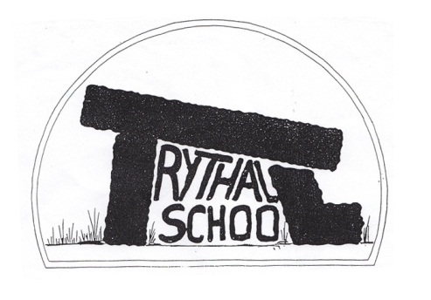
Trythall CP School
New Mill, Penzance
Cornwall. TR20 8XR
(01736) 362021
email: secretary@trythall.cornwall.sch.uk

5.12.2014
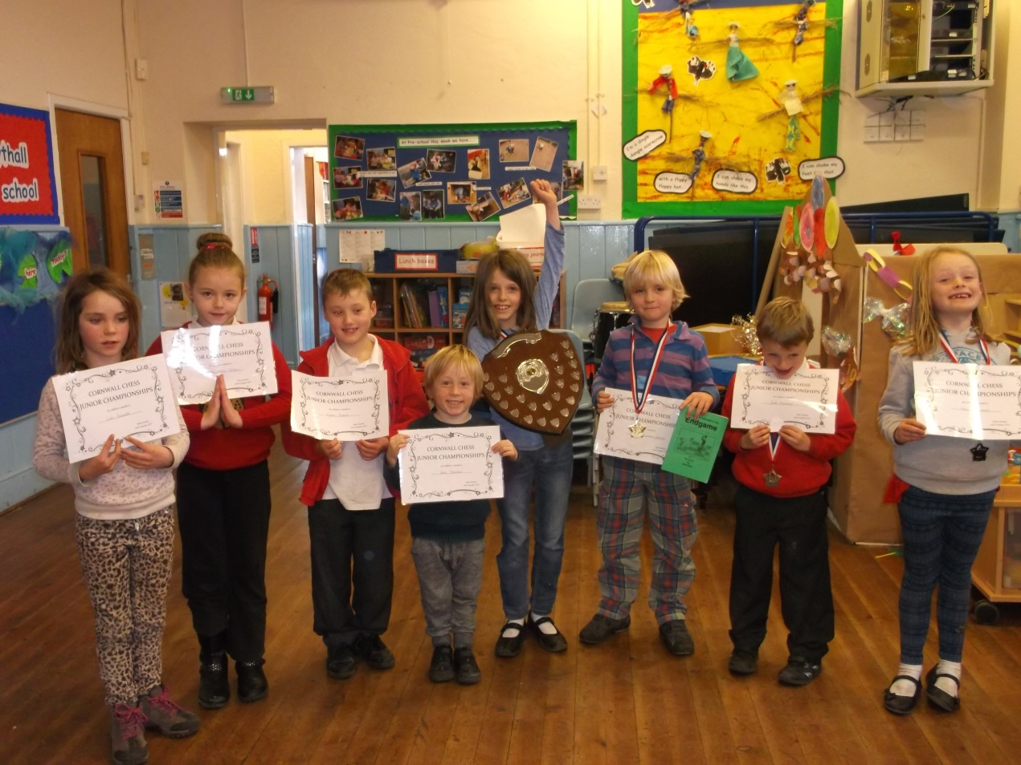

Dear Parents,
It has been a great privilege to be able to see your children practise their Christmas performance. The staff, including Shelley, have worked incredibly hard on our performance for Wednesday.

Details of the Performance
Christmas Around the World will be performed at Zennor Church at 2:00pm. We would be grateful if you could wait outside until we open the doors at approximately 1:55pm. It’s often cold there, so please wrap up warm if you intend to camp out overnight to ensure that you get the best seats. Please collect your child from the church, after the performance and join us in the village hall for refreshments and a raffle for Actionaid.
Costumes: a letter has already been circulated; please let us know if you are not sure.
Please invite relatives: anyone with a connection to the school or church is welcome to attend.

Christmas Trees at Zennor Church
This year we will decorate a tree on the theme of China. The trees will be on display on the day of our performance, but you are welcome to visit the church at other times, over the Christmas Period, in order to have a better look.

Chess Success-the magnificent Seven
Well done to the chess players who stormed the County Championship again. Seven children took part including Ben, Otto, Jack H. , Katie, Lily, Lolo, Lauren, Dylan and many of the children managed good scores. The school came second in Cornwall overall, despite having no players for the under 12 category. Lily won the under ten competition. Otto was the best under seven, while Katie was the best girl for the under eights. Lolo came second in the same category. Jack achieved 3rd place for the under eights. With such a good batch of young players we can look forward to even greater success in the next few years. Our chess Club is held on Wednesday lunchtimes for players who know the basic moves (or Class 1 children who are keen to learn). Players may wish to take part in the UK Chess Challenge which we hold during chess club in the Spring Term. It’s free, the children enjoy it and they get lots of lovely prizes. Please see Mat if you would like any help or advice about children playing chess.
Any Old Clothes?
Lizzie has organised a collection box for the Cardigan of Love Appeal. Donations of fleeces , warm jumpers, hats and coats will be most gratefully accepted. These will be used for victims of floods and landslides in Asia. The box will be collected on the 16th December. Lost property clothes that are not claimed by this point will be sent with them so please check for any lost items before then. More information is shown on Lizzie’s poster in the Lobby next to the collection box.

Outdoor Learning
Next term, we will be running an exciting whole school project, focussed on improving/finishing the outdoor classroom and orchard area. We anticipate that the project will involve all curriculum areas including some lovely opportunities for outdoor art. If parents would like to come along on Thursday afternoons to join in, we would be very grateful.

On the first Thursday back (8th January) the whole school will visit the Eden Project with a focus on gaining inspiration for our own developments. In order to make the trip worthwhile, we are planning to arrive back later than normal.

Defibrillator
Clare Roberts contacted me recently, as Chairman of Madron Parish Council, to request that a defibrillator is sited on the outside wall at the front of the school. I have provisionally said yes to the request but would welcome your views, particularly if you have any concerns. The cost of the machine and installation will be met by the Council together with a donation from Madron Young Farmers Club. The school will raise money for the running costs which are approximately £10 per year. The council expressed that they hoped that this item would never be used but with children being an unknown quantity in respect of heart defects and an ageing population they feel it is an extremely good piece of kit to have locally. The box will have a code which will be given by emergency services to persons needing to gain access.
Another machine is being placed at Madron. There a website regarding the machines we are considering www.communityheartbeat.org.uk.

I feel that this seems like an excellent opportunity to improve the safety of the school and community and would like to thank Clare and Madron Parish Council for giving us this opportunity.

I –Pads
We will soon pick up our I-pads and begin to use them once we are confident that the machines and the children are ready. We will take things one step at a time and will ensure that all preparations have been made before sending them home. Parents will be notified before this takes place. We have a ring-fenced fund that we usually use for ICT which we will use to purchase the I-mac computer needed to manage the individual I-pads. It will also be a great machine for the children to use on appropriate projects.

E-Safety: An e-safety section has been added to the school website with links to the excellent CEOP site: https://www.thinkuknow.co.uk/

Do you know what SMART stands for? There is a poster in both classrooms or your child might be able to tell you.

Homework
There will be no spelling homework given out Class 1 children on Friday 5th December. The homework is to get ready for the Christmas performance. They have already worked hard, but it would good if they could spend some time learning lines or practising songs.

Swimming
The school is now taking part in the School Swimming Charter in partnership with the ASA (Amateur Swimming Association). This means that we will have a more formal structure for teaching swimming. The children will be able to achieve badges and certificates when they reach milestones. In turn parents/carers will gain a better understanding of how well their children are learning and developing in the water. There are 6 levels of school swimming awards, a self-rescue award and an aquatic skills award. The activity resources in the teacher’s pack look great too. We will start the scheme in January.

After School Play
It is great to see so many children playing after school on our grounds. It makes me proud to see how the grounds have been developed by everyone involved and how responsibly the children make use of what is on offer. I do need to point out that, parents/carers need to be responsible for the supervision of their children after the end of the end of the school day. Unfortunately, we are unable to provide supervisors after school.

Information Sharing
We are currently working on the school website to improve our information sharing. All newsletters will now be placed in the Parent’s Information Section. After a good idea from a parent, we would soon like to share messages by email in addition to the text service that we already use. Currently, we are investigating the best way to do this. If you would prefer to receive only electronic copies of newsletters please let Lucy know. If you take this option, it might be worth watching the newsletter on display in the foyer; when this one changes it will indicate that there is a new one available on our website.

Christingles at Zennor Church
You are invited come along with your children to the village hall at 2;00pm on Saturday 13th December to make Christingles and other craft activities. The Christingle service is at 11:00am on Sunday 14th December.
Race for Wildlife
We have offered to manage a water station at the school again this year to support this event. Would anyone be prepared to bring their children along and help? In my experience the children really enjoy it.

Absence and Holidays
Although children need to stay at home when they are too ill to come to school, the school needs to encourage good attendance. If there is anything we can do to help your child’s attendance at school please let us know. We will be offering rewards, at the end of every half term for children with 100% attendance. Our attendance rates are monitored by Ofsted. It is also more difficult to grant family holidays than it used to be with holidays in term time only granted under exceptional circumstances.

School Camp Summer 2015
Two possibilities are being considered: either a London trip costing approximately £100 per child or an overnight canoe expedition on the Helford, costing about £50 per child. A 3rd option might be Porthpean Outdoor Education Centre although this is likely to cost approximately £200 per child.

Staff Comings and Goings
Virg Davies has settled in very well at the pre-school. I am very pleased to say that she will increase her input next term to 3 mornings, while Jeanette will lead on the other 2 mornings.
Unfortunately , Jess Kearey, who worked one to one with a child in Class 1, will soon be leaving us. She has been a hardworking, flexible and popular member of staff. We will make a collection for Jess, if you would like to make a donation, please see Lucy at the office.

Feedback
Thank you for the feedback given so far. Please feel free to use the attached slip to give written feedback.

Diary Dates
Wednesday, 10th December Christmas Production– Zennor church 2 pm
Monday, 15th December Christmas Disco for the children 6.30- 8.30pm
Friday 19th December Break up for Christmas Holidays
Monday, 5th January 2015 Start of the Spring Term
Thursday 8th January Whole school visit to The Eden Project – late return

Kind regards

M.Strevens

Mat Strevens
Headteacher

Attached:
- Feedback Form

School Feedback Form Parent/Carers name: __________________

Your thoughts or ideas

