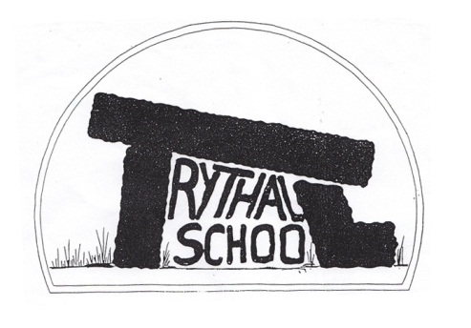
Trythall CP School
New Mill, Penzance
Cornwall. TR20 8XR
(01736) 362021
email: secretary@trythall.cornwall.sch.uk

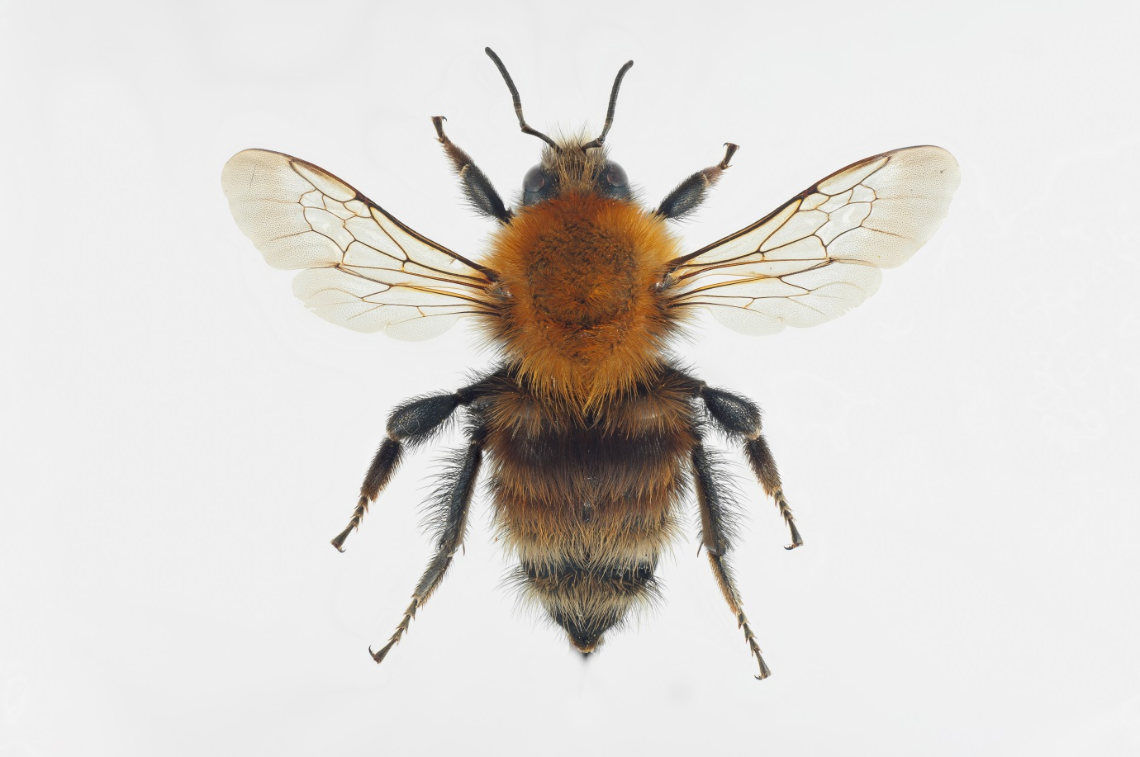
A Rare Brown Banded Carder Bee!
27.05.16

Dear Parents
Lots happening again this term but while busy, I know that the staff and children are enjoying the Summer Term at Trythall.

Pollination Project
As you probably know, Trythall is the hub school for the local area for this three year project supported by Learning Through Landscapes (LTL). So far, the project has been very exciting: Virg (leading the project) and I have learned lots about pollinators and their plants. We have made some very useful links with organisations that can help us. Owen from Plymouth University will soon come down to help us with identification while the local Wildlife Trust will help with surveys of the grounds. Dave Kilner from LTL was very impressed with Trythall in general and thought we had the best Polytunnel he had seen in a school. He was also thrilled to discover the rare Brown Banded Carder Bee in our area. It is a great project, so let us know if you would like to get involved. You might see some changes around the school grounds (such as letting the field grow longer) which are designed to help pollinators.

Top Class Camp 15, 16^{th and} 17th June
Everything is in place for us to have another adventure on the Helford this year camping for 2 nights at Point Field, just behind Tremayne Quay. As in previous years we have two qualified canoe coaches to help. Children will need to bring their own sleeping bag but should not bring too much- they may have to walk carrying all their own gear. Bulky items (pillows and sleeping mats) or heavy items are not recommended. If you have any tents that we could borrow for the trip, we would be very grateful; we have enough to cope with the whole class, but would be more comfortable with more space.

Sunburn
We do spend a lot of time outside the school building. Please ensure that children have a hat to wear.

Absence, Ofsted and Tests
Schools are under increasing pressure to have good test results and low levels of absence. Our school is quite unique and different in the way we teach and learn but we are only able to do this because we can prove ourselves by these three measures. We are very grateful for the support we have had from parents in helping their children make progress, keeping them in school unless they are ill and supporting us through inspections.

Challenge Partners Review
We will be having a visit from a Challenge Partner Review team straight after half term (6th, 7th and 8th June). The team visit is a bit like a friendlier version of Ofsted and should give us an indication of our strengths and weaknesses. The report produced carries little direct consequences, but it is important to do well so that we can have some evidence to show the next Ofsted inspectors that visit.

School Lunches/Pupil Premium
If families claim Pupil Premium, the school receives extra money to use for the benefit those children who are entitled to it.

Since September, 2014 , all Key Stage 1 (Reception Year 1 and 2) pupils have been entitled to receive a free school meal as part of the Universal Infant Free Schools Meals initiative, regardless of what benefits are being claimed. However, if you are in receipt of the benefits listed below which would entitle your child to free school meals anyway, we would be entitled to claim Pupil Premium funding to support your child’s education, just by you completing an application form.

Your child may be entitled for free school meals if you are in receipt of any of the following benefits:
- Income Support (IS)
- Jobseekers’ Allowance (Income Based) and equal based Job Seekers Allowance.
- Income Related Employment and Support Allowance (ESA-IR) and equal based Employment and Support Allowance.
- Child Tax Credit (CTC) with an Annual income of less that £16,190.
- Guaranteed Element of Pension Credit )GPC)
- Immigration and Asylum Act 1999 (IAA) Support
- Universal Credit

Please note that anyone claiming Working Tax Credit, Contribution-Based Job Seeker’s Allowance and/no Contribution-Based Employment and Support Allowance is NOT eligible for free school meals, regardless of what other benefits/credits are being claimed. However, you will be temporarily eligible to claim free school meals if you receive a Working Tax Credit run-on, which is the payment someone may receive for a further four weeks after they stop qualifying for Working Tax Credit.
A breakdown of how we use this money is shown on our website. Please see Lucy if you would like an application form or more details.

Student teachers
Paul Matthews is our current student in class 2. He is doing a great job and like all students, brings a range of benefits to the school.

Football Club
There is a lot of enthusiasm for football club at the moment and the sessions are going very well with Scott Goodchild teaching in curriculum time and Paul Matthews and myself teaching the afterschool club. As you can imagine, the boots and shinpads arrangements are quite difficult but we need to make it clear what children need. Basically, if any children are wearing boots, then everyone needs wear shinpads.

So this is what the children need:
Curriculum time teaching:
trainers not boots (no shinpads required),
and PE or football kit

After school club:
trainers or boots
shin pads
PE or football kit

Swimming After School
Swimming after school on Fridays is part of our curriculum time. Please support this by ensuring that all KS2 children come to the swimming sessions unless they are ill. We have to provide swimming as part of our curriculum. If swimming doesn’t work after school, our only alternative would be to extend the normal school day by ten minutes and stop doing drama, Friday art or outdoor projects.

Tough Enough Event
There will be a tough enough event at Pendrae Farm, St Buryan on Saturday 28th May. To take part there is a charge of £19 for children. Children can take part for nothing if their parents volunteer to help marshall 7:30 am to 4:00pm on Saturday and Sunday. For more details, please talk to Cinnamon and Mike who are organisers.

Top Class teaching Arrangements
Fiona will be off until 20th June. For the moment, Jeanette and I will teach in that class while she is away.

Fruit and Veg for Sale
We have organic fruit produced in our polytunnel for sale. However, if we make a shop outside some of it usually dies. If you would like to buy something, let us know and we will send a child up to get you some, as fresh and can be and for a reasonable price.

At the moment we have:
Lettuce, chives, rocket, mibuna, sorrel, mint and possibly some peas and beans but you can’t have the strawberries. We can also sell potted up mint or banana trees.

Our School book: A Portrait of West Penwith
We have found a good printing company and, at the moment, we are scanning in the children’s artwork. After that, we can bind up the children’s individual books, which can be taken home.

This Term’s Project: How Can We Feed Hungry People
We hope to have a focus on growing food, making food and eating food. The children will grow and cook food for themselves, for the garden open day and for the Barbecue/Performance. The performance may be based on the ‘White Horse of Zennor’.

Garden Volunteer Day : Friday 3rd June
To keep the polytunnel fit for more growing as well as one or 2 other outdoor jobs. The children will prepare some food for lunch but must be accompanied by their parents. We will be there 9 to 5 but please give up any time that you have, even if it’s only half an hour- it makes a real difference for the children. No skills required.

Diary Dates
Mon 30th May – Fri 3rd June Half-term
Wed 15th June - Fri 17th June Class 1 School Camp
Thurs 23rd June School closed for voting
Sat 25th June Mazey Day
Sun 3rd July Newmill Gardens Open Day
Fri 8th July School closed for staff training
Fri 15th July Barbecue and Performance Evening
Thurs 21st July Last day of Summer Term

Yours sincerely
M. R. Strevens
Headteacher

