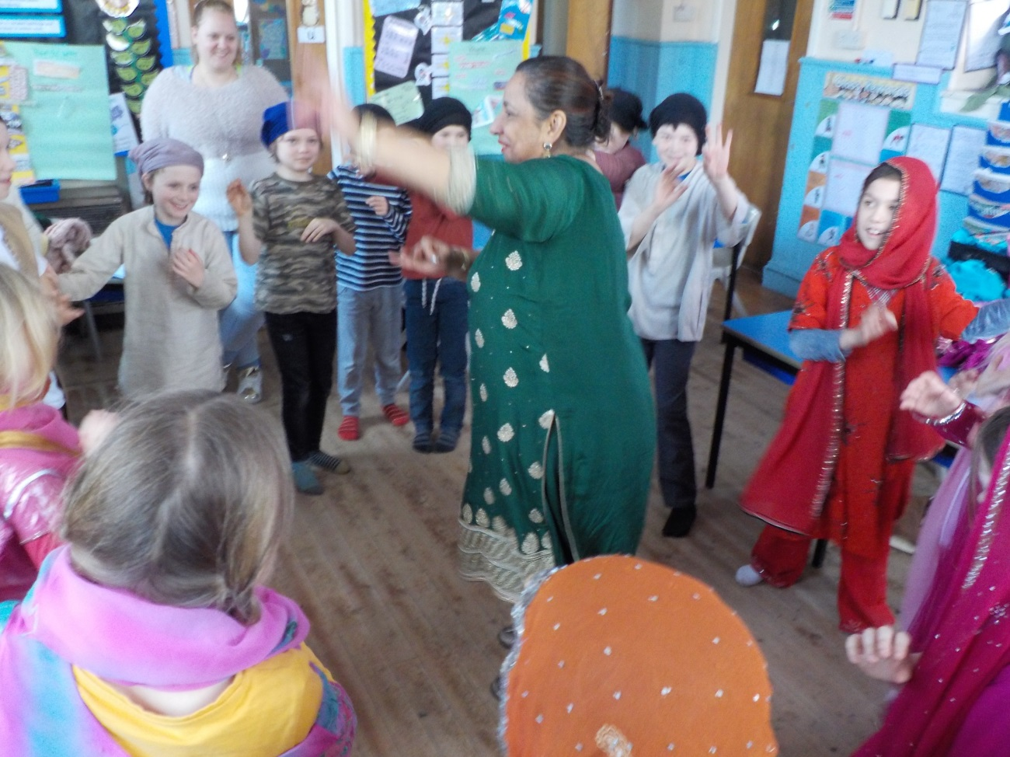
Trythall children enjoy learning about Sihkism with Daya.

23.3.2017

Easter Disco The disco for the children will be held in the school hall on Monday 27th March from 4:00pm – 6:00 p.m. Children may wish to bring party clothes to change into at the end of the school day. Please could each child contribute £1.00 which pays for a raffle ticket and goes towards the cost of the disco. Also, as the children will probably be quite hungry, after school, we would be grateful if each child could bring in some party food which they can eat before and during the disco. This arrangement worked really well at Christmas so we thought we would try it again.

Easter Hats Parade The traditional parade will be held next Wednesday, 29th March at 10 a.m. in the school hall. You may like to help your child make an Easter hat or bake a cake. Parents too can take part by making a cake! Please come along to watch; light refreshments will be available. The raffle will raise money for ACE (Aiding Conservation Through Education). If you do not want your cake used as a raffle prize please let Lucy know. Any other raffle prizes would also be gratefully accepted.

Challenge Partners
We are members of the Challenge Partner network of schools. Every year we have a review visit where 3 reviewers visit the school, have a look at how we work, and help us to identify strengths and weaknesses. The team also help us to estimate where the school would rate in Ofsted terms. It was agreed that the school is securely in the good category.

School Performance Data 2016
Trythall is not included in school performance tables because of the low numbers of pupils. However, there are some aspects of the data that we can report:
Data is given to us based on how much progress the children make between Year 2 and Year 6 for reading, writing and maths.

In reading, our pupil progress score put us in the top 12% of schools
In writing, our pupil progress score put us in the top 2% of schools
In maths, our pupil progress score put us in the top 6% of schools
100% of our pupils passed the phonics test at Year 1

Well done to all the staff and children who work so hard, not just in this very small aspect of our school but on the development of ‘the whole child’.

Training Days
Our training days will be held on Monday July 3rd, Tuesday 25th and Wednesday 26th July. The school will not be open to children on these days. This means that the last day of the Summer Term will be Monday 24th July.

New Parent Governor
Natasha Aly has taken up the position of parent governor. She joins the two existing parent governors, Elizabeth Hatchelt and Andrew Stott.

E-Safety
Whether you’re an online expert or you’re not sure where to start these are 4 key tips help you from the NSPCC:
  - explore the online world together
  - talk to your child about staying safe online
  - manage the software and tools your family use
  - agree rules about what’s ok and what’s not
More guidance on online safety can be accessed through the school. If you would like to access information on-line then CEOPs Thinkuknow website is a good starting point.
www.thinkuknow.co.uk

KS2 Camp (including Year 3 children)
We’ve put together what looks like an exciting, four day programme for this year at very good value at £50 per head.
The draft programme is as follows:
Tuesday 6th June: Praa Sands-Coasteering. Night on site at Trythall School
Wednesday 7th June: Rinsey-Amazing abseiling, beach art with National Trust. Mystery Pig Camping at Tehidy Woods
Thursday 8th June: Bikes at Tehidy/surfing at Gwithian. Camping at Tehidy Woods
Friday 9th June: Beach day and return to Trythall and home.

A Night With Sharks 22nd May?
We may have an opportunity to take class 1 and 2 to take part in an overnight trip to the Plymouth Marine Aquarium to take part in their ‘Sleeping with Sharks Experience’. This will complement the studies for next term well as we are going to have a focus on nature and the Mazey Day Theme is ‘All at Sea’. We will spend a week or two looking at sea life so this trip would be a great project starter. I would like to gauge the interest, as we need nearly everyone to go to keep the cost down. Please complete the simple sheet at the bottom of the form and return it to Lucy so that we know if the trip is viable. The cost of the trip will be £30 to £35 depending on take up. I know that the children in Class 1, who have taken part before, are keen to go again.

Reading at School
It’s been great to have everyone working so hard on reading and we are beginning to see the effect of everybody’s efforts.
- We will continue to have volunteers in school to listen to readers on Tuesdays (9:00-9:20) so please come along and help if you have some time.
- Every day, parents/carers will be able to listen to their own children read in the school library.

New Faces at Trythall
Jenny is working as a teaching assistant and Alice works on Wednesdays as a volunteer. Shirley, Jenny’s mum, will be volunteering on Mondays and Tuesdays to hear readers. After Easter, Amy Wynn will be working at the school on Wednesdays on outdoor activities.

In nine days time, aliens will visit Trythall at some point during the morning. Landing at Ding Dong.

Diary Dates
Monday, 27th March – Children’s Disco 4 – 6 p.m.
Wednesday 29th March – Easter Hat Parade 10 a.m.
Friday 31st March – Last day of Spring Term
Tuesday - April 18th - First day of Summer Term
Monday – 22nd May - Overnight stay at Plymouth Aquarium, Class 1 and 2. t.b.c.
Monday 29th May – Fri 2nd June –Half Term
Tuesday 6th June – Friday 9th June – School Camp, KS2 including Year 3
Saturday, 24th June – Mazey Day
Monday, 3rd July – Staff Training Day – School closed to pupils
Monday, 24th July – Last day of Summer Term
Tuesday, 25th July - Staff Training Day – School closed to pupils
Wednesday 26th July - Staff Training Day – School closed to pupils

More details will be given for some of these events on separate letters.

Kind regards

M.Strevens

Mat Strevens
Headteacher

----------------------------------------------------------------------------------------------------------------------------------------

Class 1 and 2 - Overnight trip to Plymouth Aquarium

My child would/would not…………………………………………………………………………… take part in an overnight trip to the Plymouth Marine Aquarium to take part in their ‘Sleeping with Sharks’ experience costing up to £35.

(this helps us gauge the interest but does not constitute a binding commitment)

Signed…………………………………………………………………….

