.
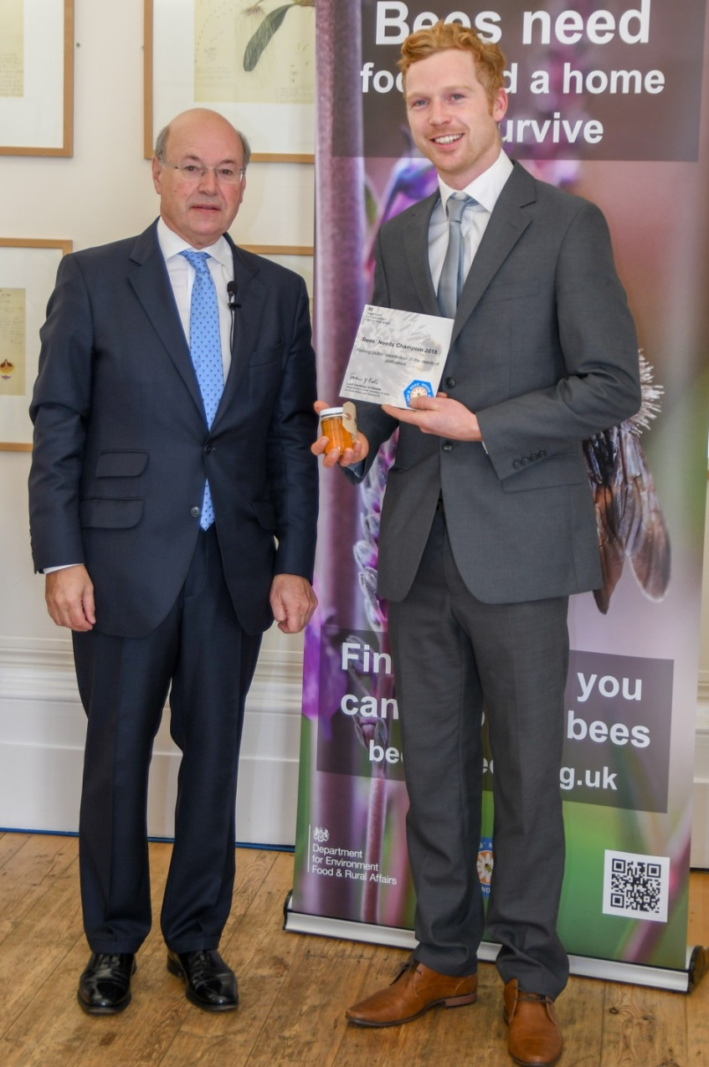
Dave Kilner recently received the Bees Needs Champions award for the outstanding work that Trythall Children did on the Polli:Nation project. Trythall were one of only two schools nationally to receive the award.
Lord Gardiner of Kimble, Parliamentary Under Secretary of State for Rural Affairs and Biosecurity, was blown away by the work our children are doing and repeatedly referred to Trythall pupils as ‘outstanding ambassadors for the future.’ We are so proud of them all.
Furthermore, our children’s work helped the Polli:Nation project win the award for the best Lottery Funded environmental Project in the UK this year.
We are hoping that Dave will be able to visit Trythall again to see what we are doing on our own Peas4Bees project. In return we’ll show him how to tie proper knots so that they stay done up!

Dear Parents/Carers 20.12.18

New Building
A huge thank you to all the volunteers who have, over the last three years, worked on the new building. It has been a real community effort; something which we see as a special part of Trythall School. It has also saved us a considerable amount of money! The pre-school is now moving across to their wonderful new building. We would still appreciate any help that volunteers can give us with painting or other jobs over the coming break. No special skills required.
_{e}
Next Term’s Whole School Project
The children will be looking at the problem of plastics and recycling; trying to find an answer to the central question: ‘Should we go plastic free?’. Part of the project might involve having a fundraising day by wearing Christmas jumpers entitled ‘Jumpers Are Not Just For Christmas’. So don’t put them up in the loft but please don’t go out and buy one especially for the event!

Pre-school Prices
In order to bring our costs in line with the nationally set levels, we need to make a small increase in the hourly rate for pre-schoolers. From Easter 2019, the charges will be:
- 2 year olds - £4.40 per hour
- 3 year olds - £5.40 per hour

Congratulations to Emma and Welcome to the World Milly May
We are pleased to inform you that Emma gave birth to Milly May on Sunday morning. Of course, Emma will take some time off to be with her baby. In January, Paul Hooper will be taking over as classroom teacher in the mornings while, in the afternoons, lessons will be led by our existing teachers. Having known Paul as a student here and as a parent for many years, we have great confidence that he will fit in well at Trythall and do great job with the class while Emma is away.

Dr William Bauress
William ( Fletch, Zeph and Skyer’s grandfather) has recently had a heart bypass and is recovering in hospital. We are so grateful to William, for working as a volunteer, to lead the transformation of our school grounds. The performance area, the pond, the new building were all designed and built by him, for the benefit of our children, without any personal reward. I am sure you will all join us in wishing him a speedy recovery and we look forward to seeing him soon.

Peas 4 Bees Update
Peas 4 Bees is our own project and the children’s invention. We work in partnership with Paddy Saunders of Kernow Ecology. Our aim is to concentrate on growing flower meadows (containing the right legumes) around 4 of the few remaining Long Horned Bee colonies, with the aim of saving this species. The children will continue with their 4 Ps : plan; persuade; plant; protect. They have now planted up about 100 plants at St Loy and collected 1000s of wild legume seeds (with Paddy’s help) in the Autumn which are now kept in the staff room fridge! We also have a new field near Sennen. Next year we plan to grow 1000s of plants for planting out in the Autumn and to persuade owners in Mousehole and Kenidjack to give us more land for planting.

You can help: There are lots of ways in which parents/carers will be able to be involved next term but in the meantime.. we need hundreds of big pots. If you have anything in the range of 2 litres to 6 litres that we could have, we would be very grateful. Old beach buckets/plastic pots/big milk bottles would be great too as we can put holes in the bottoms.

Sports at Trythall
We are developing sports opportunities at Trythall, with Rob, our sports apprentice, helping to organise a greater range (and number) of activities, competitions and clubs. I am very pleased to say that out football team, who are still quite young, have reached the final of the Centenary Shield, the County Cup Competition for schools with less than 100 pupils. The match will be played on Tuesday 19th March . So well done, good luck to the team and keep practising!

Attendance at Trythall
Attendance at Trythall is generally good with the majority of children having above average levels. However, there is a relatively high number of children with high absences levels (greater than 10%), defined by the government as persistent non-attenders. While we understand that some absences are unavoidable, this is not helpful for the children involved, and puts pressure on the teachers and school. The school must take every reasonable measure to reduce the level of persistent non-attenders. For your information, I have attached two letters to this newsletter: one about general absence and the ‘Exceptional Circumstance Leave Request Notice to parents and carers’ (this covers holiday requests).

Parents/carers will now receive a letter, at the end of each term, keeping them informed of their child’s attendance levels.

Being Late for School
Late arrival at school has a similar effect to absence with children often missing the most important part of the lesson and finding it hard to settle in. it also effects the school’s absence figures. Children should arrive at school between 8:45am and 8:55am. We would like to ask parents to sign in at the office if their children arrive after 9:10 am. Arrival after the class registers have closed result in an unauthorised absence for the morning session.

A Big Thank You
Thank-you so much to all the parents who have provided un-precedented levels of support this year: listening readers, painters, digger drivers, diggers; gardeners, PTA, water-givers, grant-finders, card makers; artists; chefs; drivers ; present-wrappers; shoppers; vetch-planters; Christmas tree-makers; tortoise keepers etc. No matters how big or how small every bit of help makes a difference to the children. We truly appreciate the help you give.

Volunteer for the Future
There is always work to be done at Trythall, which saves a huge amount of money and gives extra opportunities to the children. Perhaps you could help with:

- Painting: If you have any time to help with painting inside the new building over Christmas, please let us know. There will be a couple of parents in on Thursday 3rd January so you may want to come in and help, but your help would be very welcome on any day that you have free.
- Polytunnel day: We hope to get a good group of volunteers together to prepare the area for this years growing.
- Animals: Could you help us to look after any of our animals? Or perhaps something new; animals are one of the most important things for the children at Trythall.

Trythall Christmas Performance
I hope that everyone enjoyed the brilliant performance in Zennor Church this week. I don’t think we’ve ever seen as many people there before. Well done to everyone for another great performance and thank you to all the parents for coming and for giving us such lovely children, who are, genuinely, a pleasure to work with.
Last of all, I hope you all have the fantastic Christmas that you all deserve. Take care and we look forward to seeing you all in January.

On behalf of all the staff at Trythall:

M.Strevens
Headteacher

Diary Dates:

Mon 7th January - Children return to school for the Spring term
Half Term – Week Beginning 18th February
Tues 19th March – Final of the Centenary Shield County Cup Competition
Last day of Term- 5th April

