Trythall CP School
New Mill, Penzance
Cornwall. TR20 8XR
(01736) 362021
email: secretary@trythall.cornwall.sch.uk

Thanks to Class 1, we now have a continual feed of water to the sand pit pump and stream.
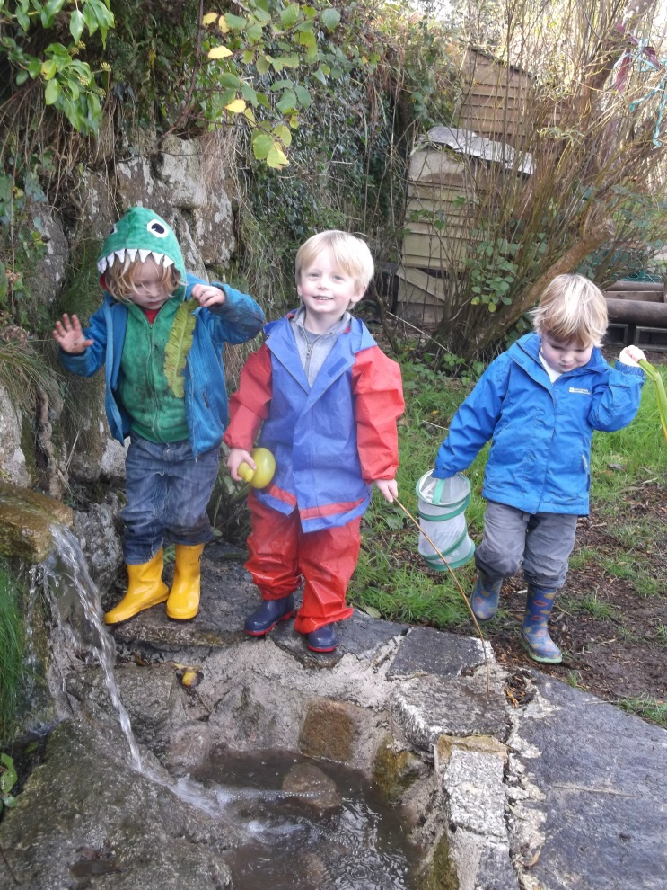
Thank you, everyone for making the harvest celebration such a special event feedback has been overwhelmingly positive. Although it is hard to single people out because so many were involved, special praise is due to Emma for organising the event and to Bruce and Lynn for their hard work preparing food with the children. I hope that we can enjoy a similar event next year.

Project Based Learning and Outdoor Learning
Trythall staff continue to centre our learning on our own project rather than schemes or resources that are available. We now focus more of our activities on outdoor learning in order to enrich the experiences of the children. A typical example is the design, by Class 1, of the valves and pipes that supply river water to the stream and sand pit. In planning these activities, teachers have to ensure coverage of all areas of the curriculum as well as development of the appropriate skills. Although this approach requires more time to plan and assess, we believe that the time invested is worth- while because of the benefits to the children. Many schools are becoming interested in this approach and are visiting Trythall to see how we do it. However, moving forward so quickly has only been possible because of the support that we have enjoyed from parents and a community who care
deeply about their children’s school experiences- so
well done everyone.

I –Pads
We have the offer of making use of I-pads at school. We believe that the careful use of these devices will enhance the children’s learning. However, the staff are well aware that availability of technology can be a ‘Double Edged Sword’ and that it needs to be introduced with great caution. If you would like to hear more about our plans, and to give your views please come along to our parents forum meeting on Monday 17th November at 2:45pm repeated at 6:30pm – meetings will last approximately half an hour. It is worth noting that parents were also concerned 4 years ago when a wi-fi computer network and 17 laptops were introduced at Trythall but have since been reassured by the way in which we have made use of them.

Communication
The school has a real open door policy and we are always ready to make time to deal with your questions or to listen to your point of view. I would encourage parents to continue to communicate in this way if they feel comfortable to do so. I can appreciate that people do not always wish to communicate in this way so I have included a slip, attached to the newsletter, for you to make your comments in writing. Additionally, I will now hold parents and carers forum meetings which provide an opportunity for you to learn more about nominated topics and to give your views. On Monday, the once a term parent consultations will be held which is another opportunity for discussion relating to your child.

Parent Consultations
Please book an appointment by putting your name into an appropriate time slot on the sheets in the entrance hall . It would be helpful if people can do their best to stick to the slots provided. However, if this is impossible the teacher should be able to book a consultation at another, mutually convenient time.

School Meals Survey
Changes to free school meals for infants have gone very well. A survey produced by Chartwells was given out on Tuesday. We would be grateful if you could return this to the school office by Friday. Additionally, there is an opportunity to give more general feedback on school meals on the school feedback form.

Garden Volunteers
Thank you to the volunteers who helped in the polytunnel in the half-term break. Both adults and children had a great day and got a lot done.

Trust Shop-Don’t Buy Tomatoes
The most wonderful tomatoes are still growing in our polytunnel. If you would like to buy some please just pop up and pick them and pop some money in the box in the office. There is also a lot of spinach.

School Camp Summer 2015
Two possibilities are being considered: either a London trip costing approximately £100 per child or an overnight canoe expedition on the Helford, costing about £50 per child. I would be grateful if Class 1 parents could express a preference on the attached feedback slip.

Two year olds at Pre-School
Currently, on the term after their third birthday, children can attend pre-school and access funding. On the term of their third birthday (even if they are still 2)they can attend but no funding is available. We are currently investigating the possibility of being able to take children from their second birthday.

Organisational Staffing Changes at Trythall
We have changed the staffing organisation for Class 2. In the past, a teacher led the class (reception, year 1 and year 2) with the help of a teaching assistant (who normally worked with the reception children). We now employ two teachers for the class for 4 morning of the week, Emma working with year 1 and year2 while Sue works with reception. For the remainder of the time, Emma or Sue normally lead the class. The exception being when specialist teachers Shelley(Drama) or Dave Tremaine(Sports) lead the class with support from a teaching assistant. The increased teacher time has had a hugely beneficial effect on the learning and development of the children in this class.

Staff Comings and Goings
Amanda Prosser (teaching assistant) and Vivienne Slater (pre-school leader) have both moved on to new jobs working with children in early years settings. We are very grateful to them both for the hard work that they did and I know they will be missed. Collections will be held, to say a big thankyou, for both members of staff so please see Lucy if you would like to contribute to either or both.

Shelby Kessell and Lucy Mander are now both employed at the school as teaching assistants. They are both amazingly hard working, professional and work in a caring way with the children.

Animal comings and goings
I am sorry to say that our two baby rabbits, Fudge and Hop, died recently from myxomatosis. This was a devastating blow for many of the children, and the staff. Some parents had expressed concern that the rabbits had not been vaccinated- this was because they were too young. Sadly, they had an appointment to be vaccinated just days after they died. The mother, Betty, was vaccinated some time ago.
Some parents were also worried to see the tortoises gone on Tuesday. I am happy to say that they are just hibernating and we fully expect to see them again in the spring!

Rotary Shoeboxes
Pick-up has been delayed and will not be until Friday. Thank you to everyone who has contributed.

Clubs
Dave is quite happy to continue with the bike club and it seems very popular. However, in order to run a bike club rather than a conventional sports club, he needs me to be present which is a significant draw on my time (which is very short at the moment). Please let me know your thoughts about whether another type of sports club might be popular. At the moment it appears that the bike club will attract twice as many children as hockey, rugby or football. On the other hand, I know that lumping the bikes into the boot on a Monday morning is not always a pleasurable experience. One parent suggested a go-cart club and suggested that one of the parents might want to run this. It needn’t be a go cart club, but we are quite happy to consider any of your ideas.

Diary Dates
Wednesday, 10th December Christmas Production– Zennor church 2 pm
Monday, 15th December Christmas Disco for the children 6.30- 8.30pm
Friday 19th December Break up for Christmas Holidays
Monday, 5th January 2015 Start of the Spring Term

Kind regards

M.Strevens

Mat Strevens
Headteacher

Attached:
- Feedback Form

School Feedback Form Parent/Carers name: __________________

your thoughts related to meals at school:

Your thoughts relating to school camp for Summer (Class 1 only). Please put a tick by the preferred option.
I would prefer a trip to London (Approximate cost £100)
I would prefer a canoe expedition (Approximate cost £50)

your thoughts related to school camps

thoughts about school clubs

thoughts about Ipads

any other thoughts or ideas

Please continue overleaf if necessary

